Acronimi
- FIB: Forwarding Information Base (Lookup table usata dai router per fare le decisioni di forwarding)
- FRR: Free Range Routing (tipo di database per la gestione di dispositivi nelle reti di comunicazione)
- MIB: Management Information Base
- VRF: Virtual Routing and Forwarding (technology that allows multiple instances of a routing table to co-exist within the same router at the same time https://en.wikipedia.org/wiki/Virtual_routing_and_forwarding)

Containerlab

Comandi containerlab

Deploy
sudo containerlab deploy

Generico:
containerlab [global-flags] deploy [local-flags]

Flags
topology
With the global --topo | -t flag a user sets the path to the topology definition file that will be used to spin up a lab.
When the topology path refers to a directory, containerlab will look for a file with .clab.yml or .clab.yaml extension in that directory and use it as a topology definition file.
When the topology file flag is omitted, containerlab will try to find the matching file name by looking at the current working directory.
If more than one file is found for directory-based path or when the flag is omitted entirely, containerlab will fail with an error.
Remote topology files
https://containerlab.dev/cmd/deploy/#remote-topology-files

Lab inspection
Elenco dei nodi con info utili:
containerlab inspect

Connessione ad un nodo
You can use SSH to connect to the CLI by either using the management address assigned to the container or a node name. Ad esempio, per connettersi al nodo Nokia SR Linux del quickstart, posso usare il nome del nodo clab-srlceos01-srl, che trovo con il comando inspect:
ssh admin@clab-srlceos01-srl

Oppure posso usare un comando generico usato per i container. Nel caso del nodo Nokia SRL:
# access CLI
docker exec -it clab-srlceos01-srl sr_cli
# access bash
docker exec -it clab-srlceos01-srl bash

Distruggere il laboratorio
sudo containerlab destroy <topology-file.yaml>

Docker login

Docker logs
docker logs <nome_container>

Fa vedere l’output della CLI(?)

Manuale Containerlab: roba potenzialmente utile

Topology
dummy#
The dummy type creates a dummy interface that provides a virtual network device to route packets through without actually transmitting them.
Such interfaces are useful for testing and debugging purposes where we want to make sure that the NOS detects network ports, but doesn't actually need to send or receive packets via these ports.

IPv4 ADDRESSES
https://containerlab.dev/manual/topo-def-file/#ip-addresses
Non tutti i tipi (kinds) supportano la definizione degli IP delle interfacce nel topology file.
Nota: nel caso in cui si configuri l’IP di un solo endpoint, l’altro (credo) può essere configurato da dentro il container (o comunque nel lab dopo il deploy, in altri modi).

Groups#
groups sets the values for the properties of all nodes belonging to the group that you define, it's more flexible than kinds which only sets the properties for nodes of that specific kind.
It is useful to organise your topology, especially in cases where nodes of the same kind may require differing properties such as type or image version.
Values inherited from groups will take precedence over kinds and defaults. In other words, the inheritance model is as follows (from most specific to less specific):
node -> group -> kind -> defaults
For example, the We create separate groups for debian and alpine clients, as well as a group for spines where the nodes will be of type ixrd3l.
topology:
defaults:
kind: nokia_srlinux
image: ghcr.io/nokia/srlinux
groups:
spines:
type: ixrd3l
apline-clients:
kind: linux
image: alpine
debian-clients:
kind: linux
image: debian
nodes:
srl1:
group: spines
srl2:
group: spines
srl3:
srl4:
client1:
group: alpine-clients
client2:
group: alpine-clients
client3:
group: debian-clients
client4:
group: debian-clients
Now with the above example, we can notice:
- The client nodes in the alpine-clients group will be linux kind and run the alpine image.
- The client nodes in the debian-clients group will be linux kind and run the debian image.
- The nodes in the spines group will be ixrd3l chassis, but still inherit the kind and image from defaults.
- The srl3 and srl4 don't belong to any group, so they will inherit their properties from the defaults.

Kinds#
Definisce una “label” per un insieme di proprietà da attribuire ai nodi con kind = quella label.
Defaults#
Definisce una serie di proprietà che tutti i nodi erediteranno, a meno che non siano direttamente specificati in un “raggruppamento” di livello superiore (vedi la gerarchia in “Groups”).

Magic Variables#
(Queste sono tanta roba per rendere le topology più fluide e compatte, consiglio di rileggere la pagina prima di creare un nuovo topology file)

Environment variables#
(x definire le variabili di ambiente nei container?)

binds#
Users can leverage the bind mount capability to expose host files to the containerized nodes.
Binds instructions are provided under the binds container of a default/kind/node configuration section. The format of those binding instructions follows the same of the docker's --volume parameter.
topology:
nodes:
testNode:
kind: linux
# some other node parameters
binds:
- /usr/local/bin/gobgp:/root/gobgp
- /root/files:/root/files:ro
- somefile:/somefile
- ~/.ssh/id_rsa:/root/.ssh/id_rsa
- /var/run/somedir
Bind variables
By default, binds are either provided as an absolute or a relative (to the current working dir) path. Although the majority of cases can be very well covered with this, there are situations in which it is desirable to use a path that is relative to the node-specific example.
[Esempio con uso di magic variables omesso]
Binds defined on multiple levels (defaults -> kind -> node) will be merged with the duplicated values removed (the lowest level takes precedence).
When a bind with the same destination is defined on multiple levels, the lowest level takes precedence. This allows to override the binds defined on the higher levels.
ports#
To bind the ports between the lab host and the containers the users can populate the ports object inside the node:
ports:
- 80:8080 # tcp port 80 of the host is mapped to port 8080 of the container
- 55555:43555/udp
- 55554:43554/tcp
The list of port bindings consists of strings in the same format that is acceptable by docker run command's -p/--expose flag.
This option is only configurable under the node level.

Lab and node names
The topology must have a name associated with it. The name is used to distinct one topology from another, to allow multiple topologies to be deployed on the same host without clashes.
name: srlceos01
Its user's responsibility to give labs unique names if they plan to run multiple labs.
The name is a free-formed string, though it is better not to use dashes (-) as they are used to separate lab names from node names.
When containerlab starts the containers, their names will be generated using the following pattern: clab-${lab-name}-${node-name}. The lab name here is used to make the container's names unique between two different labs, even if the nodes are named the same.
(https://containerlab.dev/manual/topo-def-file/#name)

Bridge kind
È uno switch, appartiene al namespace dell’host. Per quanto riguarda le forwarding tables:
Containerlab automatically adds iptables rules for the referenced bridges (v4 and v6) to allow traffic ingressing/egressing to/from the bridges. Namely, for a given bridge named br-clab containerlab will attempt to create the allowing rule in the filter table, FORWARD chain like this:
iptables -I FORWARD -i br-clab -j ACCEPT
iptables -I FORWARD -o br-clab -j ACCEPT
This will ensure that traffic is forwarded when passing this particular bridge.
Warning
Once you destroy the lab, the rules in the FORWARD chain will stay, if you wish to remove it, you will have to do it manually. For example the with the following script (for v4 family):
sudo iptables -vL FORWARD --line-numbers -n | \
grep "set by containerlab" | awk '{print $1}' \
| sort -r | xargs -I {} sudo iptables -D FORWARD {}

FRR (Free Range Routing)
“If you are new to networking, an important thing to remember is that FRR is control plane software. It does not itself forward packets - it exchanges information with peers about how to forward packets. Forwarding plane performance largely depends on choice of NIC / ASIC.” (Da https://docs.frrouting.org/en/latest/about.html)

REBUILD FRR IMAGE WITH SNMP SUPPORT
OK looks like i have to get my hands dirty with dockerfiles.
Prima di tutto, ho trovato il dockerfile su github: https://github.com/FRRouting/frr/blob/master/docker/alpine/Dockerfile
Sembra che mi debba inserire prima che venga fatto il build di frr:
Ok Virdis mi ha fornito la guida definitiva, ho creato un’immagine FRR, si suppone con SNMP configurato, ora provo a testarla.
Il container va perfettamente, il problema è che non riesco a raggiungerlo con l’exporter: connettendomi a http://172.18.234.221:9116/snmp?target=172.20.20.5&auth=public_v2&module=if_mib ottengo:
An error has occurred while serving metrics:

error collecting metric Desc{fqName: "snmp_error", help: "Error scraping target", constLabels: {module="if_mib"}, variableLabels: {}}: error walking target 172.20.20.5: error reading from socket: read udp 172.20.20.2:39121->172.20.20.5:161: recvfrom: connection refused

(172.20.20.5 è l’IP di management del router)
Provo a metterli come target di prometheus, vediamo se ottengo qualche metrica. Per ora niente (da incollare le impostazioni)

ALCUNE PROVE
il comando ss -<some_options> nel container frr mi dice che snmpd sta ascoltando sulla porta udp 161 dell’interfaccia localhost. Forse il problema è che dovrebbe ascoltare sull’interfaccia di management, che è dove si collega snmp-exporter. Proviamo ad attivarlo su tutte le interfacce con il comando snmpd [OPTIONS] [LISTENING ADDRESSES] (http://www.net-snmp.org/docs/man/snmpd.html). Però la documentazione dice anche: “By default, snmpd listens for incoming SNMP requests on UDP port 161 on all IPv4 interfaces”. Quindi in teoria non dovrebbe dare problemi.
Provato il comando docker exec clab-testfrrexpo-router1 snmpd 0.0.0.0 FAILED
Con docker logs clab-testfrrexpo-router1 però appare pure questo messaggio molto sus:
systemstats_linux: unexpected header length in /proc/net/snmp. 237 != 224

-> facendo delle ricerche sembra che la cosa non dovrebbe compromettere il funzionamento.
Come potrei indagare?
Prova: stato socket:
clab@LAPTOP-BSFQRKKR:~/Documents/testfrrexpo$ docker exec clab-testfrrexpo-router1 ss -lun
State Recv-Q Send-Q Local Address:Port Peer Address:Port
[...]
UNCONN 0 0 127.0.0.1:161 0.0.0.0:*
[...]

Da https://www.geeksforgeeks.org/linux-unix/ss-command-in-linux/:
State: Indicates the current status of the socket, such as LISTEN (waiting for connections) or ESTABLISHED (active communication between systems)
Recv-Q / Send-Q: Shows the amount of data queued for receiving or sending, which helps identify delays or bottlenecks in communication
Local Address:Port: Displays the IP address and port number on your system where the socket is created or listening for connections
Peer Address:Port - Represents the remote system’s IP address and port number connected to your machine
Protocol Type: Specifies the communication protocol used by the socket, such as TCP (connection-oriented) or UDP (connectionless
E in effetti risulta che snmpd sia in ascolto solo sull’interfaccia localhost.

FORSE L’HO TROVATO
Il bastardo nello script di avvio fa questo:
snmpd -f -Lo -C -c /etc/snmp/snmpd.conf &
Mentre il mio binding è questo: ./snmp-test/snmpd.conf:/etc/frr/snmpd.conf:ro
PATH DELLA CARTELLA CON IL BUILD: /home/clab/Tesi/FRR-SNMP
Provo a cambiare lo script. Se faccio destroy e deploy a dritto, non mi cambia la location:
clab@LAPTOP-BSFQRKKR:~/Documents/testfrrexpo$ docker exec clab-testfrrexpo-router1 ps aux | grep snmp
1 root 0:00 /sbin/tini -- /usr/local/sbin/start-frr-snmp
12 root 0:00 snmpd -f -Lo -C -c /etc/snmp/snmpd.conf
43 frr 0:00 /usr/lib/frr/zebra -d -F traditional -A 127.0.0.1 -s 90000000 -M snmp

Proviamo a rifare la build.
Verifico che le nuove configurazioni siano state caricate:
clab@LAPTOP-BSFQRKKR:~/Documents/testfrrexpo$ docker exec clab-testfrrexpo-router1 ps aux
PID USER TIME COMMAND
1 root 0:00 /sbin/tini -- /usr/local/sbin/start-frr-snmp
7 root 0:00 {docker-start} /bin/bash /usr/lib/frr/docker-start
12 root 0:00 snmpd -f -Lo -C -c /etc/frr/snmpd.conf

E FUNZIONA FUCK YESSSS
PROBLEMA: Però gli scrape non arrivano a prometheus.
PROVA 1
con il comando docker logs risulta questo:
time=2026-09-08T15:24:11.889Z level=DEBUG source=scrape.go:1427 msg="Scrape failed" component="scrape manager" scrape_pool=snmp-network-devices target="http://clab-snmp-exporter:9116/snmp?auth=public_v2&module=if_mib&target=clab-testfrrexpo-router2%3A161" err="Get \"http://clab-snmp-exporter:9116/snmp?auth=public_v2&module=if_mib&target=clab-testfrrexpo-router2%3A161\": dial tcp: lookup clab-snmp-exporter on 127.0.0.11:53: no such host"
PROVA 1.1: il nome del container era sbagliato: clab-snmp-exporter (sbagliato) invece di clab-testfrrexpo-snmp-exporter (corretto). Però non spiega perché prima le metriche riguardanti l’exporter stesso invece le rilevasse. Ora però il messaggio ri errore nei log è cambiato:
time=2026-09-08T15:29:17.886Z level=DEBUG source=scrape.go:1427 msg="Scrape failed" component="scrape manager" scrape_pool=snmp-network-devices target="http://clab-testfrrexpo-snmp-exporter:9116/snmp?auth=public_v2&module=if_mib&target=clab-testfrrexpo-router1%3A161" err="server returned HTTP status 500 Internal Server Error"

PROVA 1.2:
Proviamo a mettere gli ip dei container come target. Modifico questo pezzo di prometheus.yml:
# metriche SNMP di router1 e router2
[...]
- targets:
- clab-testfrrexpo-router1:161
- clab-testfrrexpo-router2:161

in:
- targets:
- 172.20.20.5
- 172.20.20.2
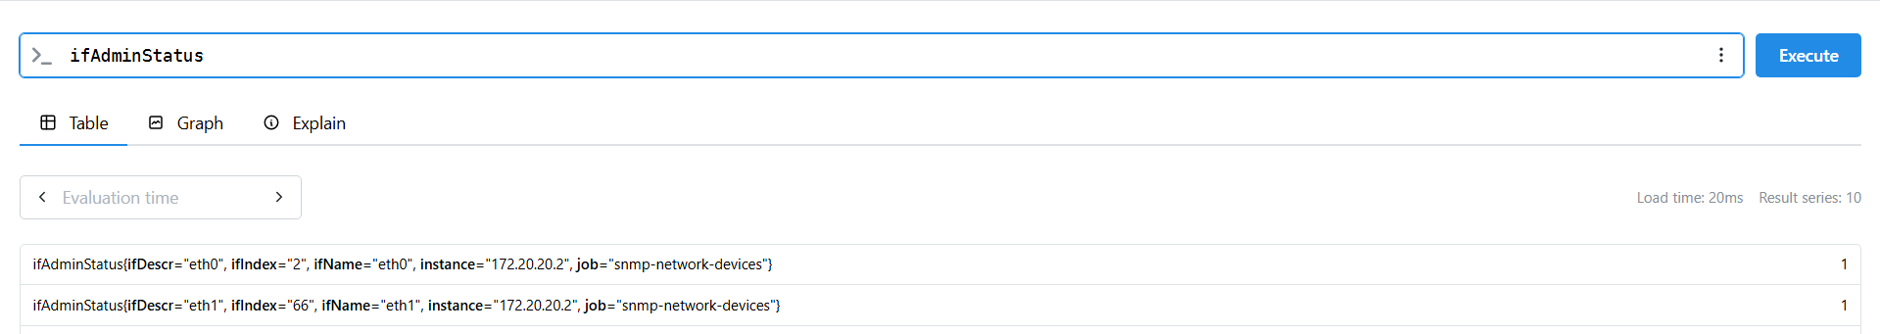
FUNZIONA!
Quindi è un problema di risoluzione dei nomi probably. Ora tocca vedere come dargli gli hostname in modo che il suo dns li risolva.
PROVA 2.1:
nslookup potrebbe dare degli hint. Così non lo trova:
clab@LAPTOP-BSFQRKKR:~/Documents/testfrrexpo$ docker exec clab-testfrrexpo-prometheus nslookup clab-testfrrexpo-router2
Server: 127.0.0.11
Address: 127.0.0.11:53

** server can't find clab-testfrrexpo-router2.sca.unipi.it: NXDOMAIN

** server can't find clab-testfrrexpo-router2.sca.unipi.it: NXDOMAIN

Ma così sì:
clab@LAPTOP-BSFQRKKR:~/Documents/testfrrexpo$ docker exec clab-testfrrexpo-prometheus nslookup clab-testfrrexpo-router2.clab
.clab
Server: 127.0.0.11
Address: 127.0.0.11:53

Non-authoritative answer:
Name: clab-testfrrexpo-router2.clab
Address: 172.20.20.2

Non-authoritative answer:
Name: clab-testfrrexpo-router2.clab
Address: 3fff:172:20:20::2

Provo a cambiare di nuovo lo YAML:
# metriche SNMP di router1 e router2
[...]
- targets:
- clab-testfrrexpo-router1.clab
- clab-testfrrexpo-router2.clab

FUNZIONA (non era vero) :(
BUT il log mi dà sempre questo:
time=2026-09-08T15:58:08.026Z level=DEBUG source=scrape.go:1427 msg="Scrape failed" component="scrape manager" scrape_pool=snmp-network-devices target="http://clab-testfrrexpo-snmp-exporter:9116/snmp?auth=public_v2&module=if_mib&target=clab-testfrrexpo-router1.clab" err="server returned HTTP status 500 Internal Server Error"

Eeee non funziona più (img sotto):
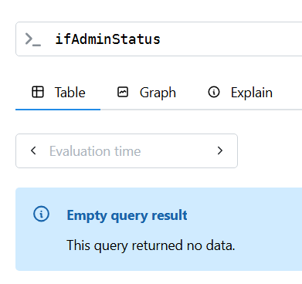
rimettendo gli IP funziona. Poi rimetto gli hostname e funziona ancora, ma mi dà sempre l’errore (per un po’ poi non mi funziona di nuovo. forse ha i target in una cache o qualcosa)
PROVA 2.2
vediamo se mettendo dei nomi a caso nei target ottengo sempre lo stesso errore. tipo:
# metriche SNMP di router1 e router2
[...]
- targets:
- pippo
- pluto

time=2026-09-08T16:25:23.259Z level=DEBUG source=scrape.go:1427 msg="Scrape failed" component="scrape manager" scrape_pool=snmp-network-devices target="http://clab-testfrrexpo-snmp-exporter:9116/snmp?auth=public_v2&module=if_mib&target=pluto" err="server returned HTTP status 500 Internal Server Error"

Yess, sempre lo stesso, quindi forse è un problema di risoluzione dei nomi al livello dell’exporter SNMP?
PROVA 2.3
da dentro il container prometheus, provo a vedere cosa succede se provo a raggiungere il link (tipo con wget)
Questo mi dà effettivamente le metriche PER L’EXPORTER: /prometheus $ wget -O - http://clab-testfrrexpo-snmp-exporter:9116/metrics
Però questo mi dà errore:
/prometheus $ wget -O - http://clab-testfrrexpo-snmp-exporter:9116/snmp?auth=public_v2&module=if_mib&target=clab-testfr
rexpo-router1
/prometheus $ Connecting to clab-testfrrexpo-snmp-exporter:9116 (172.20.20.4:9116)
wget: server returned error: HTTP/1.1 400 Bad Request

Dovevo mettere gli apostrofi. Con gli apostrofi mi ritorna sempre gli stessi errori (se uso l’hostname) e le metriche se uso gli IP.

STA A VEDERE CHE L’EXPORTER MI RISOLVE L’HOSTNAME CON IPv6
Infatti se sul browser cerco
http://172.18.234.221:9116/snmp?target=3fff%3A172%3A20%3A20%3A%3A5&auth=public_v2&module=if_mib
oppure:
http://172.18.234.221:9116/snmp?target=3fff:172:20:20::5&auth=public_v2&module=if_mib

mi dà: An error has occurred while serving metrics:
error collecting metric Desc{fqName: "snmp_error", help: "Error scraping target", constLabels: {module="if_mib"}, variableLabels: {}}: error walking target 3fff:172:20:20::5: error reading from socket: read udp [3fff:172:20:20::4]:60867->[3fff:172:20:20::5]:161: recvfrom: connection refused
Da dove viene questa ipotesi?
clab@LAPTOP-BSFQRKKR:~/Documents/testfrrexpo$ docker exec -it clab-testfrrexpo-snmp-exporter nslookup clab-testfrrexpo-router1.clab
Server: 127.0.0.11
Address: 127.0.0.11:53

Non-authoritative answer:
Name: clab-testfrrexpo-router1.clab
Address: 3fff:172:20:20::5

Non-authoritative answer:
Name: clab-testfrrexpo-router1.clab
Address: 172.20.20.5

L’IPv6 è quello che viene mostrato prima!
Prova: sostituisco nel file di prometheus
- 10.0.0.10 # clab-testfrrexpo-router1
- 10.0.0.11 # clab-testfrrexpo-router2

Però non sembra che si possa forzare l’exporter SNMP a risolvere con IPv4. La cosa non sarà un problema nella rete definitiva, perché userò degli IP statici delle interfacce. Ogni container avrà un indirizzo statico (how am i doing this on “server” containers? exec isn’t gonna work if i restart. i’ll need some way to hard code the ip into the containers interfaces(???) maybe useful read: https://docs.docker.com/engine/network/drivers/none/).
Comunque, per ora, per poter intanto lavorare con le metriche, darò ai container dei router degli IP di management statici e userò quelli nelle config di prometheus.
router1 -> mgmt-ipv4: 172.20.20.101
router2 -> mgmt-ipv4: 172.20.20.102

e in prometheus:
- targets:
- 172.20.20.101 # clab-testfrrexpo-router1
- 172.20.20.102 # clab-testfrrexpo-router2
FUNZIONA!
Ora però vorrei che nella label instance comparisse il nome dei container:
non è che posso settare il file host dell’snmp exporter per sovrascrivere?

WAIT A SECOND!
clab@LAPTOP-BSFQRKKR:~/Documents/testfrrexpo$ docker exec clab-testfrrexpo-snmp-exporter cat /etc/hosts
127.0.0.1 localhost
::1 localhost ip6-localhost ip6-loopback
fe00:: ip6-localnet
ff00:: ip6-mcastprefix
ff02::1 ip6-allnodes
ff02::2 ip6-allrouters
172.20.20.101 router1
172.20.20.102 router2
172.20.20.5 snmp-exporter
3fff:172:20:20::7 snmp-exporter

Non è che semplicemente voleva “router1” senza il clab ecc.?
Proviamo a togliere gli indirizzi di mgmt fissi e a cambiare i target su prometheus. No ok se tolgo gli ip statici di mgmt scompaiono anche dal file hosts del container snmp-exporter.

Avvio FRR Exporter automatico
Come fare?
# file start_frr_snmp.sh

#!/bin/sh
set -eu
rm -rf /var/agentx
mkdir -p /var/agentx
chown root:frr /var/agentx
chmod 755 /var/agentx

snmpd -f -Lo -C -c /etc/frr/snmpd.conf &

/bin/frr_exporter \
--no-collector.bgp \
--collector.route \
--collector.route.detailed-routes \
--web.listen-address=:9342 \
--log.level=debug \
> /var/log/frr_exporter.log 2>&1 &

exec /usr/lib/frr/docker-start

Questo non funziona: probabilmente l’avvio fallisce perché frr non è stato ancora avviato, e quindi i socket (da cui l’exporter legge – ma scrive anche mi sa?) non esistono ancora.
TENTATIVO 1:
Renderlo processo gestito da systemd. Come? Boh, intanto leggo questo: https://www.digitalocean.com/community/tutorials/understanding-systemd-units-and-unit-files.
systemctl, journalctl, e systemd-analyze non sono presenti nel container. MA è presente sysctl, che a quanto capisco serve anch’esso ad inizializzare servizi al boot. FORSE riesco a fare qualcosa con quello.
A quanto pare sysctl è una roba diversa che non serve a fare quello che dico io, ma c’entra con le impostazioni del kernel, quindi nada
TENTATIVO 2:
Chiedere a chat.
Mi fa modificare start-frr-snmp.sh:
#!/bin/sh
set -eu

rm -rf /var/agentx
mkdir -p /var/agentx
chown root:frr /var/agentx
chmod 755 /var/agentx

snmpd -f -Lo -C -c /etc/frr/snmpd.conf &

/usr/lib/frr/docker-start &
FRR_PID=$!

echo "Waiting for zserv.api..."

while [ ! -S /var/run/frr/zserv.api ]; do
sleep 1
done

echo "Starting frr_exporter..."

/bin/frr_exporter \
--no-collector.bgp \
--collector.route \
--collector.route.detailed-routes \
--web.listen-address=:9342 \
--log.level=debug \
> /var/log/frr_exporter.log 2>&1 &

wait "$FRR_PID"

Funziona. Grazie chat.
Ora però devo capire cosa fanno le varie parti perché se poi non lo so spiegare è brutto.

Prometheus
Questo è spiegato bene ed è breve:
https://www.youtube.com/watch?v=_F1ulJWsipc
Pure l’overview ufficiale, ma è breve: https://prometheus.io/docs/introduction/overview/

Architettura
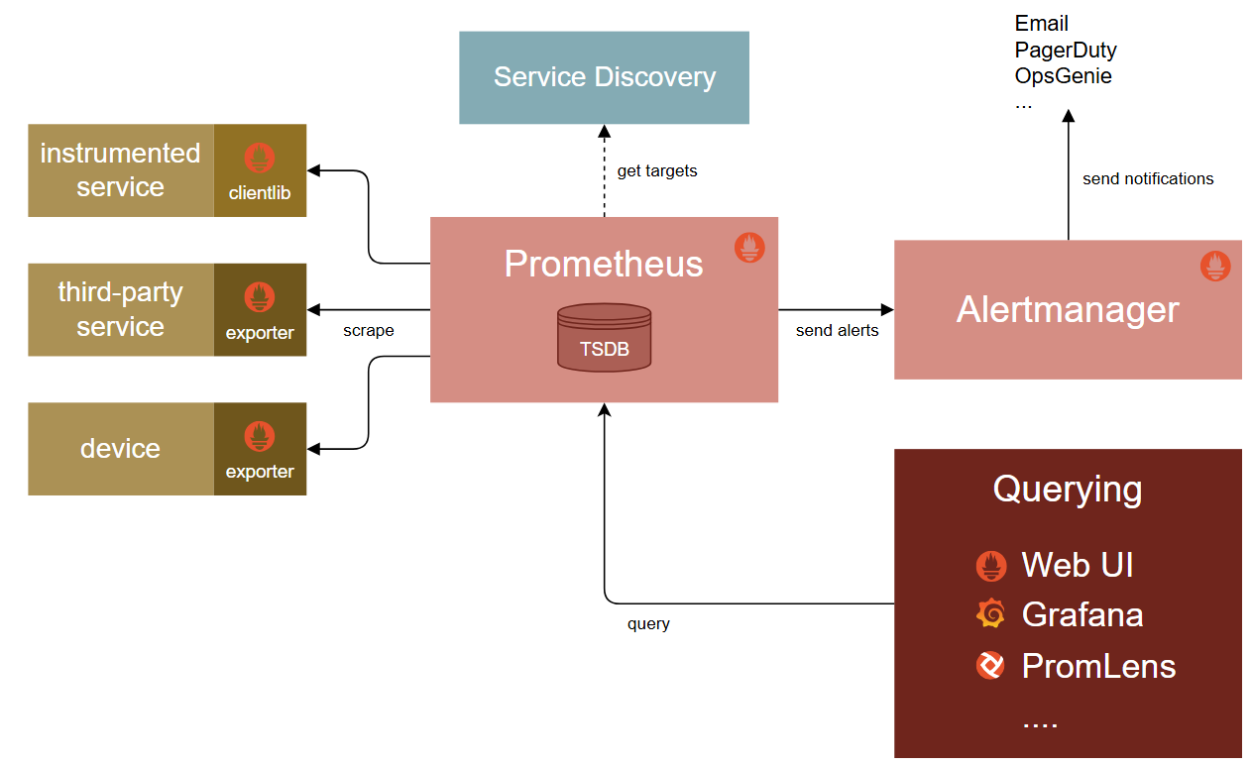
TSDB
A time series database (TSDB) is a software system optimized for handling time series data—a sequence of data points indexed in chronological order.^{[1]}In various scientific and financial disciplines, these chronological sequences may be referred to as profiles, curves, traces, or trends.^{[2]} Early iterations of these databases were primarily associated with industrial applications, where they functioned as data historians to efficiently record measurements from physical sensors; however, modern implementations now span a much wider range of uses. Due to the high ingestion rates and sequential nature of this data, TSDB repositories heavily utilize specialized compression algorithms to manage storage efficiently.^{[3]} While time-series data can be stored across various database types, systems designed around a temporal primary index differ structurally from relational databases, which optimize for discrete relationships using referential models.
https://en.wikipedia.org/wiki/Time_series_database

Metriche
Metrica = “nome della metrica”
Serie temporale = “nome della metrica” + “insieme completo di etichette”
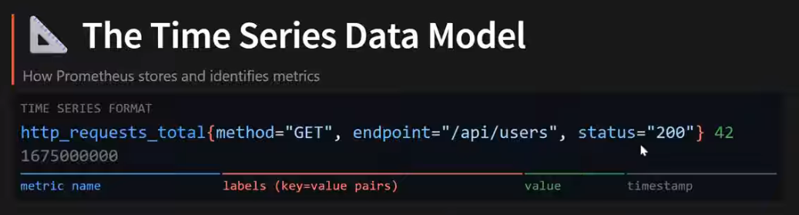
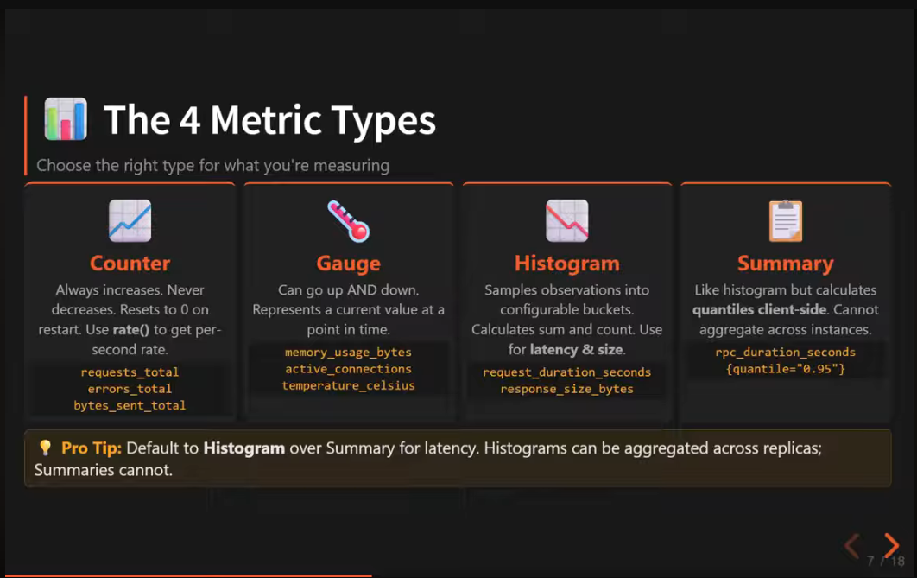

Tipi di metrica
3 tipi principali: Counter, Gauge and Histogram.
Counter
Usato per misurazioni accumulative (possono solo crescere). Es: numero di richieste HTTP. Come regola generale, se la metrica finisce con _total, si tratta di un counter.
Es:
# HELP prometheus_http_requests_total Counter of HTTP requests.
# TYPE prometheus_http_requests_total counter
prometheus_http_requests_total{code="200",handler="/metrics"} 3

Gauge
Usato per misurare valori che possono sia crescere che diminuire. Es: utilizzo di CPU, RAM (in generale di risorse), ...
Es:
# HELP process_resident_memory_bytes Resident memory size in bytes.
# TYPE process_resident_memory_bytes gauge
process_resident_memory_bytes 9.6268288e+07

Histogram
Qui actually si capisce molto bene: https://prometheus.io/docs/concepts/metric_types/#histogram
Ideale ad esempio per misurare statistiche come tempo impiegato per servire richieste HTTP: non analizza la singola istanza, ma considera dei “bucket”. Es:
- Numero di richieste servite in meno di 5 ms
- Numero di richieste servite in meno di 10 ms
- Numero di richieste servite in meno di 15 ms
- Numero di richieste servite in meno di 20 ms
- Tutte le altre (+Inf)
Gli intervalli di tempo considerati sono “equidistanti”. Nel bucket N rientrano anche i casi del bucket N-1, se analizzo la relazione “meno di” (una richiesta servita in <5ms è anche servita in <20ms).
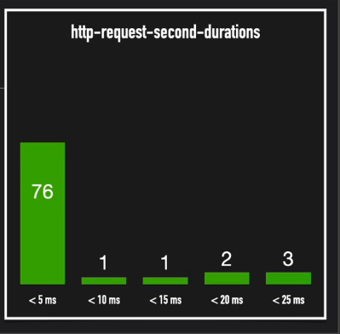
^ Qui in realtà mi sta prendendo gli intervalli: la colonna “< 10 ms” indica il num di richieste servite in un tempo compreso tra 5 ms e 10 ms (the bins are cumulative).
Es:
# HELP prometheus_http_response_size_bytes Histogram of response size for HTTP requests.
# TYPE prometheus_http_response_size_bytes histogram
prometheus_http_response_size_bytes_bucket{handler="/metrics",le="100"} 0
prometheus_http_response_size_bytes_bucket{handler="/metrics",le="1000"} 0
prometheus_http_response_size_bytes_bucket{handler="/metrics",le="10000"} 0
prometheus_http_response_size_bytes_bucket{handler="/metrics",le="100000"} 185
prometheus_http_response_size_bytes_bucket{handler="/metrics",le="1e+06"} 185
prometheus_http_response_size_bytes_bucket{handler="/metrics",cle="1e+07"} 185
prometheus_http_response_size_bytes_bucket{handler="/metrics",le="1e+08"} 185
prometheus_http_response_size_bytes_bucket{handler="/metrics",le="1e+09"} 185
prometheus_http_response_size_bytes_bucket{handler="/metrics",le="+Inf"} 185
prometheus_http_response_size_bytes_sum{handler="/metrics"} 2.403263e+06
prometheus_http_response_size_bytes_count{handler="/metrics"} 185

# le = less or equal

Qui l’esempio non è molto significativo perché apparentemente le risposte HTTP hanno tutte dimensione compresa tra 100’000 e 10’000 byte.
Quel _count alla fine penso che sia il totale delle richieste, il _sum invece no idea (forse la somma di tutti i valori?).

Percentili e quantili (TODO)

PromQL
Query Language
To make the collected data useful, Prometheus implements its own query language called PromQL. PromQL allows you to perform flexible and efficient computations on time series data to tell you what is going on in your systems. In contrast to SQL-like languages, PromQL is only used for reading data, not for inserting, updating, or deleting data (this happens outside of the query engine).
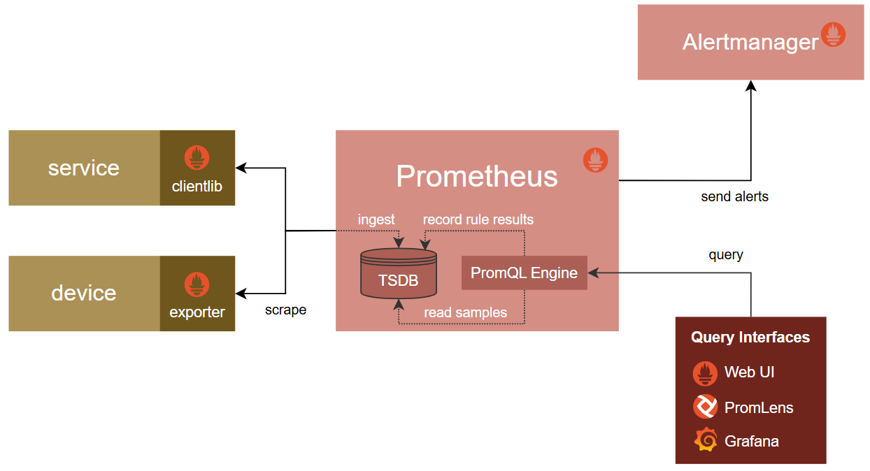
https://training.promlabs.com/training/introduction-to-prometheus/prometheus-an-overview/query-language/
...
The following query would select the total count of all handled HTTP requests that resulted in a 500 status code:
http_requests_total{status="500"}
Since the absolute value of a cumulative counter value is rarely useful, the following query tells you the per-second rate of increase for each selected counter series, as averaged over a window of 5 minutes:
rate(http_requests_total{status="500"}[5m])

Label selection
A.K.A. filtraggio dell’output, sulla base delle etichette. Posso:
- Selezionare un’etichetta specifica che le time series devono avere.
Es: http_request_total{ path = “/” }
- O che non devono avere: http_request_total{ path != “/” }
Oppure usare le RegEx per selezionare:
- Tutte le serie con una label che fa match con il pattern indicato.
Es: http_request_total{ path =~ “/items.*” }
Con: (.) = un qualsiasi carattere; (*) = ripetuto 0 o più volte.
- Tutte le time series che non hanno una label che fa match col pattern.
Es: http_request_total{ path !~ “/items.*” }

Dalla docu:
Label matchers that match empty label values also select all time series that do not have the specific label set at all. It is possible to have multiple matchers for the same label name.
The query http_requests_total{environment=""} would match and return:
http_requests_total
http_requests_total{replica="rep-a"}
http_requests_total{replica="rep-b"}

and would exclude:
http_requests_total{environment="development"}

Multiple matchers can be used for the same label name; they all must pass for a result to be returned.
The query:
http_requests_total{replica!="rep-a",replica=~"rep.*"}

Would then match:
http_requests_total{replica="rep-b"}

Vector selectors must either specify a name or at least one label matcher that does not match the empty string. The following expression is illegal:
{job=~".*"} # Bad!
In contrast, these expressions are valid as they both have a selector that does not match empty label values.
{job=~".+"} # Good!
{job=~".*",method="get"} # Good!

Label matchers can also be applied to metric names by matching against the internal __name__ label. For example, the expression http_requests_total is equivalent to {__name__="http_requests_total"}. Matchers other than = (!=, =~, !~) may also be used. The following expression selects all metrics that have a name starting with ‘job:’:
{__name__=~"job:.*"}

Query evaluation
AKA “output” di una query. Tipi (that we know of): Instant Vector, Range Vector, Scalar.
Instant vector
Se faccio una query vanilla su una metrica, con o senza filtri, il risultato che ottengo è un instant vector.
“Vector”: stessa metrica per diverse combinazioni di label;
“Instant”: prende solo il valore del timestamp più recente.
Esempio:
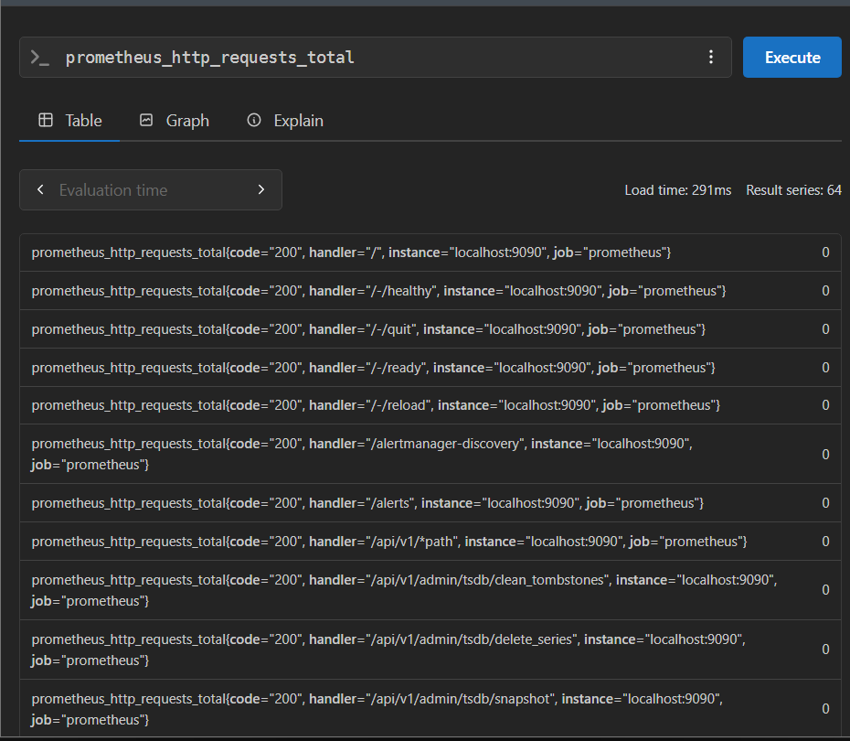

Range vector
Se specifico un intervallo di tempo tra parentesi quadre (es: 5 minuti: [5m]), per ogni combinazione di label, mi vengono restituite tutte le coppie valore-timestamp raccolte negli ultimi 5 minuti.
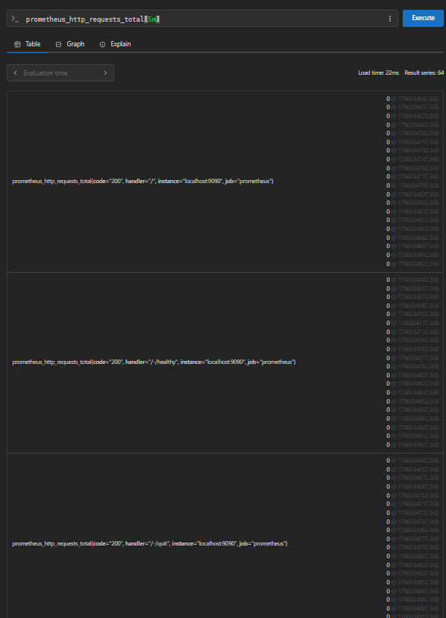

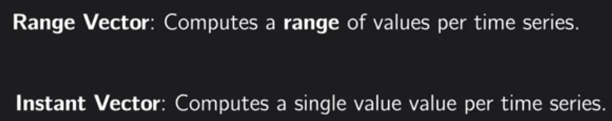
IMPORTANTE: le funzioni di PromQL spesso sono specifiche per uno dei tipi di vettore -> CONTROLLARE SEMPRE LA DOCUMENTAZIONE!
Es: la funzione rate() vuole in input un range vector.
Scalare
Risultato di una query di aggregazione (vedi dopo).

Aggregation operators
Prometheus supports the following built-in aggregation operators that can be used to aggregate the elements of a single instant vector, resulting in a new vector of fewer elements with aggregated values:
- sum(v) (calculate sum over dimensions)
- avg(v) (calculate the arithmetic average over dimensions)
- min(v) (select minimum over dimensions)
- max(v) (select maximum over dimensions)
- bottomk(k, v) (smallest k elements by sample value)
- topk(k, v) (largest k elements by sample value)
- limitk(k, v) (sample k elements, experimental, must be enabled with --enable-feature=promql-experimental-functions)
- limit_ratio(r, v) (sample a pseudo-random ratio r of elements, experimental, must be enabled with --enable-feature=promql-experimental-functions)
- group(v) (all values in the resulting vector are 1)
- count(v) (count number of elements in the vector)
- count_values(l, v) (count number of elements with the same value)
- stddev(v) (calculate population standard deviation over dimensions)
- stdvar(v) (calculate population variance over dimensions)
- quantile(φ, v) (calculate φ-quantile (0 ≤ φ ≤ 1) over dimensions)
These operators can either be used to aggregate over all label dimensions or preserve distinct dimensions by including a without or by clause. These clauses may be used before or after the expression.

<aggr-op> [without|by (<label list>)] ([parameter,] <vector expression>)
or

<aggr-op>([parameter,] <vector expression>) [without|by (<label list>)]
label list is a list of unquoted labels that may include a trailing comma, i.e. both (label1, label2) and (label1, label2,) are valid syntax.
without removes the listed labels from the result vector, while all other labels are preserved in the output. by does the opposite and drops labels that are not listed in the by clause, even if their label values are identical between all elements of the vector.

group by()
In Prometheus, group by is an operator that tells the system which labels to preserve when aggregating metrics. It doesn’t perform aggregation itself—it just defines how data should be grouped.
https://last9.io/blog/prometheus-group-by-label/
Dalla documentazione Prometheus riguardo group (senza by):
group(v) returns 1 for each group that contains any value at that timestamp.
The value may be a float or histogram sample.

Funzioni PromQL

Rate
rate (v _range_vector)
Per ogni serie temporale, calcola il numero medio di <misura> / secondo nel time range specificato.
Da usare SOLO per range vector di metriche di tipo COUNTER.

Service Discovery
Prometheus supports multiple built-in service discovery mechanisms, for example for:
- Discovering VMs on cloud providers (AWS, Azure, Google, ...),
- Discovering service instances on cluster orchestrators (Kubernetes, Marathon, …),
- Discovering targets using generic lookup methods such as DNS, Consul, Zookeeper, or custom discovery mechanisms.
Prometheus uses service discovery for three distinct, yet related purposes:
- To build a view of what targets should exist (so that it can record and alert if one is missing),
- To gain technical information of how to pull metrics from a target via HTTP,
- To enrich the series collected from a target with labeled metadata about the target.
In this way, Prometheus uses service discovery as a source of truth to reliably monitor dynamic environments while minimizing administrative overhead.

Installation
Probabilmente per eseguirlo in un container dovrò fare così (jk c’è già l’immagine: prom/prometheus):
https://prometheus.io/docs/prometheus/latest/installation/#using-docker

Rules and Configs Syntax Check
Rules:
https://prometheus.io/docs/prometheus/latest/configuration/recording_rules/#syntax-checking-rules
Configs:
promtool check config prometheus/prometheus.yml

Per altre funzionalità:
promtool help

Configurazioni
Prometheus can reload its configuration at runtime. If the new configuration is not well-formed, the changes will not be applied. A configuration reload is triggered by sending a SIGHUP to the Prometheus process or sending a HTTP POST request to the /-/reload endpoint (when the --web.enable-lifecycle flag is enabled). This will also reload any configured rule files.
To specify which configuration file to load, use the --config.file flag.

Tabelle
Opzioni query (img sotto):
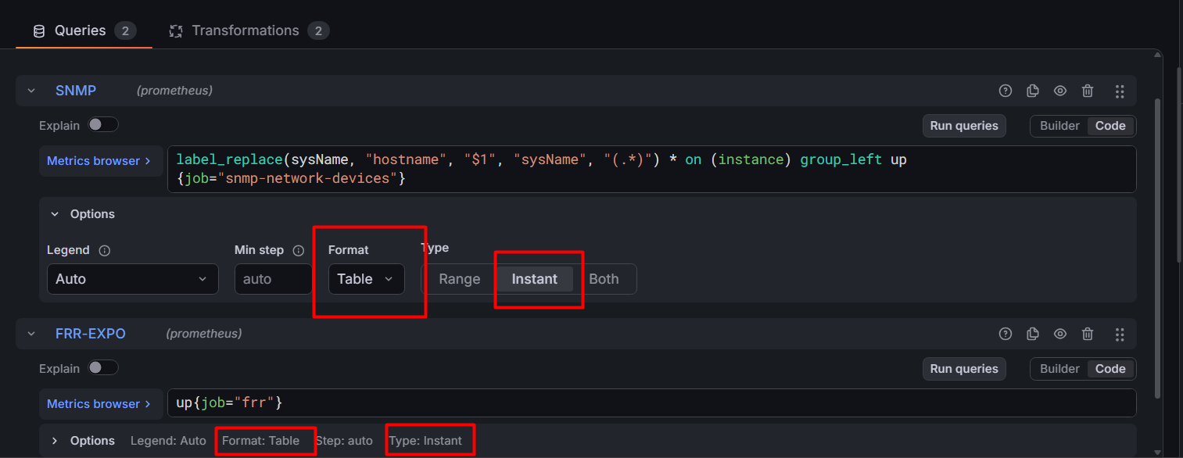
Trasformazioni (img sotto):
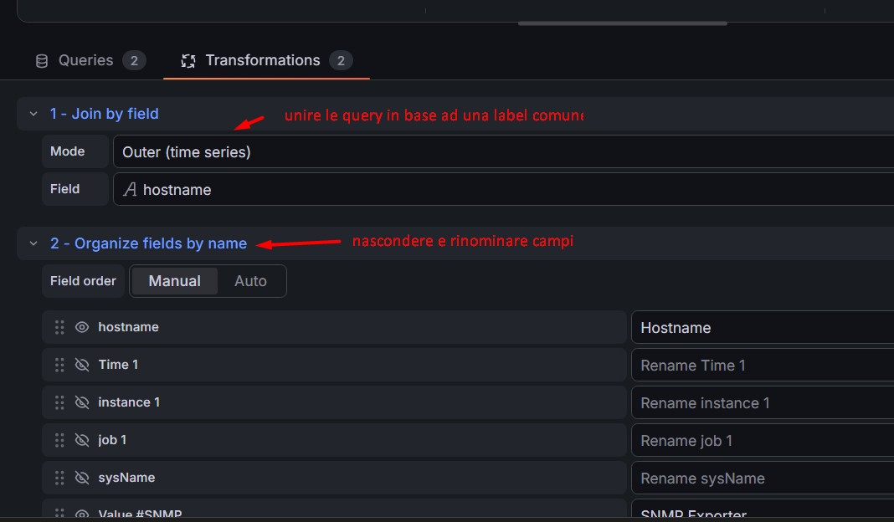

Vector Matching
Per fare join su label values, anche con nomi diversi.
Risorse:
- https://grafana.com/blog/promql-vector-matching-what-it-is-and-how-it-affects-your-prometheus-queries/
- https://saikiranpikili.medium.com/vector-matching-in-promql-a3fc07266b87
- https://oneuptime.com/blog/post/2025-12-17-prometheus-join-two-metrics/view

one-to-many: one_vector <op> on(<common_labels>) group_right many_vector
many-to-one: many_vector <op> on(<common_labels>) group_left one_vector
Con:
<op> = operatore binario
one_vector = vettore con cardinalità minore
many_vector = vettore con cardinalità maggiore
DA RICORDARE:
- vengono mantenute solo le label del many-side
- se voglio mantenere delle label dal on-side, devo specificarle nel group_left(label_da_tenere) -> tiene label da vettore di sx (stessa cosa con group_right, con vettore di dx)
Es: se volessi unire le info per router1 derivanti da:
- ospfIfAdminStat{instance="172.20.20.101", job="snmp-network-devices", ospfAddressLessIf="0", ospfIfIpAddress="10.1.0.10"} # 1 = enabled; 2 = disabled
- frr_ospf_neighbor_state{instance="clab-testfrrexpo-router1:9342"}
- ospfLsdbRouterId{instance="172.20.20.101"}
- sysName{instance="172.20.20.101", job="snmp-network-devices", sysName="router1"}
?
Con queste potrei mettere insieme (penso) nome Interfaccia (ethX), area, IP interfaccia, router ID.
IMPORTANTE: per avere hostname come label è necessario il label_replace:
label_replace(sysName, "hostname", "$1", "sysName", "(.*)")

OSPF interface admin status
sysName * on(instance) group_right(sysName) ospfIfAdminStat
#produce:
{instance="172.20.20.102", job="snmp-network-devices", ospfAddressLessIf="0", ospfIfIpAddress="10.1.0.11", sysName="router2"} 1

# 1 = enabled; 2 = disabled.

Riesco ad aggiungerci il nome dell’interfaccia? proviamo col modulo ip_mib

Indirizzo IP – nome interfaccia
Intanto, per avere solo indirizzi IPv4 con lunghezza network mask:
ipAddressPrefixOnLinkFlag{ipAddressPrefixPrefix !~ ".*[:].*"}
#produce:

Associazione AREA - nome interfaccia – ip interfaccia - stato adiacenza
frr_ospf_neighbor_state * on(instance, iface) group_left(area) frr_ospf_neighbors
# produce:
{area="0.0.0.0", group="testing", hostname="router2", iface="eth0", instance="clab-testfrrexpo-router2:9342", job="frr", local_address="10.0.0.11", neighbor="1.1.1.1", vrf="default"} 7

NON VA BENE!
frr_ospf_neighbors conta il numero di vicini visti dall’interfaccia, quindi potrebbe essere > 1!
QUELLA GIUSTA:
frr_ospf_neighbor_state * on(instance, iface) group_left(area) ( frr_ospf_neighbors * 0 + 1 )
# produce:
{area="0.0.0.0", group="testing", hostname="router2", iface="eth0", instance="clab-testfrrexpo-router2:9342", job="frr", local_address="10.0.0.11", neighbor="1.1.1.1", vrf="default"} 7

hostname – router ID OSPF
label_replace(sysName, "hostname", "$1", "sysName", "(.*)") * on (instance) group_right(hostname) ospfRouterId
# produce:
{hostname="router2", instance="172.20.20.102", job="snmp-network-devices", ospfRouterId="2.2.2.2"}

PROVE VECTOR MATCHING
Es: voglio sapere se lo scrape di snmp exporter è operativo in base all’host. Info necessarie: instance (per il join 1-to-1), hostname. Fatte le seguenti prove:
CORRETTA:
label_replace(sysName, "hostname", "$1", "sysName", "(.*)") * on (instance) group_left up{job="snmp-network-devices"}

# results in:

{hostname="router2", instance="172.20.20.102", job="snmp-network-devices", sysName="router2"} 1
{hostname="router1", instance="172.20.20.101", job="snmp-network-devices", sysName="router1"} 1

IMPORTANTE: serve un operatore binario (in questo caso *) prima dell’ on()!
----------------------------
FOR SOME FUCKING REASON quello sopra sì e quello sotto no :/ (img sotto)
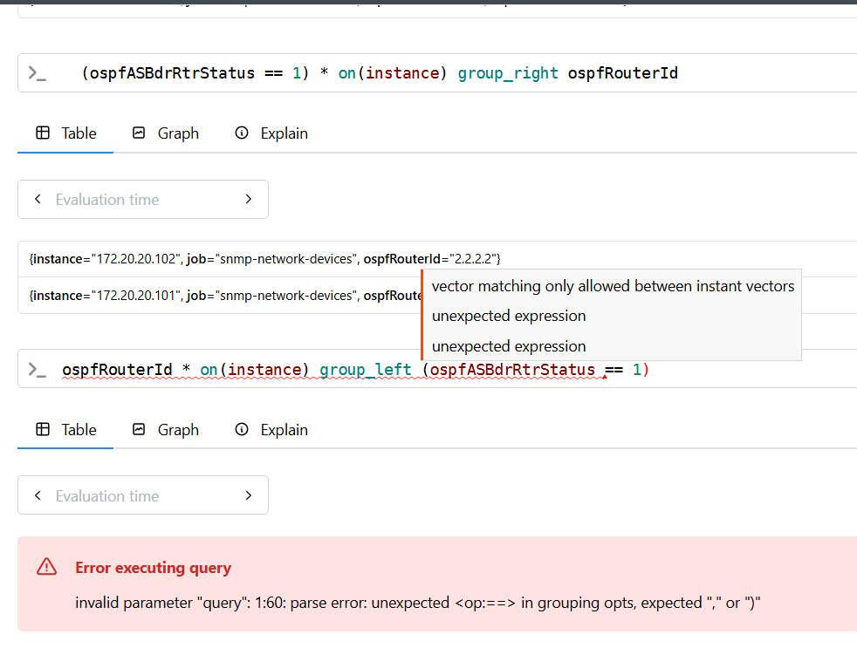
Ok no that’s the fucking reason:
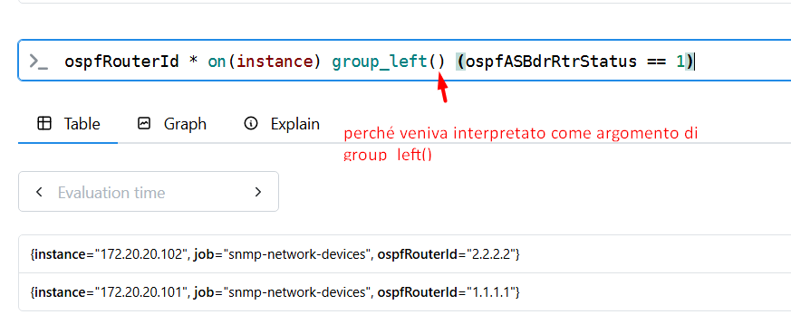

Query utili x panel

Settare il valore di una metrica a 1
metrica * 0 + 1
Esempio:
ifIndex * 0 + 1
#produce:
{ifDescr="eth0", ifIndex="2", ifName="eth0", instance="172.20.20.102", job="snmp-network-devices"} 1

Problema: override del nome.

Indirizzo IP rete con lunghezza subnet mask
Per avere solo IPv4:
ipAddressPrefixOnLinkFlag{ipAddressPrefixPrefix !~ ".*[:].*"}
#produce:
ipAddressPrefixOnLinkFlag{instance="172.20.20.101", ipAddressPrefixIfIndex="2", ipAddressPrefixLength="24", ipAddressPrefixPrefix="172.20.20.0", job="snmp-network-devices"}

Varie utili

Histogram Buckets
Histogram buckets (also called bins) are adjacent, non-overlapping intervals that divide a range of numerical data. Each bucket counts how many data points or observations fall within its specific range, allowing a chart or monitoring system to display data distribution rather than raw values. [1, 2, 3]
How Histogram Buckets Work
- Interval Boundaries: Each bucket covers a defined numerical scope, such as values from 0 to 10, 10 to 20, and so on.
- Frequency Count: As data arrives, the system increments the counter for the bucket that matches the value.
- Visual Representation: In a drawn histogram, each bucket becomes a vertical bar where the height represents the count of items inside that interval

https://last9.io/blog/histogram-buckets-in-prometheus/

External Systems
Chiesto a chat:
D: nelle configurazioni prometheus, il tag "external_labels" indica, da documentazione: " # The labels to add to any time series or alerts when communicating with # external systems (federation, remote storage, Alertmanager)." Ma in che senso "external systems"? Quand'è che un sistema è esterno?
R:
È una domanda molto importante, perché la frase della documentazione è un po' ambigua se si sta iniziando con Prometheus.
La chiave è capire che Prometheus distingue tra ciò che raccoglie (scraping) e ciò che invia ad altri sistemi.
Il flusso normale
Nel caso più semplice hai:
Node Exporter ---> Prometheus
FRR Exporter ---> Prometheus
cAdvisor ---> Prometheus
In questo scenario Prometheus è il punto finale: riceve le metriche e basta.
Le external_labels non vengono aggiunte alle metriche che Prometheus salva localmente. Vengono usate solo quando Prometheus comunica con qualcos'altro.

Cosa sono gli "external systems"
Sono sistemi esterni all'istanza di Prometheus, cioè componenti separati con cui Prometheus scambia dati.
I casi principali sono quelli citati nella documentazione.
1. Alertmanager
Supponiamo di avere:
Node Exporter
|
v
Prometheus ---------> Alertmanager
Prometheus valuta una regola:
- alert: HighCPU
Quando l'allarme scatta, invia ad Alertmanager informazioni come:
alertname="HighCPU"
instance="router1"
job="frr"
Se hai configurato:
external_labels:
monitor: lab-prometheus
site: pisa
Alertmanager riceverà anche:
monitor="lab-prometheus"
site="pisa"
Così sa da quale Prometheus proviene quell'allarme.
(continua...)
https://chatgpt.com/s/p_6a74279a18008191ab314678c07b63cf

Relabel configs
https://prometheus.io/docs/prometheus/latest/configuration/configuration/#relabel_config

Mostrare 0 in query vuote
https://nklya.medium.com/promql-how-to-return-0-instead-of-no-data-9e49f7ccb80d
TL;DR: aggiungere OR on() vector(0)

Altro
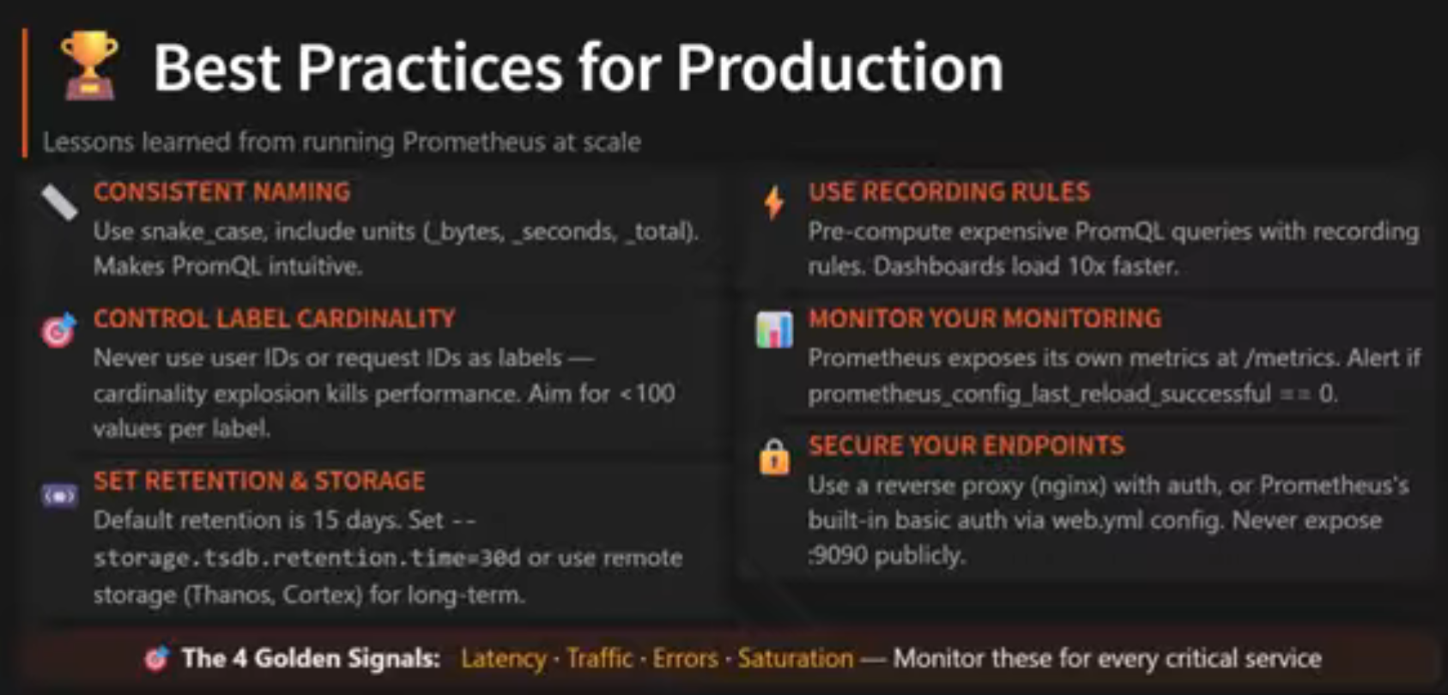

Grafana

Automatic password reset
Security Note: Change the default Grafana admin password immediately after installation. Use sudo grafana-cli admin reset-admin-password newpassword or configure authentication through the web interface. https://binadit.com/tutorials/monitor-ospf-network-topology-with-prometheus-and-grafana-dashboards

Trasformazioni nelle label
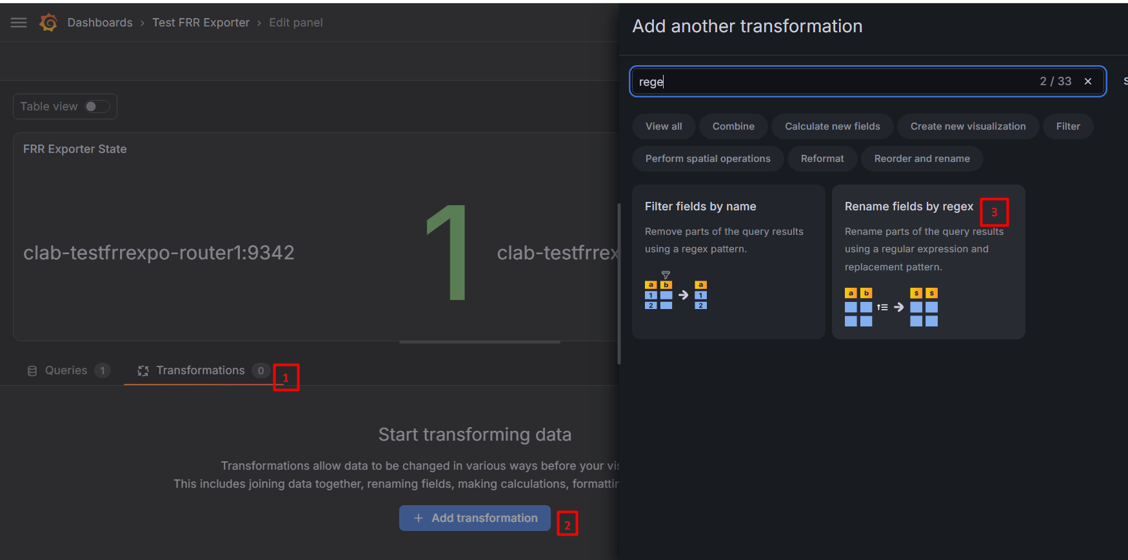
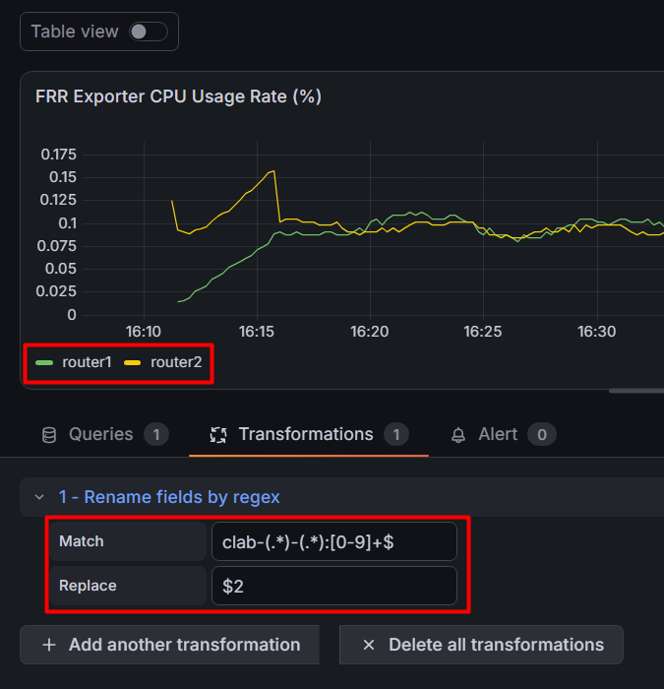
es: clab-testfrrexpo-router1:9342 -> router1
regex: clab-(.*)-(.*):[0-9]+$

Mappare valori
Es: 0 -> DOWN, 1 -> UP
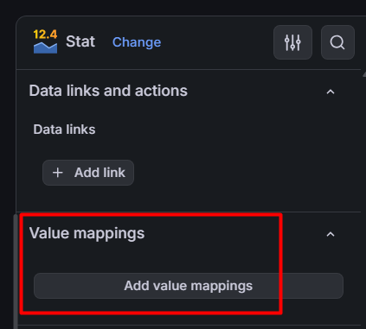

Divisione Panel in sezioni (gruppi)
https://grafana.com/whats-new/2026-07-08-organize-dashboards-faster-with-multi-select-grouping/
IL METODO DEL LINK SOPRA NON FUNZIONA!
METODO FUNZIONANTE:
Per creare gruppi:
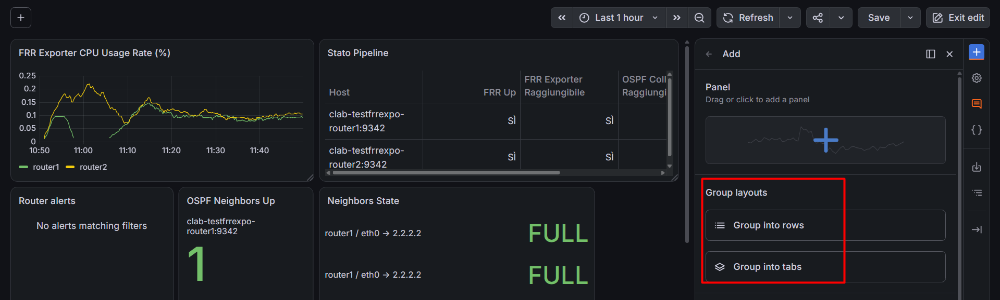
Problema: mi raggruppa tutto.
Per dividere in gruppi diversi: creare nuova row e spostarci i panel

Variabili

Aggiungere variabile di tipo query
Edit mode.
In alto a sinistra sulla dashboard:
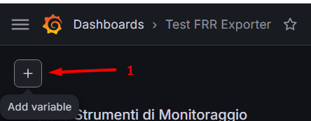
Nel menù a destra:
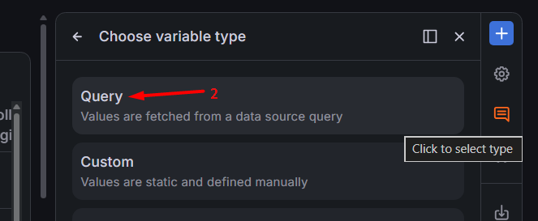
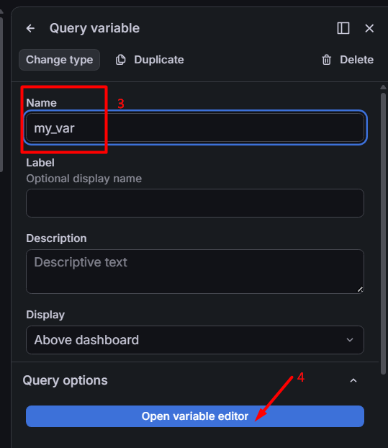
(3): scegliere un nome per la variabile. È quello che verrà usato per far riferimento ai valori della variabile nelle query, nei panel ed eventualmente nei nomi delle sezioni.
Nell’esempio: voglio che my_var contenga i valori della label instance:
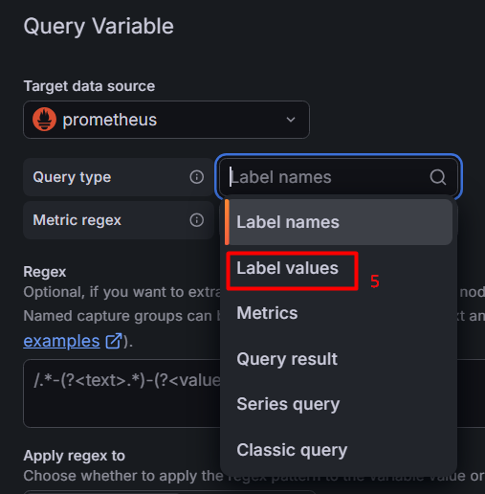
Posso scegliere se restringere la query ad una singola metrica: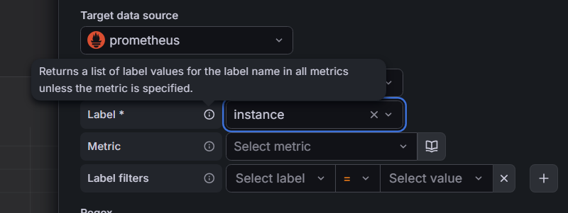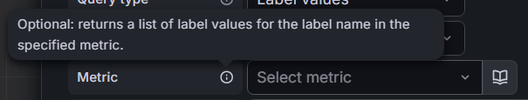
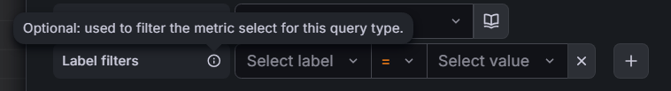
Infine Preview e Close. La variabile con i suoi valori apparirà in alto a destra:
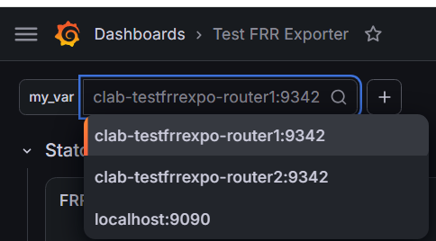

Le variabili hanno lo scope in cui vengono definite (globale, row, tab...). Se do ad una variabile un nome già usato per un’altra, l’ultima creata sovrascrive la precedente. (probabilmente me lo sono inventato, perché ci ho provato e mi ha sminchiato un panel:
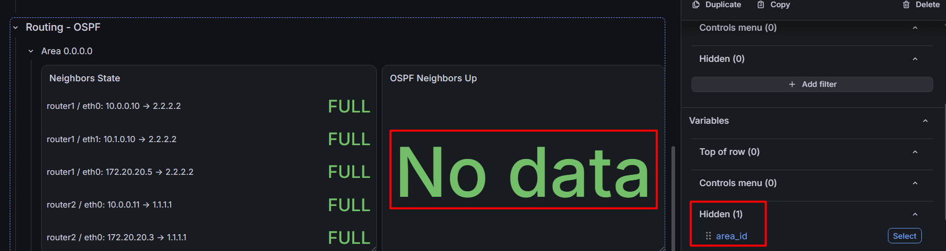

Nascondere variabili nella visualizzazione utente
Se non voglio che in modalità normale (non edit) le variabili non siano visibili agli utenti (img sotto):
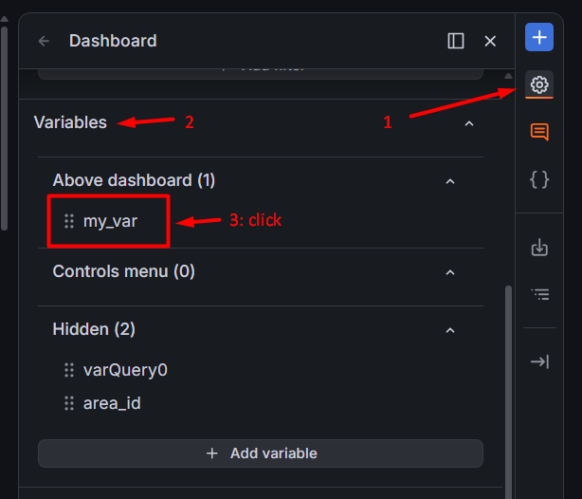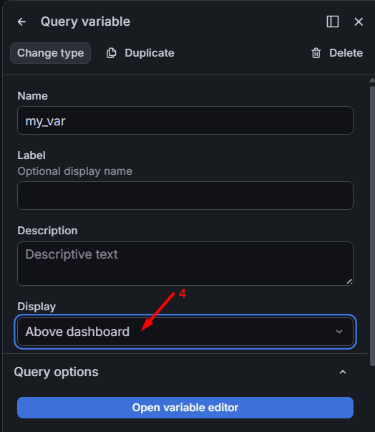
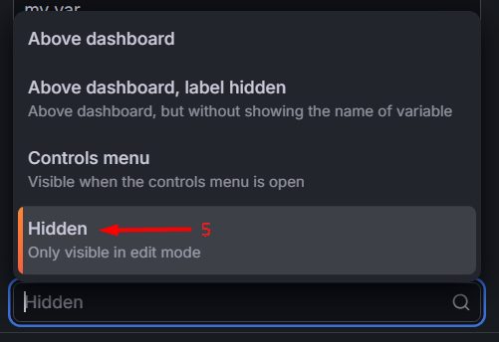

Ripetere pannelli e righe per ogni valore di una variabile
Nelle opzioni della variabile (passi 1 – 3 della sezione precedente):
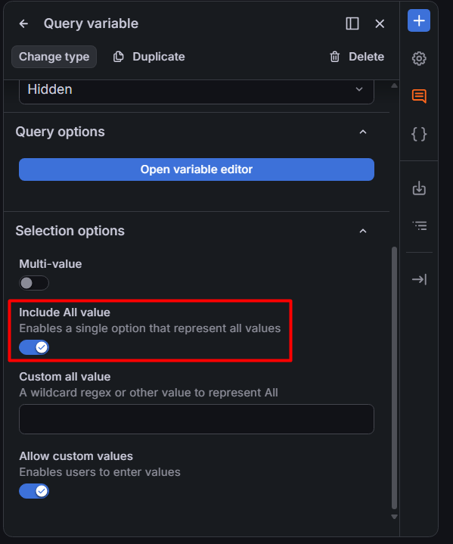
Poi, nella row (similmente nei panel):
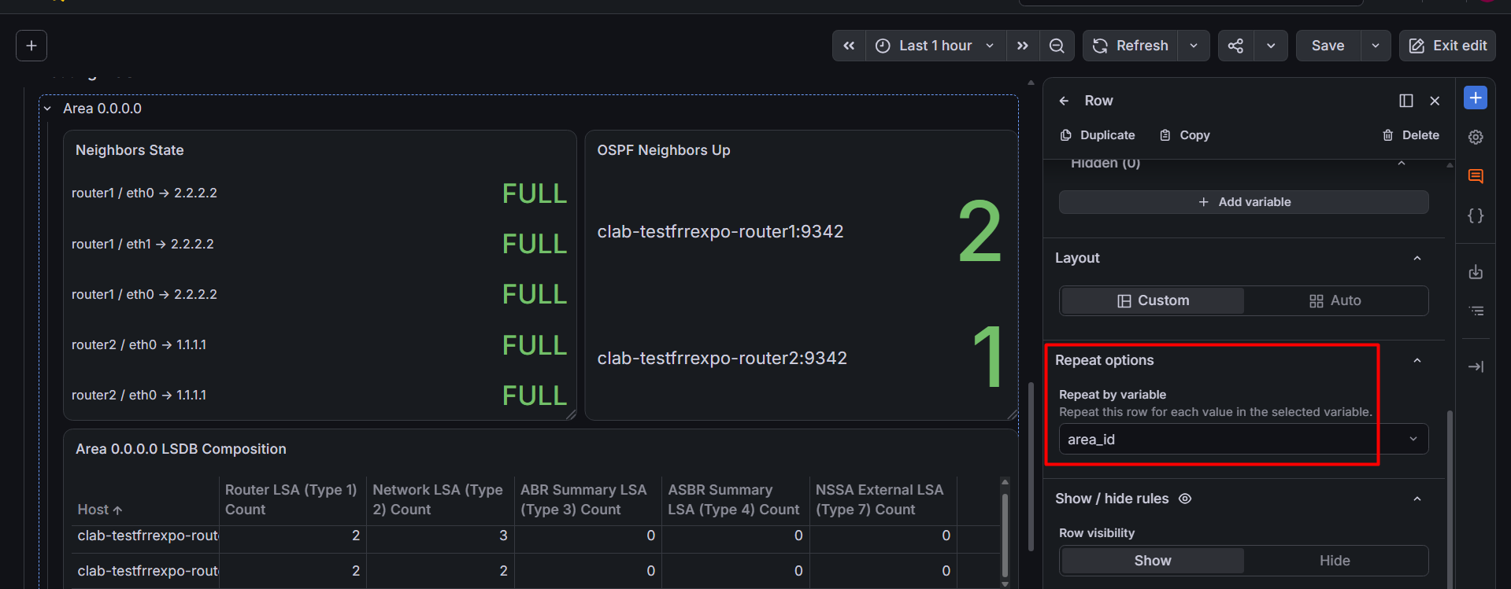

Usare variabili nelle query
https://grafana.com/docs/learning-paths/interactive-dashboards/use-variables-queries/

Integrazione con Prometheus
https://grafana.com/docs/grafana/latest/datasources/prometheus/template-variables/

Documentazione utile
Template Query, aka queries che includono variabili template.
https://grafana.com/docs/grafana/latest/visualizations/dashboards/variables/#templates
Query variables: https://grafana.com/docs/grafana/latest/visualizations/dashboards/variables/add-template-variables/#add-a-query-variable
Query variables enable you to write a data source query that can return a list of metric names, tag values, or keys. For example, a query variable might return a list of server names, sensor IDs, or data centers. The variable values change as they dynamically fetch options with a data source query.
Query variables are generally only supported for strings. If your query returns numbers or any other data type, you might need to convert them to strings to use them as variables. For the Azure data source, for example, you can use the tostring function for this purpose.
Query expressions can contain references to other variables and in effect create linked variables. Grafana detects this and automatically refreshes a variable when one of its linked variables change.
Variabili template in Prometheus: https://grafana.com/docs/grafana/latest/datasources/prometheus/template-variables/.
Custom variables: https://grafana.com/docs/grafana/latest/visualizations/dashboards/variables/add-template-variables/#add-a-custom-variable.
potrebbe essere una buona idea cambiare la variabile Area OSPF in una variabile custom, visto che le aree sono poche e il loro numero è pressochè costante. Questo ridurrebbe il numero di query che grafana deve fare.
Utile: If you need more room in a single input field query editor, then hover your cursor over the lines in the lower right corner of the field and drag downward to expand.
Consider the following: visto che diverse metriche sono ottenibili sia da frr expo che da snmp expo, potrebe essere utile mettere una variabile che faccia da “toggle” per il data source. Da studiare però, anche perché alcune query useranno metriche da entrambe le source. Priorità bassa.
-----------
Opzione no value: https://grafana.com/docs/grafana/latest/visualizations/dashboards/variables/add-template-variables/#variable-best-practices.
Variable drop-down lists are displayed in the order in which they’re listed in the Variables section of the sidebar, so put the variables that you change often at the top, so they’re shown first.
By default, variables don’t have a default value. This means that the topmost value in the drop-down list is always preselected. If you want to pre-populate a variable with an empty value, you can use the following workaround in the variable settings:
Select the Include All Option checkbox.
In the Custom all value field, enter a value like .+.
--------------
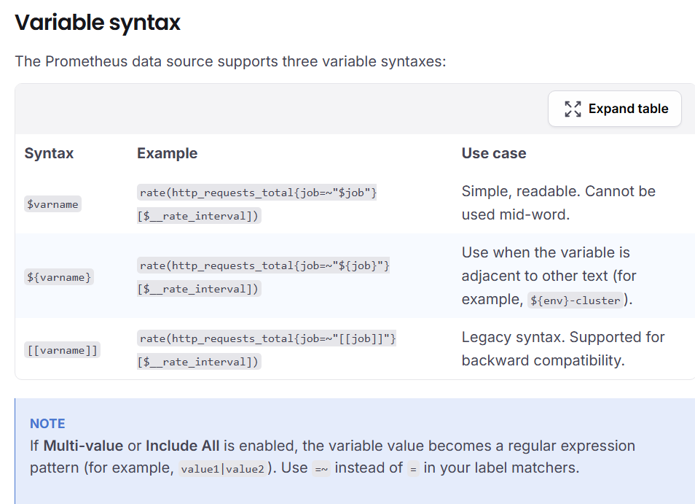
---------
Filter variables: https://grafana.com/docs/grafana/latest/datasources/prometheus/template-variables/#filters-variable
After you add the variable, a filter bar appears at the top of the dashboard. Viewers can add filters by selecting a label, operator (=, !=, =~, !~), and value. Grafana automatically applies these filters to all Prometheus queries on the dashboard.
Example: A viewer adds the filter namespace = production. All queries on the dashboard now include {namespace="production"} without any query modifications.
--------------
Advanced variables: https://grafana.com/docs/grafana/latest/visualizations/dashboards/variables/advanced-variables/
- Multi-property variables: Map one logical value to multiple source-specific values.
- Chained variables: Update the options in one variable based on the selections in another.
- Regular expression filtering: Filter the values returned by a variable query.

PROBLEMA QUERY CON VARIABILI
Vogliono il ~= (vedi img sotto)
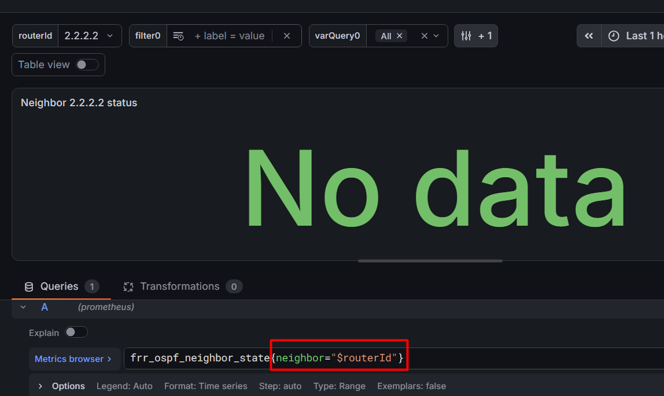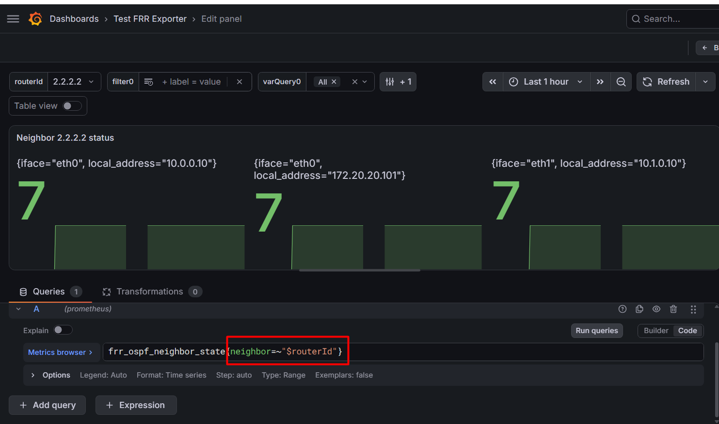
https://community.grafana.com/t/query-with-variable-does-not-return-data-when-multi-value-is-enabled/37879
https://community.grafana.com/t/dashboards-report-no-data-when-using-a-multi-value-variable-works-with-single-value/67912/3
In realtà viene detto anche nella documentazione: https://grafana.com/docs/grafana/latest/datasources/prometheus/template-variables/#selection-options
(just read mf)

Conditional show panel/rows
Possibile nascondere panel a seconda di valore di variabile o con condizionamente ad un query result:
https://oneuptime.com/blog/post/2025-12-17-hide-grafana-panels-template-variables/view
Method 2: Conditional Queries and Query-Result Rules (https://oneuptime.com/blog/post/2025-12-17-hide-grafana-panels-template-variables/view#method-2-conditional-queries-and-query-result-rules)
Make queries return no data, then use a Show / hide rule with "Query result: Has data" to hide panels when the query returns nothing:
Using Label Matching
# Only returns API data when the selected service list includes "api"
sum(rate(http_requests_total{service="api", service=~"${service:regex}"}[5m]))
Simplified Conditional

# For a production-only panel - returns nothing if another environment is selected
sum(rate(http_requests_total{environment="production", environment=~"${environment:regex}", service=~"${service:regex}"}[5m]))

Panel Configuration for No Data
Show / hide rules:
Panel visibility: Show
Query result: Has data
Without a Show / hide rule, a panel that shows "No Data" still takes space but clearly indicates irrelevance.

IMPORTANTE: nel modulo SNMP ospf non compaiono gli indirizzi di rete (né tantomeno le subnet mask - solo quelli delle interfacce) (in realtà sono nell’LSA ma divertiti a parsarlo con prometheus/grafana).
Rete e maschera compaiono nel modulo IP-MIB, c’è da vedere se si riesce a fare un join.
Non compaiono neanche i nomi delle interfacce (poco male, per quelle si può fare join per indirizzo).

cAdvisor

Metriche utili
https://www.dash0.com/guides/cadvisor-docker-monitoring#prerequisites#exploring-some-common-cadvisor-metrics

SNMP Exporter
Istruzioni seguite per il config: principalmente queste:
https://oneuptime.com/blog/post/2026-02-08-how-to-run-prometheus-snmp-exporter-in-docker/view
https://binadit.com/tutorials/monitor-ospf-network-topology-with-prometheus-and-grafana-dashboards
Però ora vorrei capire come funziona SNMP exporter, time to read the docs: https://hub.docker.com/r/prom/snmp-exporter. Potrebbe valere la pena di accennare qualcosa dalla documentazione, ma non mi soffermerei troppo sugli exporter.

Blackbox exporter
Ho fatto il deploy come container docker, seguendo le istruzioni in:
- https://www.geeksforgeeks.org/devops/prometheus-blackbox-exporter/
- https://hub.docker.com/r/prom/blackbox-exporter/
Github:
- https://github.com/prometheus/blackbox_exporter
Formato delle configurazioni:
- https://github.com/prometheus/blackbox_exporter/blob/master/CONFIGURATION.md#http_client_config

File configurazioni (al 3/9 10:15):
modules:
http_2xx:
prober: http
timeout: 5s
http:
valid_http_versions: ["HTTP/1.1", "HTTP/2"]
valid_status_codes: [] # Defaults to 2xx
method: GET
preferred_ip_protocol: ip4 # ip6 di default,
# ma il lab non è configurato per IPv6
# quindi senza la probe fallirebbe
no_follow_redirects: false

Nota: bbexpo usa /bin/sh come shell. Per accedervi: docker exec -it clab-testfrrexpo-blackbox /bin/sh

MORE EXPORTERS
Mi servono più statistiche di rete. Qui raccatto un po’ di roba:

Node Exporter:
Node exporter, collector aggiuntivi:
https://github.com/prometheus/node_exporter#collectors
Da Include & Exclude flags:
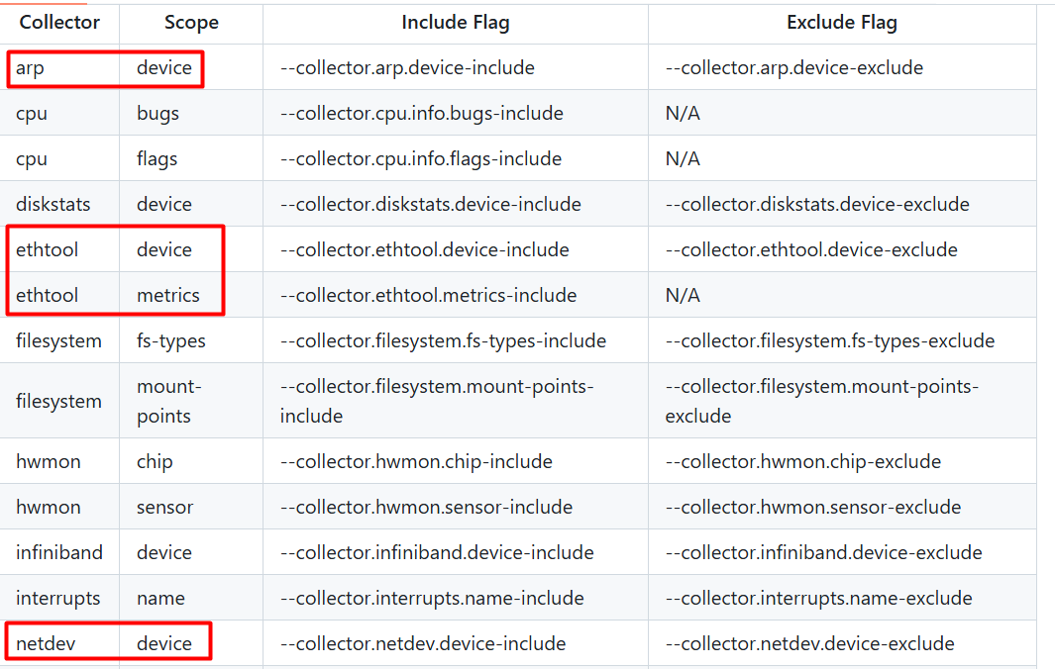

Da Enabled by default:
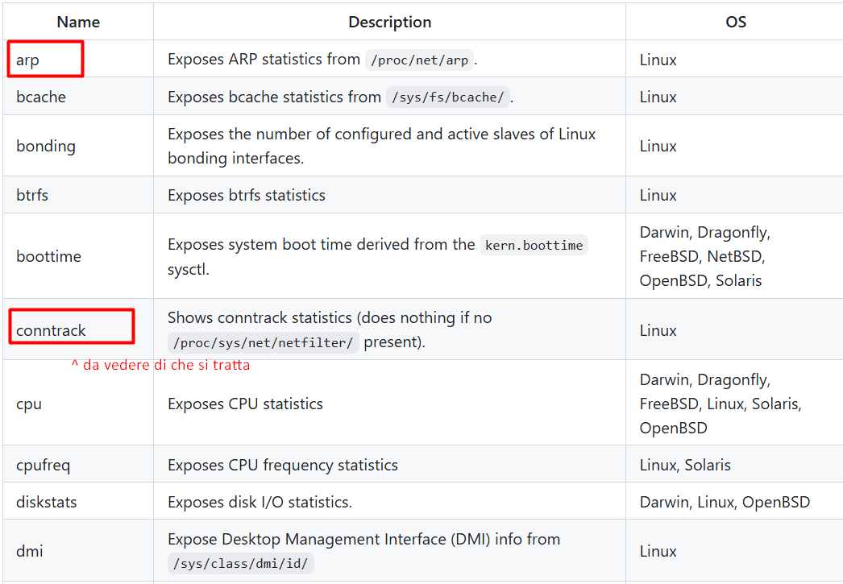
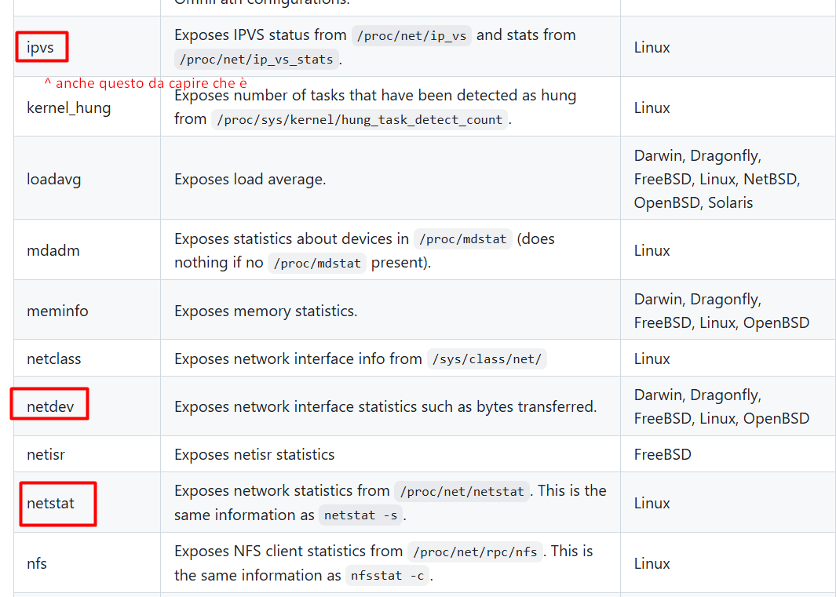
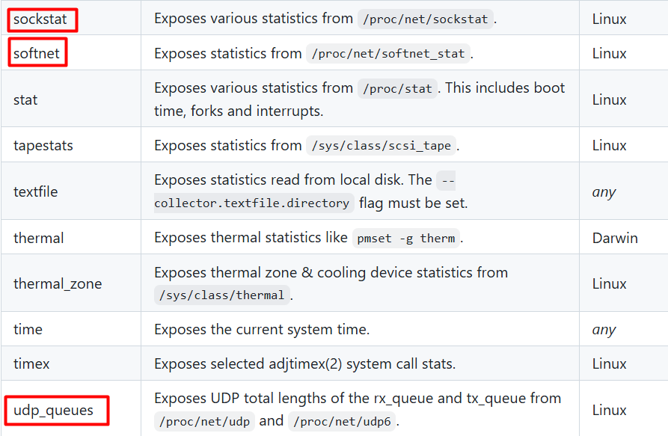

Da Disabled by default:
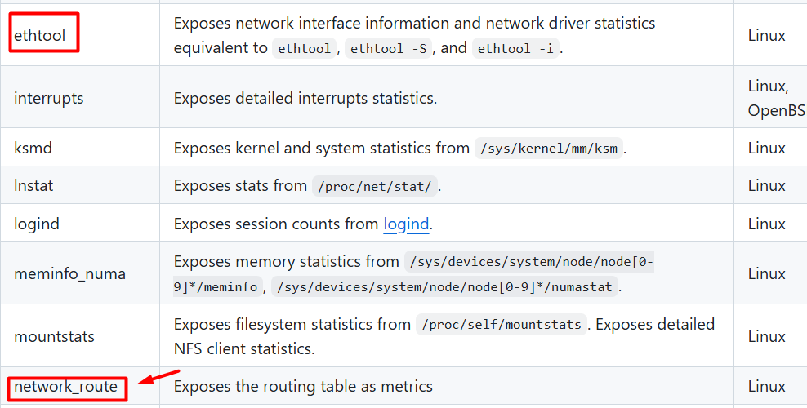
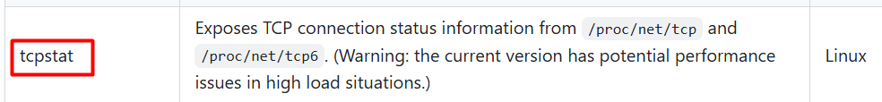

Per decidere quali usare tramite configurazione prometheus:
https://github.com/prometheus/node_exporter#filtering-enabled-collectors
Collect only cpu and meminfo collector metrics:
params:
collect[]:
- cpu
- meminfo
Collect all enabled collector metrics but exclude netdev:
params:
exclude[]:
- netdev

Setup node exporter come systemctl daemon
https://secnate.medium.com/week-11-observability-with-prometheus-and-grafana-0aca9eeeb654
per la creazione di un nuovo utente cerca:
OK so this is just a starting point.
per la creazione del system service cerca:
Next up was to set up Node Exporter as a systemd service
Ci sono anche degli stress test:
sudo apt-get install -y stress-ng

SNMP exporter
Docker image: https://hub.docker.com/r/prom/snmp-exporter

https://binadit.com/tutorials/monitor-ospf-network-topology-with-prometheus-and-grafana-dashboards
Vedo già roba interessante:
ospfSpfRuns:
type: counter

Abilitare SNMP nei router FRR
- FRR non è provvisto nativamente di agente SNMP, ma è possibile scaricare un agente ed abilitarlo. Da https://docs.frrouting.org/en/latest/snmp.html:
“SNMP is a widely implemented feature for collecting network information from router and/or host. FRR itself does not support SNMP agent (server daemon) functionality but is able to connect to a SNMP agent using the the AgentX protocol (RFC 2741) and make the routing protocol MIBs available through it.
Note that SNMP Support needs to be enabled at compile-time and loaded as module on daemon startup. Refer to Loadable Module Support on the latter. If you do not start the daemons with snmp module support snmp will not work properly.
Getting and installing an SNMP agent
The supported SNMP agent is AgentX. We recommend to use the latest version of net-snmp which was formerly known as ucd-snmp. It is free and open software and available at http://www.net-snmp.org/ and as binary package for most Linux distributions.”

- Questo sarebbe un’altro modo: https://packages.debian.org/sid/frr-snmp?pow_referer=https%3A%2F%2Fwww.google.com%2F

Scaricato Net-SNMP. e decompresso nella cartella testfrrexpo/frr-exporter (WHY?). Per l’installazione: Tesi/SNMP-INTALL.txt. Spostato in ~/Documents/net-snmp<versione>

- qui parla di package frr-snmp (dovrei provare ad installarlo in una delle immagini): https://lists.frrouting.org/archives/list/dev@lists.frrouting.org/message/PMPS5NMWKTMC75SVRTT4Z4YHLDWREKWZ/

Nel topology file, fatto il bind con la repo net-snmp (per ora solo in router1):
- ~/Documents/net-snmp-5.9.5.2:/etc/net-snmp-5.9.5.2

Per compilare il package, entro nella shell di router1 e seguo queste istruzioni da SNMP-INSTALL.txt:

QUICK INSTRUCTIONS
==================

1) Run ./configure
(type "./configure --help" for a quick usage summary.)
(--prefix=PATH will change the default /usr/local installation path.)
(see "Compilers and Options" on changing the compiler to use)

2) Optionally edit include/net-snmp/net-snmp-config.h
(due to prompting done by the configure script, this is very rarely
necessary.)

3) make

4) Run the next command as root:
5) make install

6) configure the agent
(either using 'snmpconf' or by crafting an snmpd.conf file manually.
The file 'EXAMPLE.conf' may be a suitable starting point)

Note: By default, everything will be installed in /usr/local.

Fallito: non c’è un compilatore in router1:
/etc/net-snmp-5.9.5.2 # ./configure
checking for gcc... no
checking for cc... no
checking for cl.exe... no
checking for clang... no
configure: error: in '/etc/net-snmp-5.9.5.2':
configure: error: no acceptable C compiler found in $PATH
See 'config.log' for more details

Con l’aiuto di chat, si è deciso che compilarlo fuori e poi bindarlo dentro non è una buona idea, perché il container ha come OS Alpine. Quindi, quello che si fa ora è:
apk add net-snmp
(alpine non usa apt, ma apk)
RISOLTO: build di un’immagine custom

MIB per OSPF
Di default nel file snmp.yml non c’è il modulo per ospf, quindi c’è da generarlo (o copiarlo?).
Visto che volevo aggiungerci anche qualcosa sulle routing table, meglio farmi un file da capo. Serve il generator dell’snmp exporter: https://hub.docker.com/r/prom/snmp-generator.
Qui le istruzioni ufficiali: https://github.com/prometheus/snmp_exporter/blob/main/generator/README.md
Qui le istruzioni e il generator.yml per generare il file snmp.yml tramite container docker snmp-generator: https://github.com/prometheus/snmp_exporter/blob/main/generator/README.md.
Intanto però faccio un tentativo mettendoci il file snmp.yml per ospf trovato su https://binadit.com/tutorials/monitor-ospf-network-topology-with-prometheus-and-grafana-dashboards.
FALLITO: non gli è piaciuto (da docker logs):
time=2026-09-09T13:56:38.098Z level=ERROR source=main.go:226 msg="Error parsing config file" err="yaml: unmarshal errors:\n line 54: field lookups not found in type config.plain\n line 60: field overrides not found in type config.plain"
time=2026-09-09T13:56:38.098Z level=ERROR source=main.go:227 msg="Possible version mismatch between generator and snmp_exporter. Make sure generator and snmp_exporter are the same version."
time=2026-09-09T13:56:38.098Z level=ERROR source=main.go:228 msg="See also: https://github.com/prometheus/snmp_exporter/blob/main/auth-split-migration.md"

proviamo ad usare il container del generator.
Ok ancora non l’ho installato, ho perso tempo perché volevo vedere se quella informazione era estraibile da net-snmp da dentro il container. Proviamo a seguire questo:
https://www.monotux.tech/posts/2025/05/custom-snmp-exporter/#mibs
Ok qui ho trovato la MIB ospf: https://github.com/librenms/librenms/tree/master/mibs
A quanto scritto su observium (https://mibs.observium.org/mib/OSPF-MIB/), ha 4 dipendenze:
- IF-MIB
- SNMPv2-CONF
- SNMPv2-SMI
- SNMPv2-TC
scarichiamole tutte in Tesi/snmp-MIBS (ho aggiunto IP-FORWARD-MIB per avere la tabella di roting)
Ho controllato la versione dell’exporter:
clab@LAPTOP-BSFQRKKR:~/Documents/testfrrexpo$ docker exec clab-testfrrexpo-snmp-exporter /bin/snmp_exporter --version
snmp_exporter, version 0.30.1 (branch: HEAD, revision: 48b810afbd9222b74439ad1cf7d0d7b7c0cf4290)
build user: root@7b6e0f2b3e4e
build date: 20260106-14:50:13
go version: go1.25.5
platform: linux/amd64
tags: unknown

Qui alcune info utili: https://mibs.observium.org/help/snmp.
Qui è spiegata meglio la sintassi del file generator:
https://github.com/prometheus/snmp_exporter/tree/main/generator#file-format
Questo invece è il formato del file di configurazione dell’exporter, snmp.yml:
https://github.com/prometheus/snmp_exporter/blob/main/generator/FORMAT.md
Per ora si è arrivati qui: https://chatgpt.com/share/6aa1b909-49f0-83eb-9f9c-e41f9227d672
OK FUNZIONA
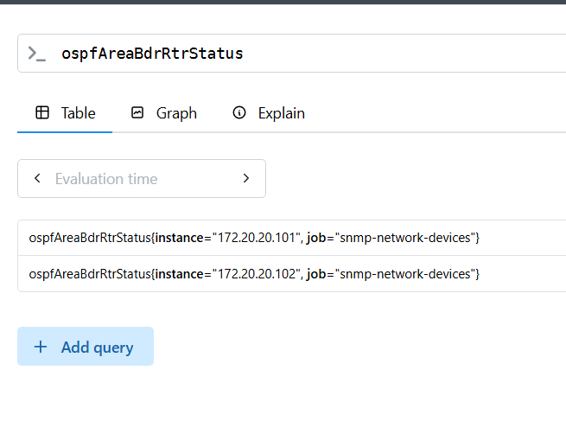
devo ancora un po’ lavorarci e segnare tutti i passaggi che ho fatto
(domani)

Altre metriche utili:
ospfNbrEvents: The number of times this neighbor relationship has changed state or an error has occurred. Discontinuities in the value of this counter can occur at re-initialization of the management system, and at other times as indicated by the value of ospfDiscontinuityTime.
IMPORTANTE: GENERAZIONE DI snmp.yml:
Il file generator.yml da usare si trova in ~/Documents/testfrrexpo/snmp-generator/snmp_exporter/generator, non direttamente in snmp-generator.
Per generare il file, eseguire /.run-generator.sh, che creerà snmp.yml nella stessa cartella. Poi copiarlo nella cartella dell’exporter.
IMPORTANTE NEGLI SCRAPE: valore dei flag: 1 = true, 2 = false ^{(WHY!?)}
VALORI DELLE METRICHE STATUS CHE NON SONO SCRITTI NELLE DESCRIZIONI:
- ospfIfAdminStat:
  - 1 enabled
  - 2 disabled
- ospfIfState
  - 1 down
  - 2 loopback
  - 3 waiting
  - 4 pointToPoint
  - 5 designatedRouter
  - 6 backupDesignatedRouter
  - 7 otherDesignatedRouter
- ospfIfType
  - 1 broadcast
  - 2 nbma
  - 3 pointToPoint
  - 5 pointToMultipoint
- ospfNbrState
  - 1 down
  - 2 attempt
  - 3 init
  - 4 twoWay
  - 5 exchangeStart
  - 6 exchange
  - 7 loading
  - 8 full
^ Queste possono essere utili per ricreare la topologia. Però c’è anche il caso in cui un router abbia 2 interfacce in 2 reti broadcast diverse. Lì devo trovare un fattore che mi identifichi la rete (e forse è già possibile con FRR exporter)
Altre utili:
ospfNbrRtrId A 32-bit integer (represented as a type IpAddress) uniquely identifying the neighboring router in the Autonomous System. - 1.3.6.1.2.1.14.10.1.3
# TYPE ospfNbrRtrId gauge
ospfNbrRtrId{ospfNbrAddressLessIndex="0",ospfNbrIpAddr="10.0.0.11",ospfNbrRtrId="2.2.2.2"} 1

dall’frr expo:
frr_ospf_neighbor_state{iface="eth0",local_address="10.0.0.10",neighbor="2.2.2.2",remote_address="",vrf="default"} 7

Da qui posso fare l’associazione indirizzo IP – nome interfaccia. A che mi serve? Ad associare il router id alle sue interfacce: l’FRR exporter non fa esplicitamente questa associazione.

Prove containerlab

FRR ring topology w/ OSPF
29/07 – ho provato questo laboratorio che usa l’immagine FRR che userò nel progetto di tesi.
https://brianlinkletter.com/2021/05/use-containerlab-to-emulate-open-source-routers/
(Ci sono arrivata partendo da qui: https://containerlab.dev/lab-examples/frr01/#description)

Note:
invece di image: praqma/network-multitool:latest ho scritto image: wbitt/network-multitool:latest (vedi https://hub.docker.com/r/praqma/network-multitool)
-------------------------------------
ho fatto il deploy senza fare prima $ sudo docker login e ha funzionato lo stesso
-------------------------------------
nel destroy:
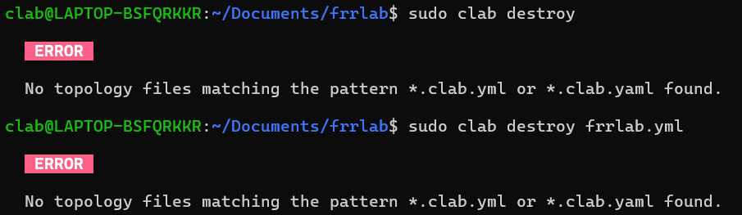
provo a rinominare il file: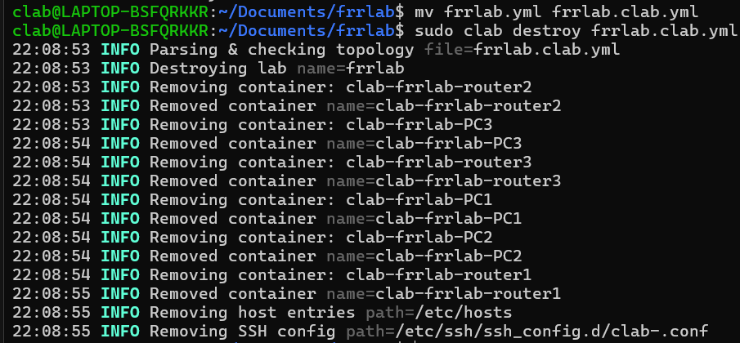
questo file non è menzionato nella guida:
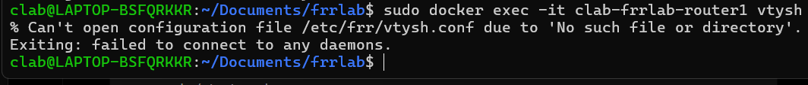
Proviamo così:
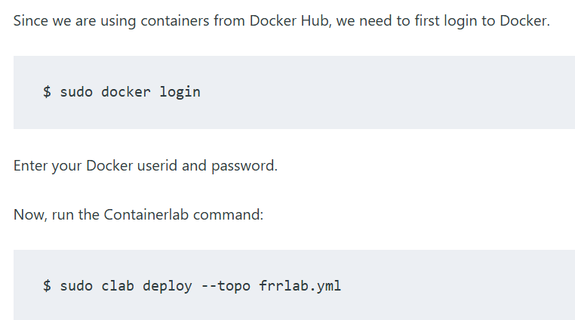
Dopo essermi connessa a router1:
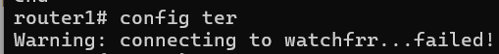
Provo a rifare l’installazione di containerlab con debian, come suggerito sulla guida all’istallazione di containerlab su windows. Perché? https://manpages.debian.org/unstable/frr/frr-watchfrr.8.en.html
possibile che sia una cosa specifica di debian.
In realtà no
POSSIBILE SPIEGAZIONE:
1. Il file daemons ha terminatori di riga Windows (CRLF)
Questa riga:
/etc/frr/daemons: line 18: $'\r': command not found
significa che il file contiene caratteri \r\n (formato Windows) invece di \n (formato Linux).
Probabilmente hai creato/modificato i file dalla parte Windows (ad esempio con Notepad), quindi sono rimasti con terminatori CRLF.
Dentro il container verifica:
cat -A /etc/frr/daemons | head
Vedrai qualcosa del genere:
zebra=yes^M
bgpd=no^M
ospfd=yes^M
Quel ^M è il carattere \r.
Correzione
Dal tuo WSL puoi convertire il file:
dos2unix router1/daemons
dos2unix router2/daemons
dos2unix router3/daemons
Se dos2unix non è installato:
sudo apt update
sudo apt install dos2unix

quindi ho installato dos2unix e applicato la conversione ai daemon, ora mi fa entrare nel vtysh, anche se mi dice sempre che il file vtysh.conf non esiste (che è vero).

---------------------------------
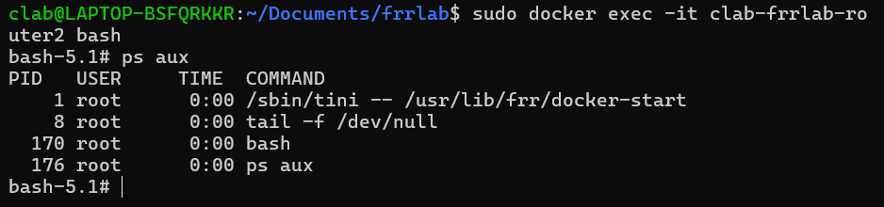
Questo comando mi entra nel bash del container!

----------------------
ok problema con vtysh che non parte risolto: il file daemon era formattato per windows, doveva essere convertito nel formato unix. Nel wsl di clab ho scaricato dos2unix che mi fa la conversione (utilizzo: $ dos2unix file). Ora partono tutti i daemon.
Poi ho voluto rendere permanenti le configurazioni, così nelle cartelle routerX ho creato un file frr.conf e cambiato la topologia:
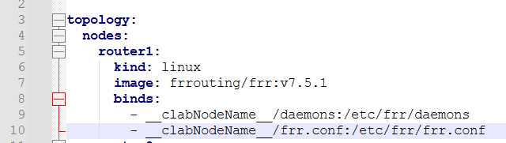
Problema: quando da dentro la vtysh del router salvo le configurazioni:
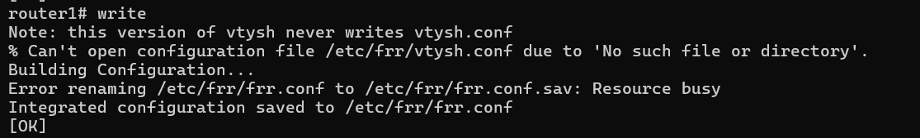
e questo risulta in un file routeer1/frr.conf così:
clab@LAPTOP-BSFQRKKR:~/Documents/frrlab$ sudo cat router1/frr.conf
frr version 7.5.1_git
frr defaults traditional
hostname router1
domainname localdomain
no ipv6 forwarding
!
interface eth1
ip address 192.168.1.1/24
!
interface eth2
ip address 192.168.2.1/24
!
interface eth3
ip address 192.168.11.1/24
!
interface lo
ip address 10.10.10.1/32
frr version 7.5.1_git
frr defaults traditional
hostname router1
domainname localdomain
no ipv6 forwarding
!
interface eth1
ip address 192.168.1.1/24
!
interface eth2
ip address 192.168.2.1/24
!
interface eth3
ip address 192.168.11.1/24
!
interface lo
ip address 10.10.10.1/32
!
router ospf
passive-interface eth3
passive-interface lo
network 192.168.1.0/24 area 0.0.0.0
network 192.168.2.0/24 area 0.0.0.0
network 192.168.11.0/24 area 0.0.0.0
!
line vty
!frr version 7.5.1_git
frr defaults traditional
hostname router1
domainname localdomain
no ipv6 forwarding
!
interface eth1
ip address 192.168.1.1/24
!
interface eth2
ip address 192.168.2.1/24
!
interface eth3
ip address 192.168.11.1/24
!
interface lo
ip address 10.10.10.1/32
!
router ospf
passive-interface eth3
passive-interface lo
network 192.168.1.0/24 area 0.0.0.0
network 192.168.2.0/24 area 0.0.0.0
network 192.168.11.0/24 area 0.0.0.0
!
line vty
!
router ospf
passive-interface eth3
passive-interface lo
network 192.168.1.0/24 area 0.0.0.0
network 192.168.2.0/24 area 0.0.0.0
network 192.168.11.0/24 area 0.0.0.0
!
line vty
!

Praticamente invece di modificare il file, mi fa un append.
Chat dice questo, a riguardo:
Hai trovato un effetto collaterale abbastanza tipico quando si usa un bind mount diretto di frr.conf.
L'indizio chiave è questo:

Error renaming /etc/frr/frr.conf to /etc/frr/frr.conf.sav: Resource busy

Quando fai write, FRR non scrive semplicemente sul file esistente. Normalmente fa qualcosa di simile a:
1. scrive un file temporaneo
2. rinomina frr.conf -> frr.conf.sav
3. rinomina il nuovo file -> frr.conf
È una tecnica standard per evitare di corrompere il file se il processo si interrompe a metà.
Ma nel tuo caso:
- router1/frr.conf:/etc/frr/frr.conf
/etc/frr/frr.conf è un bind mount Docker che punta direttamente a un file host.
I rename atomici che FRR vuole fare non funzionano correttamente su quel tipo di mount, quindi ottieni:
Resource busy
e FRR finisce per comportarsi in modo anomalo durante il salvataggio.
Prima cosa: il file è ormai corrotto
Quello che hai mostrato:
frr version ...
...
interface lo
ip address 10.10.10.1/32

frr version ...
...
router ospf
...
non è una configurazione valida. Ti conviene cancellarla e ricrearla. Per esempio:
cp router1/frr.conf router1/frr.conf.bak
poi ricrea router1/frr.conf con una sola copia della configurazione.

SOLUZIONE
Soluzione consigliata
Anziché montare il singolo file:
- router1/frr.conf:/etc/frr/frr.conf
monta tutta la directory:
- router1:/etc/frr
oppure:
- configs/router1:/etc/frr

In questo modo FRR può creare: frr.conf, frr.conf.sav, vtysh.conf, e fare rename liberamente.

Building a Scalable BGP Lab with Containerlab and FRRouting (per testing progetto)
https://francois.is/building-a-scalable-bgp-lab-with-containerlab-and-frrouting/
Qui c’è una documentazione, completa di script per creare il laboratorio, su come implementare un laboratorio che simula una piccola rete BGP di un ISP.
Idea: una volta che ho integrato i vari strumenti ed ho un progetto funzionante, potrei costruire questo lab per testare il mio sistema.

Homelab with Prometheus and Grafana
https://secnate.medium.com/week-11-observability-with-prometheus-and-grafana-0aca9eeeb654
Riguardo il target Windows: è l’host stesso!
“I used the special Docker hostname host.docker.internal because Prometheus ran inside a container and needed to reach out to the Windows host machine where this service was installed.”
Ora, questo laboratorio prevede l’uso di docker. Lo voglio adattare per funzionare in Containerlab.
Prendo spunto da questo progetto su github per configurare i container: https://github.com/openconfig/gnmic/blob/main/examples/deployments/1.single-instance/4.prometheus-output/containerlab/prometheus.clab.yaml
In particolare:
prometheus:
kind: linux
image: prom/prometheus:latest
user: 65534:65534
ports:
- 9090:9090
binds:
- ./prometheus/:/etc/prometheus/
cmd: |
--config.file=/etc/prometheus/prometheus.yaml
--web.console.libraries=/usr/share/prometheus/console_libraries
--web.console.templates=/usr/share/prometheus/consoles
--log.level=debug

grafana:
kind: linux
image: grafana/grafana:latest
binds:
- grafana/datasources/datasource.yaml:/etc/grafana/provisioning/datasources/datasource.yaml:ro
#- grafana/dashboards/:/var/lib/grafana/dashboards
ports:
- 3000:3000

Prevedo di sostituire la VM Ubuntu con un container.
Problema: come raggiungo i container? Devo dargli un IP?
Forse non serve, visto che sto facendo il binding del port? Apparentemente sì. Dalla documentazione di Clab:
“ports#
To bind the ports between the lab host and the containers the users can populate the ports object inside the node:
ports:
- 80:8080 # tcp port 80 of the host is mapped to port 8080 of the container
- 55555:43555/udp
- 55554:43554/tcp”

Per semplicità, non includerò l’host Windows nel lab (visto che uso WSL per runnare clab, dovrei cercarmi come si fa a far inviare pacchetti da Windows ad uno specifico container – quello con prometheus).

PROBLEMI
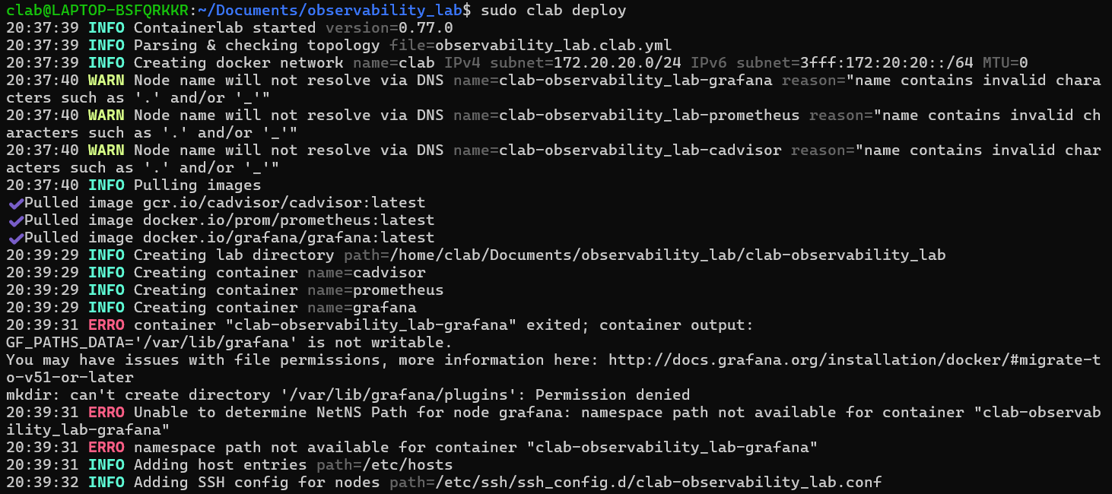
Topologia corrente:
#-observability_lab.clab.yml--------------------------------------------------#

# Topology file
name: observability_lab

topology:
nodes:
# Prometheus
prometheus:
kind: linux
image: prom/prometheus:latest
ports:
- 9090:9090
binds:
- ./prometheus/:/etc/prometheus/
cmd: |
--config.file=/etc/prometheus/prometheus.yml # Sets the path of the configuration file to load
--web.console.libraries=/usr/share/prometheus/console_libraries # A path for the prometheus web console assets
--web.console.templates=/usr/share/prometheus/consoles # A path for the prometheus web console assets
--log.level=debug

# Grafana
grafana:
kind: linux
image: grafana/grafana:latest
ports:
- 3000:3000
binds:
- ./grafana:/var/lib/grafana

# cAdvisor - monitors Docker containers
cadvisor:
kind: linux
image: gcr.io/cadvisor/cadvisor:latest
binds:
- /:/rootfs:ro
- /var/run:/var/run:ro
- /sys:/sys:ro
- /var/lib/docker/:/var/lib/docker:ro
# - /dev/disk/:/dev:disk:ro # Error: no such file or directory
ports:
- 8080:8080

# Non c'è bisogno di assegnare privilegi al container.
# Dalla documentazione:
#
# "Docker containers are currently executed in privileged mode"
# https://containerlab.dev/manual/nodes/#cap-add

# links:
#-----------------------------------------------------------------------------#

Dal browser:
- http://172.18.234.221:9090/metrics (metriche di Prometheus)
site cannot be reached – connection refused.
E infatti il container è in continuo stato di restart.
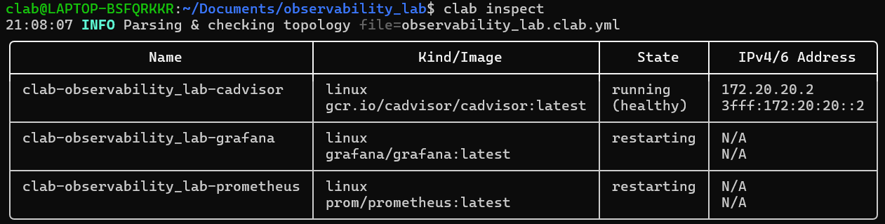
- http://172.18.234.221:8080/metrics (Metriche di cAdvisor)
Funziona correttamente.
SOLUZIONE X GRAFANA
Per grafana:
clab@LAPTOP-BSFQRKKR:~/Documents/observability_lab$ sudo chmod 777 grafana/
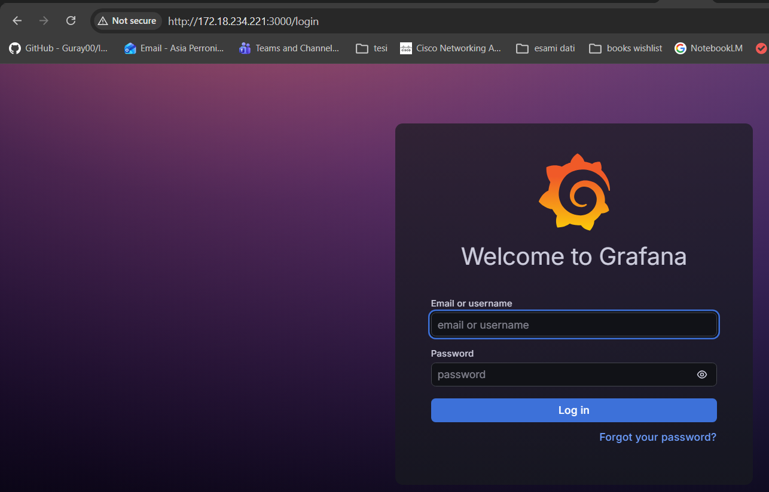

E dopo questo pare che il container di grafana vada. Quello di Prometheus ancora no tho.
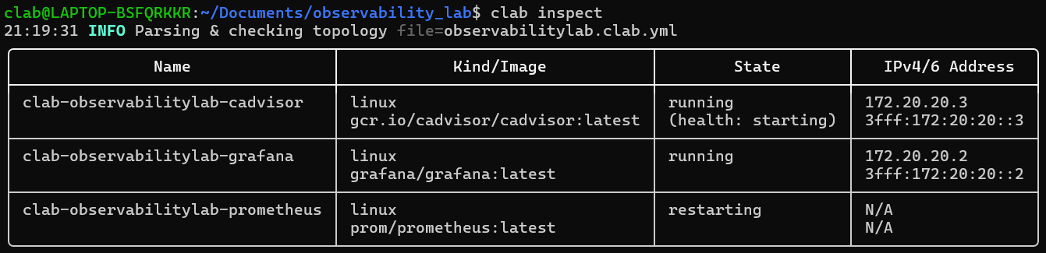

PROVA 1 (FAILED)
Elimino i commenti dalle istruzioni che il container prometheus esegue allo startup.

PROVA 2 (FAILED)
Elimino le istruzioni dello startup e le eseguo a mano.

PROVA 3
Troubleshooting:
lab@LAPTOP-BSFQRKKR:~/Documents/observability_lab$ docker logs clab-observabilitylab-prometheus
time=2026-08-03T19:45:00.227Z level=ERROR source=main.go:745 msg="Error loading config (--config.file=/etc/prometheus/prometheus.yml)" file=/etc/prometheus/prometheus.yml err="parsing YAML file /etc/prometheus/prometheus.yml: yaml: line 17: did not find expected key"
time=2026-08-03T19:45:00.805Z level=ERROR source=main.go:745 msg="Error loading config (--config.file=/etc/prometheus/prometheus.yml)" file=/etc/prometheus/prometheus.yml err="parsing YAML file /etc/prometheus/prometheus.yml: yaml: line 17: did not find expected key"
time=2026-08-03T19:45:01.366Z level=ERROR source=main.go:745 msg="Error loading config (--config.file=/etc/prometheus/prometheus.yml)" file=/etc/prometheus/prometheus.yml err="parsing YAML file /etc/prometheus/prometheus.yml: yaml: line 17: did not find expected key"
time=2026-08-03T19:45:02.114Z level=ERROR source=main.go:745 msg="Error loading config (--config.file=/etc/prometheus/prometheus.yml)" file=/etc/prometheus/prometheus.yml err="parsing YAML file /etc/prometheus/prometheus.yml: yaml: line 17: did not find expected key"
time=2026-08-03T19:45:03.272Z level=ERROR source=main.go:745 msg="Error loading config (--config.file=/etc/prometheus/prometheus.yml)" file=/etc/prometheus/prometheus.yml err="parsing YAML file /etc/prometheus/prometheus.yml: yaml: line 17: did not find expected key"
time=2026-08-03T19:45:05.213Z level=ERROR source=main.go:745 msg="Error loading config (--config.file=/etc/prometheus/prometheus.yml)" file=/etc/prometheus/prometheus.yml err="parsing YAML file /etc/prometheus/prometheus.yml: yaml: line 17: did not find expected key"
time=2026-08-03T19:45:08.797Z level=ERROR source=main.go:745 msg="Error loading config (--config.file=/etc/prometheus/prometheus.yml)" file=/etc/prometheus/prometheus.yml err="parsing YAML file /etc/prometheus/prometheus.yml: yaml: line 17: did not find expected key"
time=2026-08-03T19:45:15.506Z level=ERROR source=main.go:745 msg="Error loading config (--config.file=/etc/prometheus/prometheus.yml)" file=/etc/prometheus/prometheus.yml err="parsing YAML file /etc/prometheus/prometheus.yml: yaml: line 17: did not find expected key"

Provo a mettere la restart policy a “no”. (Non è servito a niente)

SOLUZIONE (FUNZIONA)
YAML text formatting :\
Osservando il tuo screenshot:
scrape_configs:
# Prometheus itself
- job_name: 'prometheus'
static_configs:
- targets: ['localhost:9090']
la riga static_configs: è più indentata di job_name:.
In YAML, dopo:
- job_name: 'prometheus'
non puoi semplicemente continuare ad aumentare l'indentazione. job_name e static_configs sono due chiavi dello stesso oggetto, quindi devono essere allineate:
scrape_configs:
- job_name: 'prometheus'
static_configs:
- targets: ['localhost:9090']

Test FRR Exporter
Lab di test preso dalla repo ufficiale di FRR Exporter: https://github.com/tynany/frr_exporter/tree/master/dev
Fatto partire su Containerlab con il topo file:
#----testfrrexpo.clab.yml-----------------------------------------------------#

name: testfrrexpo

topology:
nodes:
router1:
kind: linux
image: quay.io/frrouting/frr:10.7.0
binds:
- ./frr_exporter/dev/configs/router1.conf:/etc/frr/frr.conf:ro
- ./frr_exporter/dev/configs/daemons:/etc/frr/daemons:ro
- ./frr_exporter/dev/configs/startup.sh:/startup.sh:ro
cmd: /bin/bash /startup.sh
ports:
- 9342:9342

router2:
kind: linux
image: quay.io/frrouting/frr:10.7.0
binds:
- ./frr_exporter/dev/configs/router2.conf:/etc/frr/frr.conf
- ./frr_exporter/dev/configs/daemons:/etc/frr/daemons
- ./frr_exporter/dev/configs/startup.sh:/startup.sh:ro
cmd: /bin/bash /startup.sh
ports:
- 9343:9342

links:
- endpoints: ["router1:eth1", "router2:eth1"]
- endpoints: ["router1:eth2", "router2:eth2"]

#-----------------------------------------------------------------------------#

Il lab parte, la connettività va, le configurazioni ci sono, tutto bello, tranne che a quanto pare frr exporter non parte da solo:

clab@LAPTOP-BSFQRKKR:~/Documents/testfrrexpo$ sudo docker exec -it clab-testfrrexpo-router1 /bin/ash
/ # ss -tulpn | grep 9342
/ #

PROVA (failed)
Faccio il binding anche della cartella frr_exporter. Dalla documentazione:
To run FRR Exporter:
./frr_exporter [flags]
Però:
clab@LAPTOP-BSFQRKKR:~/Documents/testfrrexpo$ docker exec -it clab-testfrrexpo-router1 /bin/ash
/ # cd /etc/frr_exporter/
/etc/frr_exporter # ./frr_exporter
/bin/ash: ./frr_exporter: not found
/etc/frr_exporter # ./frr_exporter.go
/bin/ash: ./frr_exporter.go: Permission denied
/etc/frr_exporter # sudo ./frr_exporter.go
/bin/ash: sudo: not found
/etc/frr_exporter # go build -o frr_exporter .
/bin/ash: go: not found

L’eseguibile non è installato. Bisogna compilarlo a manina (dalla documentazione):
Building
go get github.com/tynany/frr_exporter
cd ${GOPATH}/src/github.com/prometheus/frr_exporter
go build

Oppure da chat:
cd ~/Documents/testfrrexpo/frr_exporter
go build -o /tmp/frr_exporter .

SOLUZIONE:
Manco go è installato, quindi per installarlo seguo le istruzioni del sito ufficiale: https://go.dev/doc/install.
Una volta installato go:
clab@LAPTOP-BSFQRKKR:~/Documents$ cd frr_exporter/
clab@LAPTOP-BSFQRKKR:~/Documents/frr_exporter$ ls
Dockerfile LICENSE Makefile README.md collector dashboards dev frr_exporter.go go.mod go.sum internal
clab@LAPTOP-BSFQRKKR:~/Documents/frr_exporter$ go build
go: downloading github.com/prometheus/common v0.70.0
go: downloading github.com/alecthomas/kingpin/v2 v2.4.0
go: downloading github.com/prometheus/client_golang v1.23.2
go: downloading github.com/prometheus/exporter-toolkit v0.17.1
go: downloading github.com/coreos/go-systemd/v22 v22.7.0
go: downloading github.com/mdlayher/vsock v1.3.0
go: downloading go.yaml.in/yaml/v2 v2.4.4
go: downloading golang.org/x/crypto v0.54.0
go: downloading golang.org/x/sync v0.22.0
go: downloading golang.org/x/time v0.15.0
go: downloading github.com/alecthomas/units v0.0.0-20240927000941-0f3dac36c52b
go: downloading github.com/xhit/go-str2duration/v2 v2.1.0
go: downloading github.com/prometheus/client_model v0.6.2
go: downloading github.com/beorn7/perks v1.0.1
go: downloading github.com/cespare/xxhash/v2 v2.3.0
go: downloading github.com/prometheus/procfs v0.21.1
go: downloading google.golang.org/protobuf v1.36.11
go: downloading github.com/golang-jwt/jwt/v5 v5.3.1
go: downloading github.com/google/uuid v1.6.0
go: downloading github.com/mwitkow/go-conntrack v0.0.0-20190716064945-2f068394615f
go: downloading golang.org/x/net v0.57.0
go: downloading golang.org/x/oauth2 v0.36.0
go: downloading golang.org/x/sys v0.47.0
go: downloading github.com/mdlayher/socket v0.6.1
go: downloading github.com/munnerz/goautoneg v0.0.0-20191010083416-a7dc8b61c822
go: downloading github.com/jpillora/backoff v1.0.0
go: downloading golang.org/x/text v0.40.0
clab@LAPTOP-BSFQRKKR:~/Documents/frr_exporter$

Ok, ora ho il bin di frr_exporter binded nei container. L’ho messo in /etc/frr_exporter//frr_exporter, TODO: bind in /bin/frr_exporter
Quindi, da dove si trova il binario:
./frr_exporter \
--collector.bgp \
--collector.bgp6 \
--collector.ospf \
--collector.bfd \
--collector.pim \
--collector.vrrp \
--collector.route \
--collector.route.detailed-routes \
--collector.bgp.peer-descriptions \
--web.listen-address=:9342 \

ED è PARTITO!
PROVA (ok)
Ora provo a runnarlo raccogliendo principalmente OSPF. Poi magari attaccarlo a prometheus e vedere che query potrei farci. Per non fare docker exec -it ... e copia-incollarci il comando /bin/frr_exporter ecc. con tutti i flag ho perso 1h a provare a scriverlo bene in un blocco exec. Però ho scoperto cose sulla sintassi YAML che metterò nella sezione dedicata.
Per il comando, sotto la descrizione dei nodi, ho usato:

exec:
- >-
/bin/ash -c '/bin/frr_exporter
--no-collector.bgp
--collector.ospf
--collector.bfd
--collector.route
--collector.route.detailed-routes
--web.listen-address=:9342
--log.level=info
> /var/log/frr_exporter.log 2>&1 &'
Spiegazione:
- exec prende una lista(?), quindi vado a capo, indento, metto il carattere ( – ) per indicare l’inizio di un elemento della lista.
- In YAML il carattere ( > ) è interpretato come inizio di un blocco folded. Visto però che voglio la redirezione dell’output in un file di log, devo mettere il (>) per la redirezione tra apici. Quindi non posso passare il comando a dritto, ma devo passare il comando che dice di usare bash (/bin/ash -c) per eseguire tutto il comando, messo tra apici.
- (>-) è il carattere che indica l’inizio di un blocco folded clipped (o stripped?), ovvero un blocco in cui le new line vengono sostituiti con spazi bianchi, e che toglie i line break dalla fine delle stringhe.
- Importante: le linee del comando devono essere indentate rispetto al 1° (-) ed avere tutte la stessa indentatura!
- Importante 2: Potrei dire vabbè stica non uso la redirezione così non devo scrivere /bin/ash -c, e NO! Perché? Perché se non lo metto, il (&) alla fine viene interpretato come un parametro da passare a frr_exporter! E se non ce lo metto? Quando faccio il deploy, rimane bloccato perché il processo continua a rimanere in esecuzione, “monopolizzando” la bash. In pratica se lo faccio, mi si blocca già al clab deploy.
Morale della favola: fai uno script bash e mettilo nell’exec o nel cmd, che fai prima (TODO)

NEXT: PROMETHEUS
Ora ci voglio mettere un server prometheus. Potrei anche runnarlo in un altro clab (penso) -> da dove prendo le metriche? Localhost del WSL?

PROBLEMA (SOLVED)
clab@LAPTOP-BSFQRKKR:~/Documents/testfrrexpo$ clab inspect
08:55:30 INFO Parsing & checking topology file=testfrrexpo.clab.yml
╭─────────────────────────────┬──────────────────────────────┬─────────┬───────────────────╮
│ Name │ Kind/Image │ State │ IPv4/6 Address │
├─────────────────────────────┼──────────────────────────────┼─────────┼───────────────────┤
│ clab-testfrrexpo-prometheus │ linux │ exited │ N/A │
│ │ prom/prometheus:latest │ │ N/A │
├─────────────────────────────┼──────────────────────────────┼─────────┼───────────────────┤
│ clab-testfrrexpo-router1 │ linux │ running │ 172.20.20.2 │
│ │ quay.io/frrouting/frr:10.7.0 │ │ 3fff:172:20:20::2 │
├─────────────────────────────┼──────────────────────────────┼─────────┼───────────────────┤
│ clab-testfrrexpo-router2 │ linux │ running │ 172.20.20.4 │
│ │ quay.io/frrouting/frr:10.7.0 │ │ 3fff:172:20:20::4 │
╰─────────────────────────────┴──────────────────────────────┴─────────┴───────────────────╯
clab@LAPTOP-BSFQRKKR:~/Documents/testfrrexpo$ docker logs clab-testfrrexpo-prometheus
time=2026-08-06T06:55:25.370Z level=INFO source=main.go:1730 msg="updated GOGC" old=100 new=75
time=2026-08-06T06:55:25.371Z level=INFO source=main.go:789 msg="Leaving GOMAXPROCS=8: CPU quota undefined" component=automaxprocs
time=2026-08-06T06:55:25.371Z level=INFO source=memlimit.go:198 msg="GOMEMLIMIT is updated" component=automemlimit package=github.com/KimMachineGun/automemlimit/memlimit GOMEMLIMIT=3589550899 previous=9223372036854775807
time=2026-08-06T06:55:25.371Z level=INFO source=main.go:896 msg="Starting Prometheus Server" mode=server version="(version=3.13.2, branch=HEAD, revision=bb5dff00cf8fdfbf5c65e0531aa835fa238a43a2)"
time=2026-08-06T06:55:25.371Z level=INFO source=main.go:901 msg="operational information" build_context="(go=go1.26.5, platform=linux/amd64, user=root@56a9973e8bdd, date=20260730-11:31:39, tags=netgo,builtinassets)" host_details="(Linux 6.18.33.2-microsoft-standard-WSL2 #1 SMP PREEMPT_DYNAMIC Thu Jun 18 21:54:43 UTC 2026 x86_64 prometheus localdomain)" fd_limits="(soft=1048576, hard=1048576)" vm_limits="(soft=unlimited, hard=unlimited)"
time=2026-08-06T06:55:25.373Z level=ERROR source=query_logger.go:161 msg="Failed to create directory for logging active queries" component=activeQueryTracker err="mkdir /Prometheus: permission denied"
time=2026-08-06T06:55:25.373Z level=ERROR source=main.go:984 msg="failed to initialize active query tracker" err="create active query log directory: mkdir /Prometheus: permission denied"

Alla fine il problema era la lettera maiuscola sulla cartella prometheus :|
Cambiato quello, il lab funzionava.
PROVA
Aggiungiamo Grafana.
# ...
# Grafana
grafana:
kind: linux
image: grafana/grafana:latest
ports:
- 3000:3000
binds:
- ./grafana/:/var/lib/grafana/
# ...

PROBLEMA:
Si è verificato il problema dell’altra volta. Stavolta provo a cercare un clab apposta con grafana. non pervenuto)
SOLUZIONE:
Devo eseguire il container grafana con un utente che abbia i permessi di creare file e scrivere nella cartella. Containerlab fornisce il tag “user:”. Prima prova: “user: clab” (clab è lo user di default di wsl per Containerlab”. Problema: l’utente deve essere presente nell’ambiente DENTRO il container. l’utente clab non esiste.
Però se uso l’id numerico funziona. Quindi:
- soluzione brutta: “user: “1000””
- soluzione bella:
“user: "${CLAB_USER_ID}"”
e “fuori”:
export CLAB_USER_ID=$(id -u)
sudo -E clab deploy

Poi fare uno scriptino che mi fa l’export + deploy automaticamente.
Per ora uso la soluzione brutta tho.

PROVA: alert rules
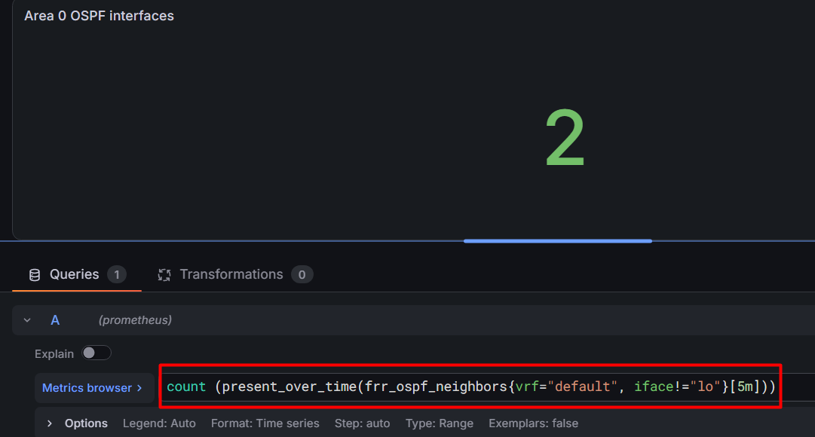
questa così non va, perché present_over_time conta il numero massimo di serie, quindi se un range vector nel tempo passa da 2 a 3 componenti (serie), conterà 3 finché c’è almeno un timestamp con 3 serie. Quindi in pratica questo si aggiorna dopo 5 minuti.

ALTRA PROVA: test alerts
Alerts:
groups:
- name: ospf_alerts
interval: 30s
rules:
# OSPF neighbor down
- alert: NeighborDown
expr: count (frr_ospf_neighbors{vrf="default", iface!="lo"} offset 1m30s) - count (frr_ospf_neighbors{vrf="default", iface!="lo"}) > 0
for: 1m
labels:
severity: warning
annotations:
summary: "OSPF neighbor count decreased."

- alert: AdjacencyNotFormed
expr: frr_ospf_neighbor_state{vrf="default"} != 7
for: 1m
labels:
severity: warning
annotations:
summary: " {{ $labels.instance }}: cannot form full adjacency with neighbor {{ $labels.neighbor }}."
description: "{{ $labels.instance }}: neighbor {{ $labels.neighbor }} on interface {{ $labels.iface }} has been in state {{ $value }} for over 1 minute. \n(States: 1=Down, 2=Init, 3=2-Way, 4=ExStart, 5=Exchange, 6=Loading, 7=Full)"

“problema”: gli allarmi partono più o meno, ma dopo un po’ scompaiono, vorrei uno storico degli allarmi (o un’opzione keep firing till te lo dico io?)

ALTRA PROVA: cambiare nome legenda
https://grafana.com/docs/grafana/latest/visualizations/panels-visualizations/query-transform-data/transform-data/?pg=how-to-visualize-csv-data-with-grafana&plcmt=in-text&utm_source=chatgpt.com#extract-fields
Rename by regex
È probabilmente la soluzione più semplice se vuoi modificare solo ciò che viene visualizzato senza toccare la query.
Mantieni:
rate(process_cpu_seconds_total{job="frr"}[5m])
e la legenda:
{{ instance }}
Poi nel pannello vai in Transformations → Add transformation → Rename by regex. Grafana permette proprio di rinominare le serie tramite regex e gruppi di cattura.
Nel tuo caso imposta:
Match:
^(.*):[0-9]+$

Replace:
$1
Quindi:
clab-testfrrexpo-router2:9342
↓
clab-testfrrexpo-router2
La regex significa:
^(.*):[0-9]+$
└─┬─┘ └─┬─┘
│ └── porta numerica
│
└──────── hostname → $1
e $1 diventa il nuovo nome della serie. È esattamente il tipo di utilizzo previsto da Rename by regex.

MODIFICA 02/09
Poiché uso l’immagine FRR per containerlab, non c’è bisogno di far partire FRR usando lo script startup.sh. Quindi ho commentato la linea “cmd: ...” e per ora uso la direttiva exec per far partire lo script. Prossimo step: automatizzare questo processo.
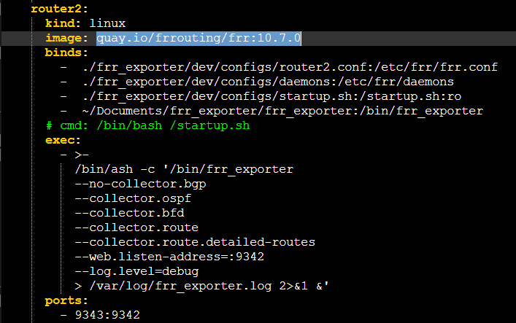

Aggiunta cAdvisor
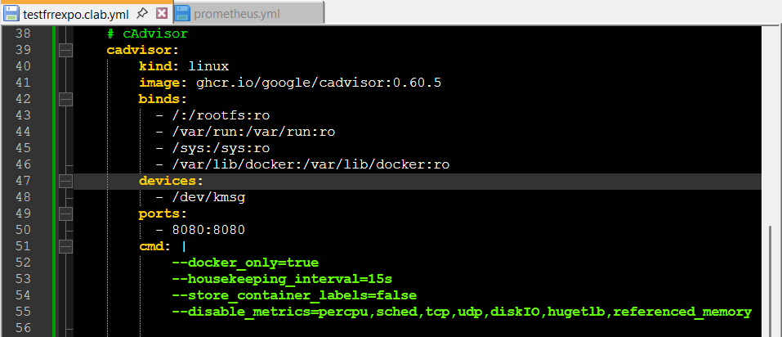
Per i dettagli sui flag: https://www.dash0.com/guides/cadvisor-docker-monitoring#tuning-cadvisors-metric-collection-behavior

Idee
- fare immagine FRR modificata con:
  - frr exporter installato
  - script per farlo partire con i flag desiderati
- OPPURE, visto che c’è: container separato con FRR. C’è da capire come fargli raggiungere i router.

RETE DEFINITIVA

Descrizione
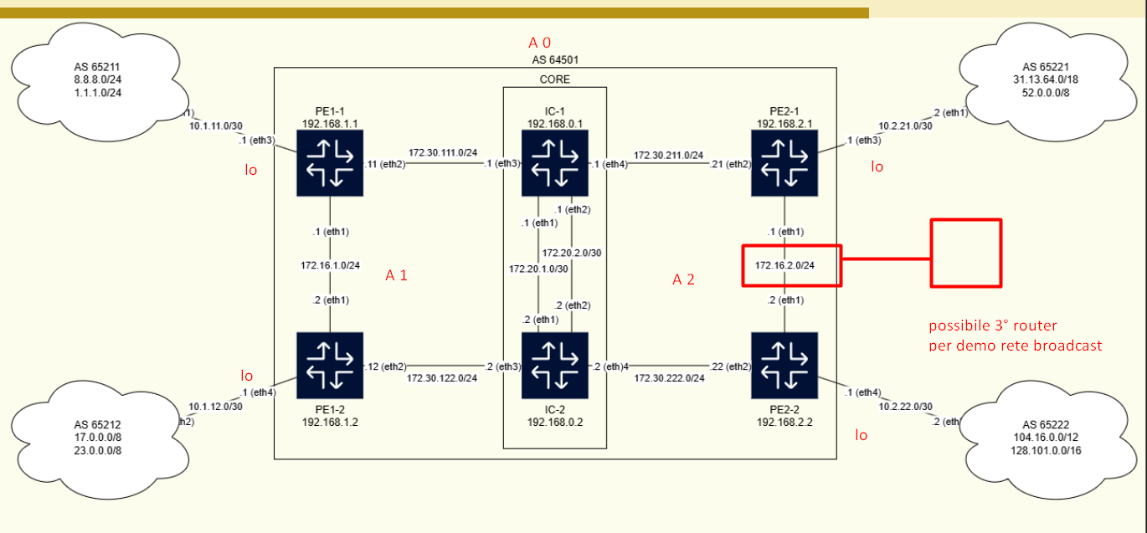
Intanto ho 6 router, quindi voglio scrivere meno linee di configurazione possibile nel topo file. Quindi vediamo come condensare le configurazioni comuni: https://containerlab.dev/manual/topo-def-file/#groups.
“Values inherited from groups will take precedence over kinds and defaults. In other words, the inheritance model is as follows (from most specific to less specific):”
node -> group -> kind -> defaults
Forse quello che voglio creare io per i router non è un group, ma un kind:
“Kinds define the behavior and the nature of a node, it says if the node is a specific containerized Network OS, virtualized router or something else.”

Le configurazioni per ora sono queste:
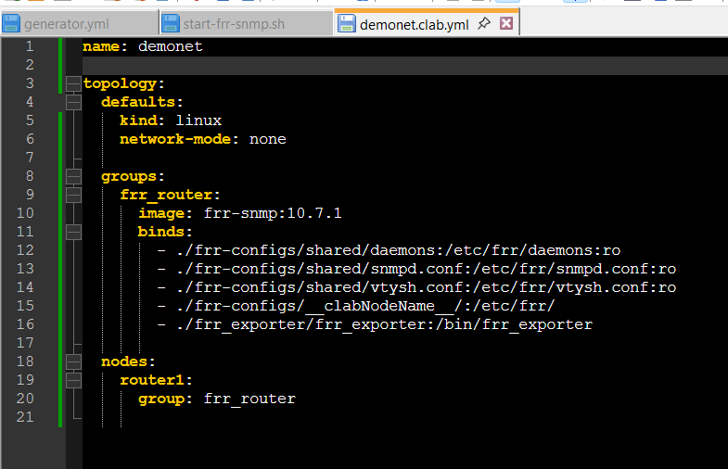

Scelte progettuali

Da quali interfacce espongo le metriche?
Se decido di mettere prometheus e gli exporter nel core, direi dall’interfaccia più vicina.
Dove si configura?
- SNMP expo e cAdvisor: config prometheus (sicura?)
- FRR exporter?
Dalla documentazione:
--web.listen-address=:9342 Addresses on which to expose metrics and web interface. Repeatable for multiple addresses. Examples: `:9100` or `[::1]:9100` for http, `vsock://:9100` for vsock
Quindi probabilmente è in ascolto su tutte le interfacce, è prometheus che decide da quale pullare. (Optimism and smile: restored)

Quali router designo come ABR?
All’inizio, senza pensarci avevo messo le interfacce “laterali” dei router nel core nelle aree 1 e 2. Poi mi sono accorta che era una cazzata, perché in questo modo sarebbero stati ABR per ben 3 aree, con l’area 0 costituita solo da i 2 link tra i 2 router.
Quindi ora la divisione è questa:
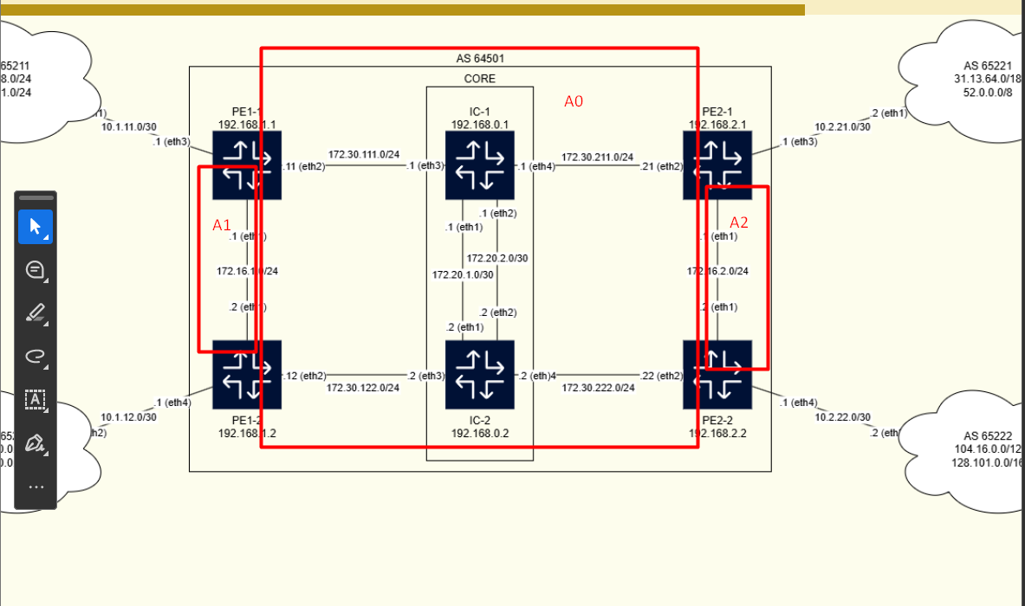

Dove metto i container di monitoraggio?
1^ soluzione pensata (img sotto) (NO!)
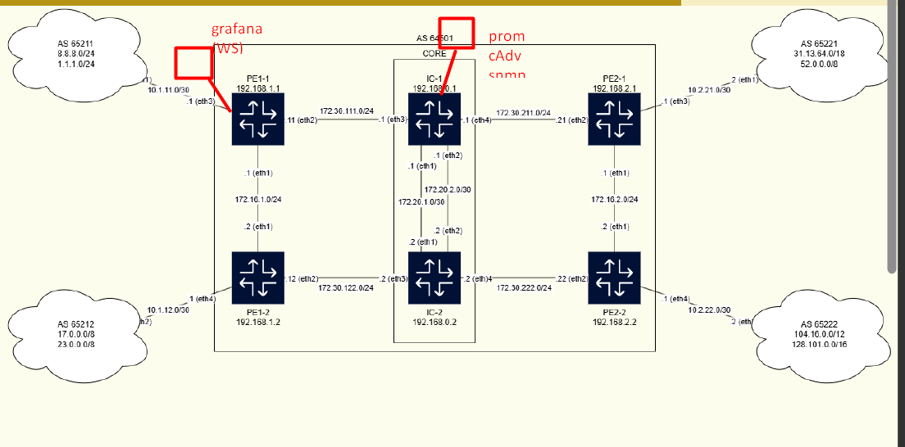
Perché no?
- intanto dovrei aggiungere un’interfaccia al router core-1.
- Poi si dovrebbe smazzare da solo tutto il traffico da quell’interfaccia
Soluzione scelta (per ora)(img sotto)
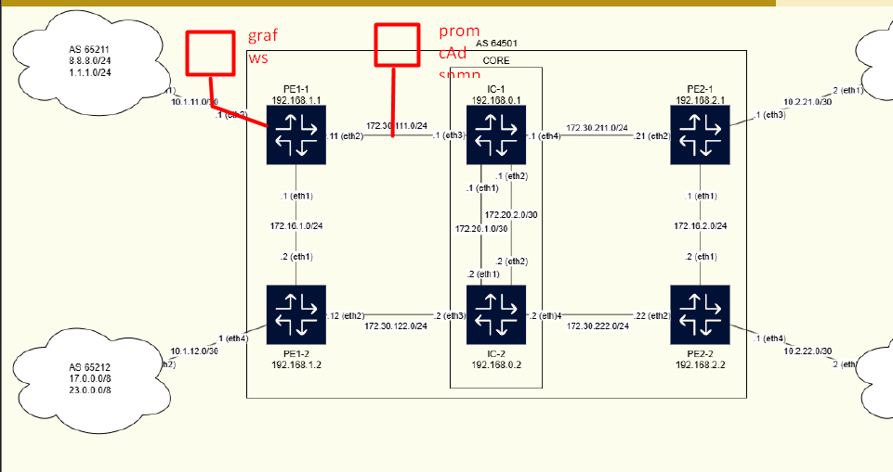
Perché è (penso) meglio?
- una parte (anche se piccola) del traffico viene gestita da PE1-1.
- rimane comunque nell’area 0 (pe1-1 ha 1 interfaccia nell’area 0)
- no nuove interfacce
NON VA BENE NEACNHE QUESTA! A parte che non riesco a impostare un default gateway al container prometheus, ma anche potendo, quale dei 2 router identifico come default gateway? Dovrei usarne uno solo, quindi la cosa di smistare il traffico non funzionerebbe comunque. :/

Configurazione

Router
Seguo lo schema fornito.
Partiamo da core, r1 -> r2
ordine configurazioni:
- interfacce (ip e ptp)
- ospf

Bridge
sudo ip link add switch1 type bridge
sudo ip link set switch1 up

PASSWORD grafana
subarubaracca

Grafana

Problemi

Permessi (RISOLTO)
Ma ci sono problemi di permessi (evidentemente):
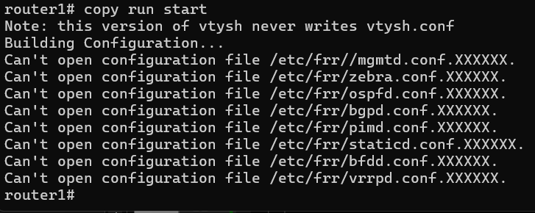

AAAAA PROBLEMI DI PERMESSI
Per ora sono rimasta a questa situazione:
ho provato a mettere tutti i file nella cartella router1 come proprietà di frr, poi
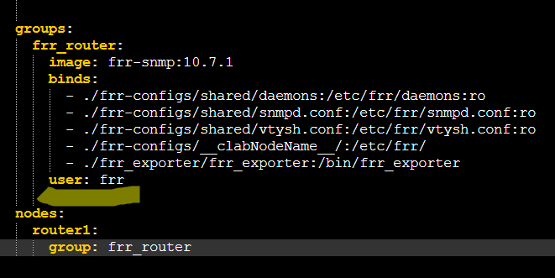
ma:
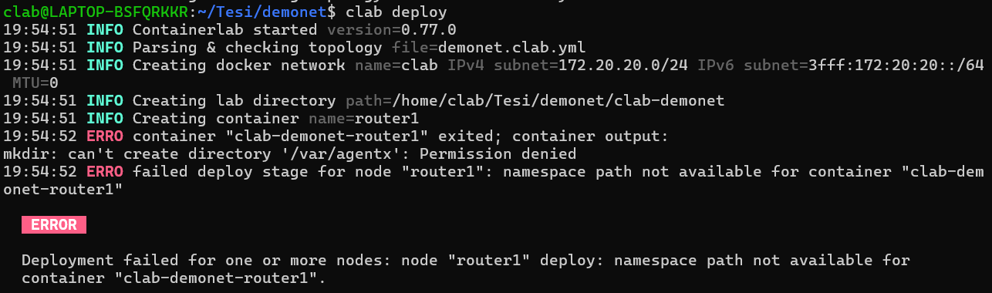

Trovata la causa: frr nel container gira come root, quindi tutti contenti, ma i daemon creati di FRR girano come utente frr, che ha UID/GID diversi dall’utente frr nell’host. Pertanto anche impostando frr come owner della cartella e file nell’host, i processi deamon non possono creare file e modificarli nella cartella. Soluzioni possibili ma brutte:
- chmod 777
- cambiare l’immagine FRR per metterci l’utente frr col UID/GID che voglio (scartata: ci mette 18938 anni a buildare l’immagine)
- far corrispondere a mano UID/GID di frr tra host e container (brutto perchè quegli specifici UID/GID potrebbero essere già presi da qualcun’altro, da una parte o dall’altra)
Soluzione che propone chat (forse la mejo):
Una soluzione elegante senza modificare l'immagine
Potresti semplicemente rendere le directory dei router scrivibili dal gruppo:
sudo chmod 775 frr-configs/router1
e poi aggiungere al container il gruppo dell'host tramite group_add.
Per esempio Containerlab passa direttamente molte opzioni Docker, quindi qualcosa del tipo:
nodes:
router1:
group: frr_router
group-add:
- 106
(se supportato dalla versione che usi).
In questo modo il processo frr nel container continuerebbe ad avere:
uid=100
gid=101
ma sarebbe membro anche del gruppo 106, che è quello proprietario della directory montata.
Quello che farei in un laboratorio Containerlab
Userei semplicemente:
chmod 775 frr-configs/router1
e farei in modo che il processo nel container abbia accesso al gruppo proprietario della directory (tramite group_add oppure impostando opportunamente il gruppo della directory).
È una soluzione più robusta perché non dipende dall'implementazione interna dell'immagine FRR e non richiede di ricostruirla o modificarla. Inoltre riflette meglio il modello Unix: l'accesso è gestito tramite gruppi e permessi della directory, non tramite la coincidenza fortuita degli UID tra sistemi diversi.

Sì peccato che group-add non sia una direttiva di containerlab, ma probabilmente di docker (o forse se l’è inventata chat di sana pianta)
vabbè chmod 777 e fuck it.
ok sì risolto

Bridge
Io pensavo che bastasse dichiararlo e sarebbe stato creato così ez pez, E INVECE.
C’era un “hint” nella documentazione containerlab (https://containerlab.dev/manual/kinds/bridge/#linux-bridge):
“Containerlab doesn't create bridges on users behalf, that means that in order to use a bridge in the topology definition file, the bridge needs to be created and enabled first.”
Ignorando la cosa, il primo errore ricevuto da clab deploy è stato questo:
12:26:47 ERRO failed to initialize node "switch1": none not a valid container reference
E questo probabilmente è derivato dall’impostazione default “network-mode:none”
Quindi ho provato a cambiare quello (tbh potrei anche metterlo solo per i router anzichè come default), mettendo “host”, ma comunque ho ottenuto questo errore:
ERROR
Unable to find node swithc1.
Quindi ho seguito il consiglio di gemini: “(Note: Ensure the Linux bridge my-bridge exists on your host OS via ip link add my-bridge type bridge and ip link set my-bridge up before running containerlab deploy)”
Verifica: ip a show
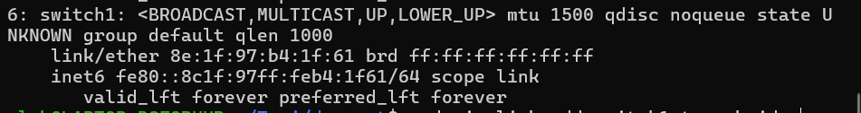
continua comunque a darmi lo stesso errore.
Risolto: il bridge andava creato come ho fatto, ma:
- typo in una dichiarazione dei link
- non va specificato un network-mode! Anche host non va bene, quindi dovevo togliere la direttiva network-mode dai default -> messa nei router

File configurazione non trovato (RISOLTO)
https://docs.frrouting.org/en/stable-7.5/basic.html#config-methods
In pratica di default sparge le config su un file per daemon. con l’istruzione service integrated-vtysh-config posso dirgli di salvare tutto in un frr.conf.

Il server prometheus non vede il mio router come default
Eh, e chi glielo aveva detto?
Possibile soluzione: dhcp? “FRRouting (FRR) does not implement or include a DHCP server.” fuck.
Se è per questo manco mi ha preso l’indirizzo che gli avevo dato :|
^Cclab@LAPTOP-BSFQRKKR:~/Tesi/demonet$ docker exec -it clab-demonet-prometheus /bin/ash
/prometheus $ ip a show
1: lo: <LOOPBACK,UP,LOWER_UP> mtu 65536 qdisc noqueue qlen 1000
link/loopback 00:00:00:00:00:00 brd 00:00:00:00:00:00
inet 127.0.0.1/8 scope host lo
valid_lft forever preferred_lft forever
inet6 ::1/128 scope host
valid_lft forever preferred_lft forever
2: eth0@if143: <BROADCAST,MULTICAST,UP,LOWER_UP,M-DOWN> mtu 1500 qdisc noqueue
link/ether 5e:60:3d:91:59:24 brd ff:ff:ff:ff:ff:ff
inet 172.20.20.2/24 brd 172.20.20.255 scope global eth0
valid_lft forever preferred_lft forever
inet6 3fff:172:20:20::2/64 scope global flags 02
valid_lft forever preferred_lft forever
inet6 fe80::5c60:3dff:fe91:5924/64 scope link
valid_lft forever preferred_lft forever
141: eth1@if142: <BROADCAST,MULTICAST,UP,LOWER_UP,M-DOWN> mtu 9500 qdisc noqueue
link/ether aa:c1:ab:78:32:98 brd ff:ff:ff:ff:ff:ff
inet6 fe80::a8c1:abff:fe78:3298/64 scope link
valid_lft forever preferred_lft forever

DHCP server? Non supportato da FRR. Tra l’altro manco mi ha preso l’ip dell’interfaccia settato tramite file di topologia.
WAIT, di default non attacco i router al default bridge perché voglio che i pacchetti che si scambiano viaggino sulla rete da me costruita, MA se attaccassi solo un’interfaccia di un router (tipo area 1, ma anche area 0 a sto punto) al default bridge, a cui collego anche prometheus?
Tbh forse potrei attaccere i router al default bridge, ma configurare una ACL che impedisca il passaggio di pacchetti su quell’interfaccia (es: drop any), tranne sul router che voglio comunichi col server prometheus: https://docs.frrouting.org/en/stable-5.0/filter.html. Beh a sto punto farei prima ad attaccare alla rete di mgmt solo l’interfaccia del router che comunica con prometheus. Rimane il fatto che il container prometheus non lo userebbe come default gateway.
“You can connect a running container to multiple networks, either by passing the --network flag multiple times when creating the container, or using the docker network connect command for already running containers. In both cases, you can use the --ip or --ip6 flags to specify the container's IP address on that particular network.” (https://docs.docker.com/engine/network/)
Da https://docs.docker.com/engine/network/drivers/bridge/:
“User-defined bridges provide better isolation.
All containers without a --network specified, are attached to the default bridge network. This can be a risk, as unrelated stacks/services/containers are then able to communicate.
Using a user-defined network provides a scoped network in which only containers attached to that network are able to communicate.” )
“Containers can be attached and detached from user-defined networks on the fly.
During a container's lifetime, you can connect or disconnect it from user-defined networks on the fly. To remove a container from the default bridge network, you need to stop the container and recreate it with different network options.”
“User-defined bridge networks are created and configured using docker network create my-net. If different groups of applications have different network requirements, you can configure each user-defined bridge separately, as you create it.”
“To connect a running container to an existing user-defined bridge, use the docker network connect command. The following command connects an already-running my-nginx container to an already-existing my-net network:
docker network connect my-net my-container
“
“Skip Bridge IP address configuration
The bridge is normally assigned the network's --gateway address, which is used as the default route from the bridge network to other networks.
The com.docker.network.bridge.inhibit_ipv4 option lets you create a network without the IPv4 gateway address being assigned to the bridge. This is useful if you want to configure the gateway IP address for the bridge manually. For instance if you add a physical interface to your bridge, and need it to have the gateway address.
With this configuration, north-south traffic (to and from the bridge network) won't work unless you've manually configured the gateway address on the bridge, or a device attached to it.
This option can only be used with user-defined bridge networks.” (https://docs.docker.com/engine/network/drivers/bridge/#skip-bridge-ip-address-configuration)
ESEMPIO USED-DEFINED BRIDGE: https://docs.docker.com/engine/network/drivers/bridge/#use-user-defined-bridge-networks.
“If you run multiple labs without changing the default management settings, the containers of those labs will end up connecting to the same management network with their management interface.”
^ e se li runnassi in 2 clab differenti? Nah, a sto punto è la stessa cosa che connettere solo 1 router al bridge di default
“default docker network (https://containerlab.dev/manual/network/#default-docker-network)
To make clab nodes start in the default docker network bridge, which uses the docker0 bridge interface, users need to mention this explicitly in the configuration:
mgmt:
network: bridge
Since bridge network is created by default by docker, using its name in the configuration will make nodes to connect to this network.”
“We allow our users to change the bridge name that the management network will use. This can be used to connect containers to an already existing bridge with other workloads connected:
mgmt:
# a bridge with a name mybridge will be created or reused
# as a backing bridge for the management network
bridge: mybridge
If the existing bridge has already been addressed with IPv4/6 address, containerlab will respect this address and use it in the IPAM configuration blob of the docker network.”
It is possible to set the desired gateway IP (that is the IP assigned to the bridge) (QUINDI NON VA BENE!) with the ipv4-gw/ipv6-gw setting under mgmt container:
mgmt:
network: custom-net
bridge: mybridge
ipv4-subnet: 10.20.30.0/24 # ip range for the docker network
ipv4-gw: 10.20.30.100 # set custom gateway ip

“bridge network driver options#
By default, containerlab will create the management bridge with default driver options2, however, for special networking setups required in some cases, this can be overridden in the driver-opts section of the mgmt block.
This section is a key-value pair for each overridden driver option:
mgmt:
network: custom-net
bridge: mybridge
driver-opts:
com.docker.network.bridge.gateway_mode_ipv4: routed
com.docker.network.bridge.gateway_mode_ipv6: routed
All driver options can be overridden, even those set by containerlab. NDA: quindi se docker permette di specificare un container come def gw, si può fare anche qui!

Point-to-point links#
Management network is used to provide management access to the NOS containers, it does not carry control or dataplane traffic. In containerlab we create additional point-to-point links between the containers to provide the datapath between the lab nodes.

Ok, con exec nel topo file è quasi risolto:
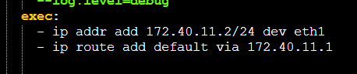
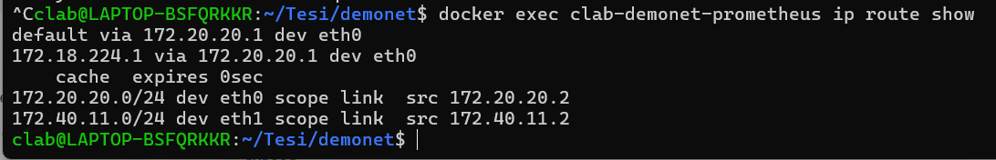
Però la default rimane il bridge di management. Quindi o gli aggiungo le route statiche per gli indirizzi, o devo mettere le route statiche... o quello, perché ora che ci penso, anche attaccassi il r1-1 alla mgmt insieme a prometheus, proverebbe comunque a inviare i pacchetti al bridge, che non è a conoscenza degli IP dei router.

Sintassi YAML
Quel | non è specifico di Prometheus: è una sintassi di YAML.
Significa che il valore del campo cmd è un blocco di testo multilinea ("literal block scalar"), e che i ritorni a capo devono essere preservati.
Ad esempio:
cmd: |
--config.file=/etc/prometheus/prometheus.yaml
--web.console.libraries=/usr/share/prometheus/console_libraries
--web.console.templates=/usr/share/prometheus/consoles
--log.level=debug
equivale a una singola stringa contenente:
--config.file=/etc/prometheus/prometheus.yaml
--web.console.libraries=/usr/share/prometheus/console_libraries
--web.console.templates=/usr/share/prometheus/consoles
--log.level=debug
con i caratteri newline inclusi.

In YAML esistono due forme molto usate:
| (literal)
Preserva le nuove righe:
message: |
riga 1
riga 2
riga 3
risulta in:
riga 1
riga 2
riga 3

> (folded)
Sostituisce le nuove righe con spazi:
message: >
riga 1
riga 2
riga 3
risulta in:
riga 1 riga 2 riga 3

Di più su blocchi literal e folded: default behavior e modificatori strip (-) e keep (+): https://redocly.com/learn/yaml/blocks-and-flows
In pratica se devo scrivere es. un comando molto lungo e lo voglio mettere su più righe nello YAML, ma mi va bene che sia eseguito in una sola riga, uso >. Se voglio strippare i line breaks dalla fine della stringa uso >-.

Cosa può andare storto in OSPF?
Cerchiamo di partire da questo per capire quali grafici potrebbero interessarci.
Alcuni siti considerati:
https://www.cisco.com/c/en/us/support/docs/ip/open-shortest-path-first-ospf/12151-trouble-main.html

Esempi di problemi:
- Le route non vengono redistribuite con OSPF. casi: route statiche e dinamiche
- Mancano route OSPF dalla tabella di routing
- Neighbors adjacency not full. (Nota: nelle reti broadcast tutti i router hanno adiacenza full solo con il designated)
- le interfacce sono down (non specifico di OSPF ma ci sta)
- area mismatch
- network mask mismatch tra router sulla stessa rete
- router id duplicati

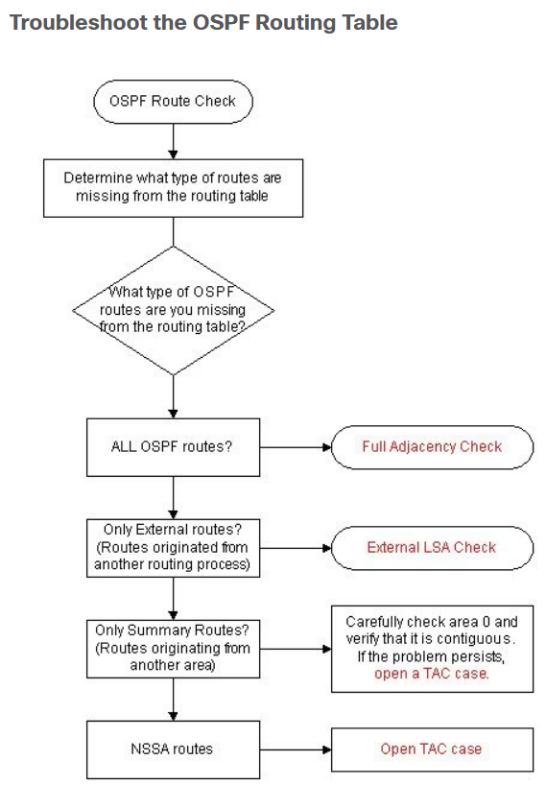
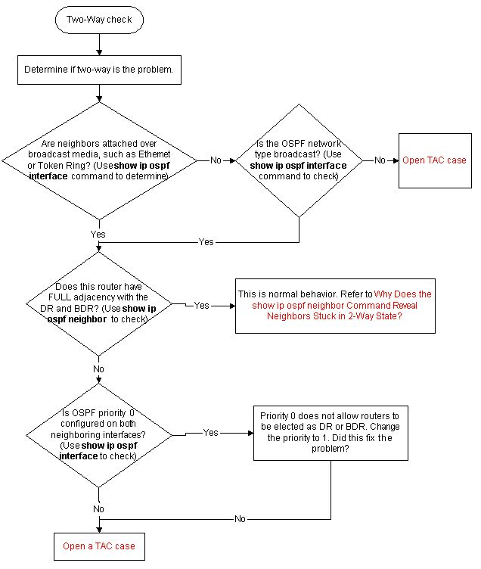

Query possibili

FRR exporter

FIB / RIB ratio
Descrizione: | 1 – (numero di entry nella FIB su numero di entry nella RIB (per tipo e per istanza))
Espressione: | 1 - frr_route_fib_count / frr_route_rib_count
Valori: | [0, 1]
Significato: | se un router ha più entry nella RIB non incluse nella FIB, indicativamente significa che se cade un link, con più probabilità sarà in grado di ristabilire la connessione con tutti o alcuni nodi della rete.
Considerazioni: | forse è più significativo contare il numero di entry FIB – numero entry RIB?
Query simili: | frr_route_total - frr_route_total_fib

-------------------------------------------------------------------------------------------------------------------------------
Descrizione:
Espressione:
Valori:
Significato:
Considerazioni:
Query simili:

OSPF
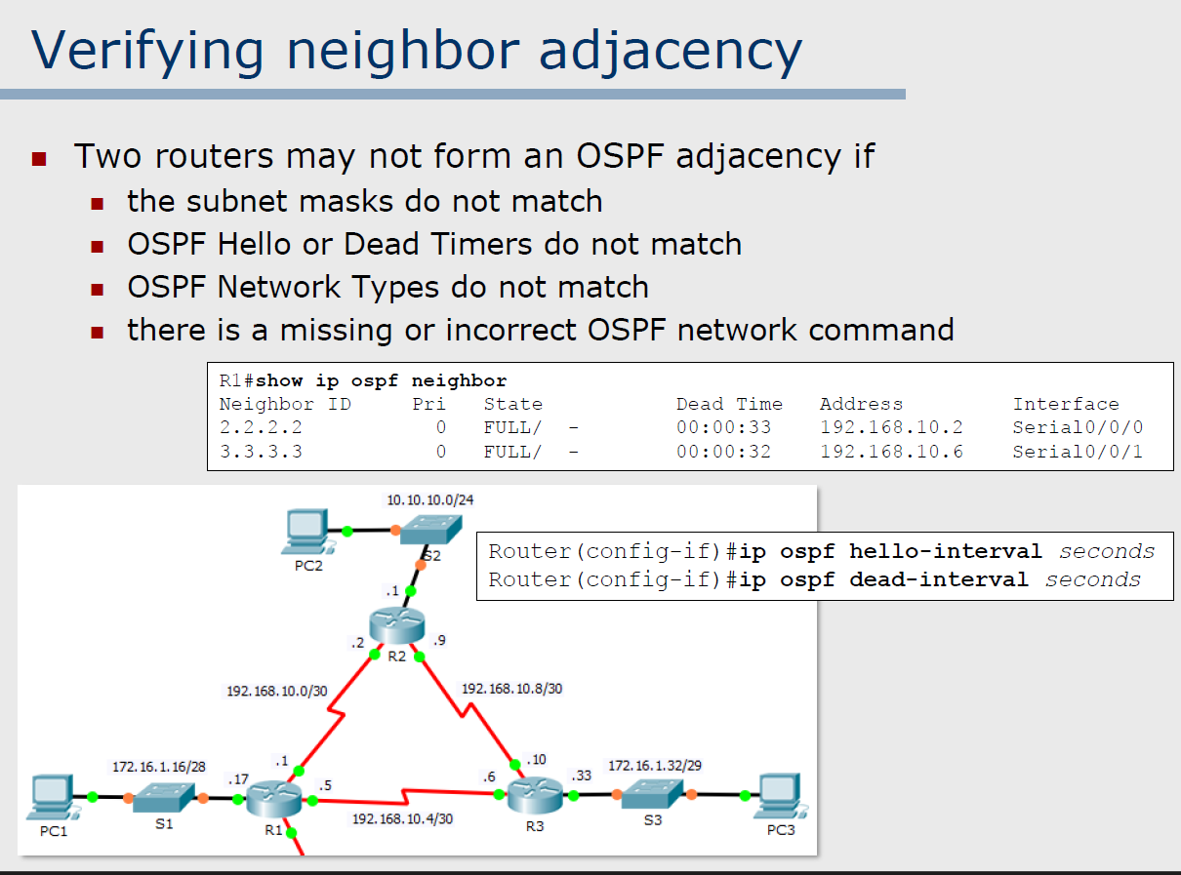
Scrivere alerts e fare panels sulle adiacenze. es: manda un alert se 2 router rimangono “troppo” tempo in stato non full (es: 2-way). Che vuol dire “troppo”? Valuto tutti i messaggi che bisogna scambiare per formare adiacenze in vari casi (link pto-pto, link broadcast con elezione DR e BDR, ...). Calcolo un tempo massimo di convergenza basato sui timer dei messaggi che vengono scambiati. Dico: manda un alert se 2 router non sono in full dopo t_max
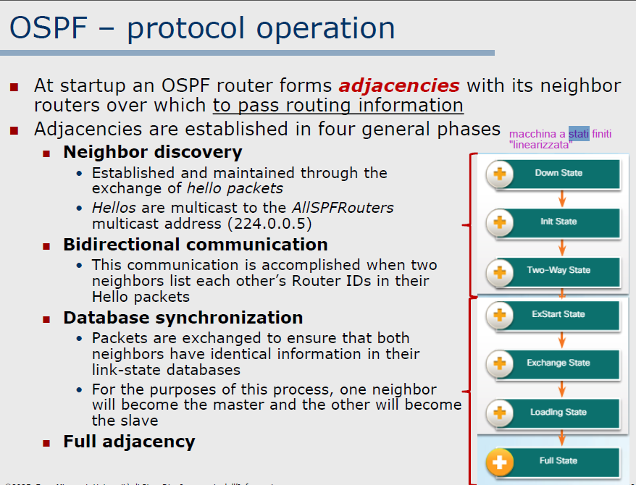
Adjacencies
Da https://www.cisco.com/c/en/us/support/docs/ip/open-shortest-path-first-ospf/13685-13.html
The states are Down, Init, 2-Way, Exstart, Exchange, Loading, and Full.
Down
This is the first OSPF neighbor state. It means that no information (hellos) has been received from this neighbor, but hello packets can still be sent to the neighbor in this state.
In the fully adjacent neighbor state, if a router does not receive hello packet from a neighbor within the RouterDeadInterval time (RouterDeadInterval = 4*HelloInterval by default) or if the manually configured neighbor is removed from the configuration, then the neighbor state changes from Full to Down.
Init
This state specifies that the router has received a hello packet from its neighbor, but the receiving router ID was not included in the hello packet.
When a router receives a hello packet from a neighbor, it must list the sender router ID in its hello packet as an acknowledgment that it received a valid hello packet.
2-Way
This state designates that bi-directional communication has been established between two routers. Bi-directional means that each router sees the hello packet from the other router.
This state is attained when the router receiving the hello packet sees its own Router ID within the received hello packet neighbor field. At this state, a router decides whether to become adjacent with this neighbor.
On broadcast media and non-broadcast multi-access networks, a router becomes full only with the designated router (DR) and the backup designated router (BDR); it stays in the 2-way state with all other neighbors.
On Point-to-point and Point-to-multipoint networks, a router becomes full with all connected routers.
At the end of this stage, the DR and BDR for broadcast and non-broadcast multi-access networks are elected. For more information on the DR election process, refer to DR Election.
Note: Receiving a Database Descriptor (DBD) packet from a neighbor in the init state can also a cause a transition to 2-way state.
Exstart
Once the DR and BDR are elected, the actual process of the exchange link state information can start between the routers and their DR and BDR.
In this state, the routers and their DR and BDR establish a primary-secondary relationship and choose the initial sequence number for adjacency formation.
The router with the higher router ID becomes the primary and starts the exchange, and as such, is the only router that can increment the sequence number.
You would logically conclude that the DR/BDR with the highest router ID is the primary for this process. The DR/BDR election could be because of a higher priority configured on the router instead of highest router ID.
Thus, it is possible that a DR plays a secondary role. Also, that primary/secondary election is on a per-neighbor basis.
Exchange
In the exchange state, OSPF routers exchange database descriptor (DBD) packets. Database descriptors contain link-state advertisement (LSA) headers only and describe the contents of the entire link-state database.
Each DBD packet has a sequence number which can be incremented only by primary which is explicitly acknowledged by secondary.
Routers also send link-state request packets and link-state update packets (which contain the entire LSA) in this state.
The contents of the DBD received are compared to the information contained in the routers link-state database to check if new or more current link-state information is available with the neighbor.
Loading
In this state, the actual exchange of link state information occurs. Based on the information provided by the DBDs, routers send link-state request packets.
The neighbor then provides the requested link-state information in link-state update packets. During the adjacency, if a router receives an outdated or lost LSA, it sends a link-state request packet for that LSA.
All link-state update packets are acknowledged.
Full
In this state, routers are fully adjacent with each other. All the router and network LSAs are exchanged and the routers' databases are fully synchronized.
Full is the normal state for an OSPF router. If a router is stuck in another state, it is an indication that there are problems when the adjacencies are formed.
The only exception to this is the 2-way state, which is normal in a broadcast network.
Routers achieve the FULL state with their DR and BDR in NBMA/broadcast media and FULL state with every neighbor in the residual media such as point-to-point and point-to-multipoint.
Note: The DR and BDR that achieve FULL state with every router on the segment can display FULL/DROTHER when you enter the show ip ospf neighbor command on either a DR or BDR. This simply means that the neighbor is not a DR or BDR, but since the router on which the command was entered is either a DR or BDR, this shows the neighbor as FULL/DROTHER
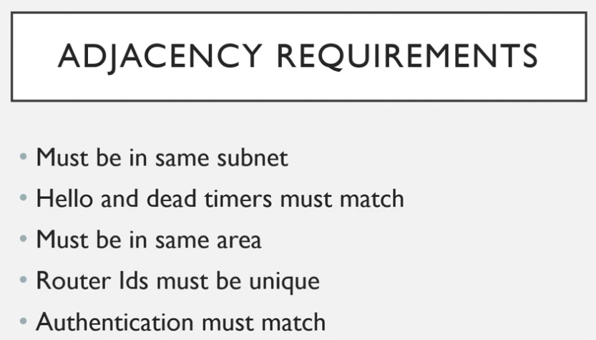
https://www.youtube.com/watch?v=ltK45xFngxs&t=169s

OK ragionamento: prendo il dead interval e considero un po’ di più. Es: de dead interval == 40s => timeout <- 1m (150% dead interval)
(scrivere la logica, poi pensiamo alle query)

LSA Max Age
https://community.cisco.com/t5/routing-and-sd-wan/ospf-lsa-aged-to-maxage/td-p/1512788
Il fatto che in un database ospf ci siano diversi LSA che hanno raggiunto il max age, può essere un indice di qualcosa che non va (può voler dire che un router non sta ricevendo aggiornamenti?). Si potrebbe fare una query su questo.

Lista di ABR e ASBR
Magari facendo vedere quali interfacce ho in quali aree

Numero di router nell’area
count (group by (instance) (frr_ospf_area_lsa_number{area="0.0.0.0"}) )

Numero di route nella FIB (***WIP***)
frr_route_fib_count{vrf="default", route_type=~"ospf|static|connected|local"}

esempio test:
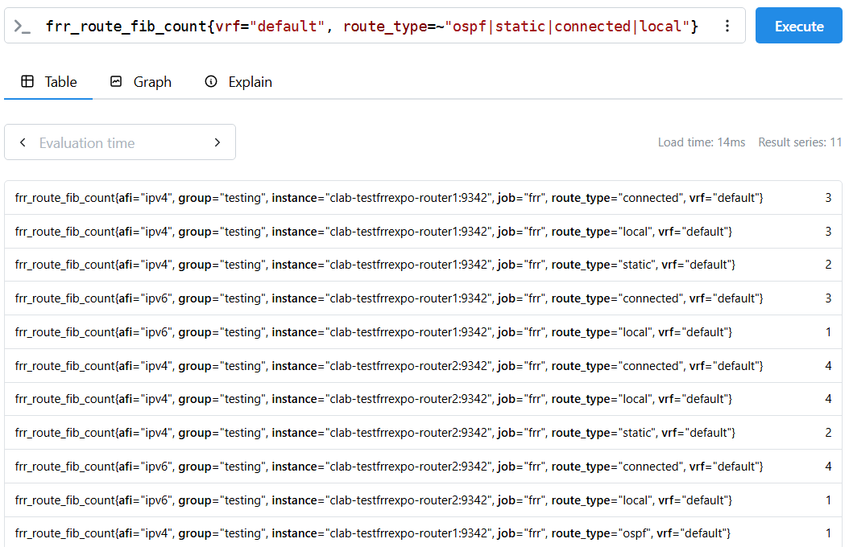
Local and Connected routes
https://networkingnotebook.com/?p=433
C stands for connected route and L stands for local route. On a router every interface has its own unique IP and MAC address, so two ports on a router can be in two different subnets. Since the subnet belongs to an interface that means the router should know how to reach it, this is where connected and local routes come into play. Connected routes are the specific network that an interface belongs to. Connected routes only show up on the routing table when these requirements are met:
- The interface is up/up (administratively up/ operationally up)
- The interface has been assigned an IP address.
Once the interface has an IP and is up, the connected route is then put onto the table, allowing that network to be reachable via that port.
A local route is a route on the routing table that is the actual IP address of the router interface. This IP is the literal identifier for that port, and since its the actual owner of that IP address it will always have a host prefix of either /32 for IPv4 or /128 for IPv6. The same rules apply to local routes for it to appear on the routing table:
- The interface must be up/up
- The interface must be assigned an IP address
Connected routes represent networks and local routes represent host routes for the router interface itself. Local routes are not meant to forward any traffic but to receive traffic meant for that IP address.

Proviamo:
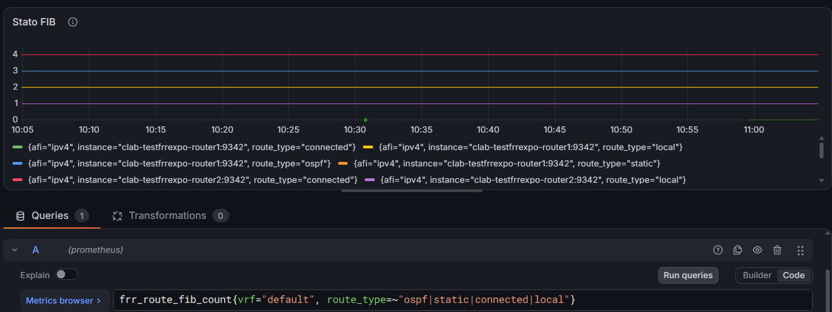
problema: tante time serie, dell’ordine di istance x route_type. MA qui ho ristretto a 4 le route type, perché sono quelle rilevanti per la tesi: ospf, static, connected, local (la prima più di tutte, le altre meno ma comunque indicative: variano quando configuro nuove interfacce, se un’interfaccia va down, se non configuro l’IP, ecc... Le statiche? forse non servono a molto, magari le posso correlare col numero di external LSA?)

IDEA: visto che mi interessano solo 4 tipi di route, fare un panel p.o. tipo. Si può fare a mano, ma sarebbe possibile fare un template?

Varie
- numero di risorse consumate (CPU, memoria, byte inviati in rete) dagli exporter (tutti o per singolo) rispetto al totale (richiede altri exporter)
- Stato generale degli exporter (done)
- overview del database: p.o. area, p.o. istanza, mettere numero di LSA per: network, ASBR, ABR, ecc..
- grafico che mostra la variazione del numero di route nella FIB e nella RIB nel tempo (specifico OSPF o anche altre? per ora solo OSPF)
- grafico che mostra la variazione del numero di LSA dei vari tipi nel tempo(?)

Prometheus

Monitoraggio stato exporter
da rete-test-prometheus-self-scrape.txt (solo voci interessanti):
# HELP net_conntrack_dialer_conn_established_total Total number of connections successfully established by the given dialer a given name.
# TYPE net_conntrack_dialer_conn_established_total counter
net_conntrack_dialer_conn_established_total{dialer_name="default"} 0
net_conntrack_dialer_conn_established_total{dialer_name="frr"} 2
net_conntrack_dialer_conn_established_total{dialer_name="prometheus"} 1
# HELP net_conntrack_dialer_conn_failed_total Total number of connections failed to dial by the dialer a given name.
# TYPE net_conntrack_dialer_conn_failed_total counter
net_conntrack_dialer_conn_failed_total{dialer_name="default",reason="refused"} 0
net_conntrack_dialer_conn_failed_total{dialer_name="default",reason="resolution"} 0
net_conntrack_dialer_conn_failed_total{dialer_name="default",reason="timeout"} 0
net_conntrack_dialer_conn_failed_total{dialer_name="default",reason="unknown"} 0
net_conntrack_dialer_conn_failed_total{dialer_name="frr",reason="refused"} 0
net_conntrack_dialer_conn_failed_total{dialer_name="frr",reason="resolution"} 0
net_conntrack_dialer_conn_failed_total{dialer_name="frr",reason="timeout"} 0
net_conntrack_dialer_conn_failed_total{dialer_name="frr",reason="unknown"} 0
net_conntrack_dialer_conn_failed_total{dialer_name="prometheus",reason="refused"} 0
net_conntrack_dialer_conn_failed_total{dialer_name="prometheus",reason="resolution"} 0
net_conntrack_dialer_conn_failed_total{dialer_name="prometheus",reason="timeout"} 0
net_conntrack_dialer_conn_failed_total{dialer_name="prometheus",reason="unknown"} 0

Nota: cos’è un dialer in questo contesto? In questo contesto un dialer è, in sostanza, il componente che inizia/apre una connessione di rete verso un endpoint remoto.
Il nome deriva dal verbo inglese to dial: concettualmente è come “comporre il numero” per iniziare una connessione. Nel networking Go (linguaggio in cui Prometheus è scritto), un Dialer è proprio l'oggetto usato per stabilire connessioni TCP/IP. (chat)
Queste posso usarle o per alert o nella dashboard (o tutte e due) per segnalare se ci sono problemi con la connessione agli exporter.
Idee:
- per le istanze di exporter contattate faccio un panel. Visto che qui mi dà solo il counter, quindi non mi dice real time se è connesso con un exporter o no, questa info non mi basta per stabilre se la connessione è up. Però potrei unirla insieme alla metrica di un exporter che mi dice se lo stato è up o down.

# HELP promhttp_metric_handler_requests_total Total number of scrapes by HTTP status code.
# TYPE promhttp_metric_handler_requests_total counter
promhttp_metric_handler_requests_total{code="200"} 105
promhttp_metric_handler_requests_total{code="500"} 0
promhttp_metric_handler_requests_total{code="503"} 0

Di questa potrei usare il rate dei diversi status code per rilevare se ci sono stati problemi.

SNMP + FRR expo
intanto da FRR expo, frr_ospf_neighbor_state{iface="eth0",local_address="10.0.0.10",neighbor="2.2.2.2",remote_address="",vrf="default"} può essere usato per associare le interfacce all’ID del router, ad esempio con
ospfNbrRtrId{ospfNbrAddressLessIndex="0",ospfNbrIpAddr="10.0.0.10",ospfNbrRtrId="1.1.1.1"} dell’SNMP exporter.

Idee varie:
- a parte tutti i rate dei count vari (# ricalcolo aree, # lsa rx, tx)
- grafo della rete (un po’ ambizioso ma vediamo, non da fare per primo)
- per reti broadcast, chi è il DR e il BDR
- Con l’info sopra si potrebbe anche identificare gli stati 2-way che sono così perché la relazione è DROTHER
- identificare gli ABR di un’area, specificando le aree adiacenti
- identificare gli ASBR, forse fare un elenco delle rotte che redistribuisce

Storico di Router/interfacce/altro non più rilevati
Al momento, la dashboard dà perlopiù un’istantanea dello stato del momento. Potrei volere che, se ci sono “elementi” non più presenti, rimanga traccia di questi nella dashboard per un certo periodo di tempo (quanto? ore?). Voglio anche che sia riconoscibile il fatto che questi elementi non siano al momento attivi. Perché? Perché se viene spento un router o la sua interfaccia usata per lo scraping, prometheus smette di ricevere metriche, e per lui il container non esiste più, negli istant vector gli elementi corrispondenti non avranno più valori associati. Quindi voglio mantenere una traccia.
A che serve? Un dispositivo/interfaccia non è più raggiungibile da 2 ore. È normale? Me lo aspetto? Devo indagare? Sono stati segnalati problemi relativi a quel dispositivo?

Panel messi (test)

FRR Exporter CPU Usage Rate (%)

query | rate( process_cpu_seconds_total{job="frr"} [5m])*100
type | time serie
labels | instance

Neighbors State
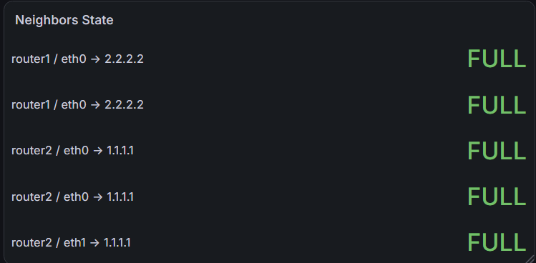
query | frr_ospf_neighbor_state{vrf="default"}
type | stat
labels | {{instance}} / {{iface}} → {{neighbor}}
value mappings | 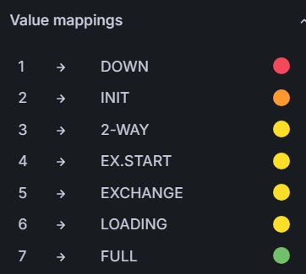

Vorrei verificare che sta roba effettivamente serva e che lo stato mostrato mi dia delle indicazioni su cosa sta avvenendo o sul fatto che ci siano problemi.
Limitazione: Vorrei metterlo come panel ripetuto per area, ma non c’è la label “area” nel vettore risultante dalla query. (vedi immagine sotto)
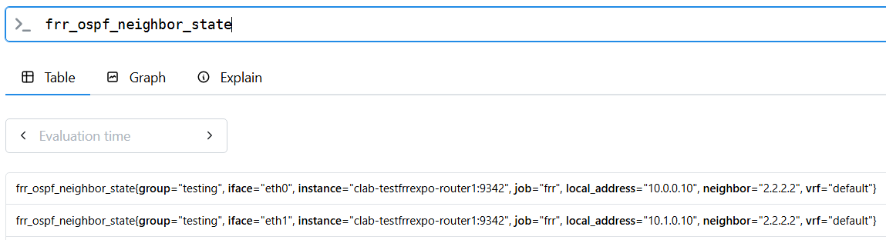
BUT c’è l’interfaccia. 1 interfaccia -> 1 area. Se ci sono metriche che mi associano l’interfaccia all’area, forse riesco a collegare queste informazioni per restringere il risultato ai vicini in una stessa area.
Ad esempio (vedi immagine sotto):
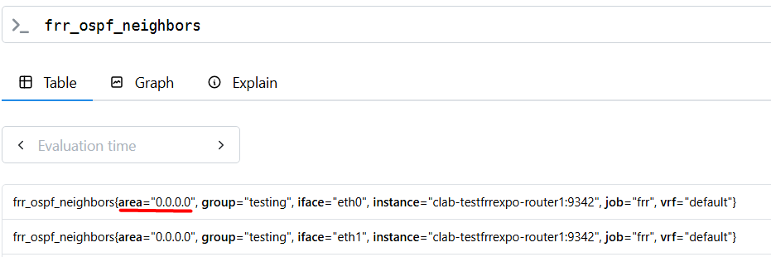
con un join tra interfaccia ed istanza, potrei associare l’area all’interfaccia anche in questa dashboard.

Prove da fare:
- connettere/disconnettere interfacce (interf up/down) -> expected: vedere gli stati che passano da down fino a full
- mismatch della subnet -> expected: stuck a init
- ospf timer differenti -> expected: stuck a init
- dimenticarsi del comando “passive interface ...” -> expected: ? probabilmente blocco su init?

OSPF Neighbor UP
Query corrente (DA MIGLIORARE) QUERY VECCHIA:
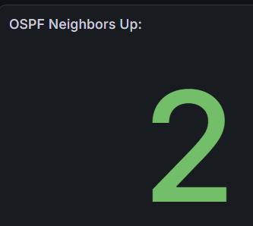
query | count (frr_ospf_neighbors{vrf="default", iface!="lo"} > 0)
type | stat
labels | -

Da chat:
2. OSPF Neighbors Up
count(frr_ospf_neighbors{vrf="default", iface!="lo"} > 0)

Questo è il pannello che modificherei per primo.
La query non somma il numero dei vicini: > 0, senza il modificatore bool, filtra le serie positive; count() conta poi quante serie sono rimaste.
Quindi la domanda a cui risponde è:
Quante interfacce hanno almeno un vicino?
Non:
Quanti vicini OSPF sono presenti?
Inoltre il count aggrega insieme router1 e router2.
Per ottenere il numero effettivo di vicini per router e VRF, nella rete di prova userei:
sum by (instance, vrf) (
frr_ospf_neighbors{
job="frr",
iface!="lo"
}
)
Legenda:
{{instance}} / {{vrf}}
Quando avrai una label esplicita router, la query diventerà più leggibile:
sum by (router, vrf) (
frr_ospf_neighbors{
job="frr",
iface!="lo"
}
)
Nella rete finale, con la sola tabella di routing predefinita:
sum by (router) (
frr_ospf_neighbors{
job="frr",
vrf="default",
iface!="lo"
}
)
Il filtro iface!="lo" è corretto: nello scrape la loopback compare con valore zero e falserebbe il numero di serie osservate.

NUOVA DASHBOARD:
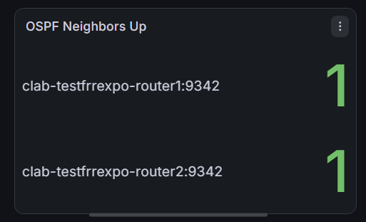
Nota: per ora la label si lascia così, poi si aggiunge una label “hostname” da prometheus.
query | sum by (instance) (frr_ospf_neighbors{iface!="lo", vrf="default"})
type | STAT
labels | instance

FRR Exporter State (TOLTA)
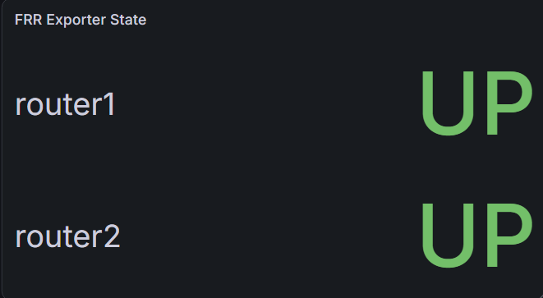
Semplice monitoraggio per vedere se l’exporter è attivo (necessario se no magari vedo delle metriche sballate e non capisco perché, invece è solo l’exporter down)
query | frr_status_up
type | stat
labels | {{instance}}

Tabella conteggio LSA nel DB
frr_ospf_area_lsa_asbr_number
frr_ospf_area_lsa_network_number
frr_ospf_area_lsa_nssa_number
frr_ospf_area_lsa_number
frr_ospf_area_lsa_summary_number
frr_ospf_lsa_as_opaque_counter
frr_ospf_lsa_external_counter
frr_ospf_neighbor_adjacencies
frr_ospf_data_ls_max_age

Per creare il result set da inserire nella tabella, chat suggerisce:
or
label_replace(
(
frr_ospf_area_lsa_number{
job="frr",
area="0.0.0.0"
}
-
frr_ospf_area_lsa_network_number{
job="frr",
area="0.0.0.0"
}
-
frr_ospf_area_lsa_summary_number{
job="frr",
area="0.0.0.0"
}
-
frr_ospf_area_lsa_asbr_number{
job="frr",
area="0.0.0.0"
}
-
frr_ospf_area_lsa_nssa_number{
job="frr",
area="0.0.0.0"
}
),
"lsa_type", "Router (Type 1, stimato)", "area", ".*"
)

label_replace() è importante per questo motivo: “vector1 or vector2 results in a vector that contains all original elements (label sets + values) of vector1 and additionally all elements of vector2 which do not have matching label sets in vector1”. (https://prometheus.io/docs/prometheus/latest/querying/operators/#logicalset-binary-operators)
le metriche sul LSDB hanno tutte(?) lo stesso set di label, quindi viene restituito un vettore contenente solo le time serie di vector1. Per averle tutte, basta aggiungere una label custom che non faccia match (da verificare).
Label replace: https://prometheus.io/docs/prometheus/latest/querying/functions/#label_replace
test di label_replacement (riuscito):
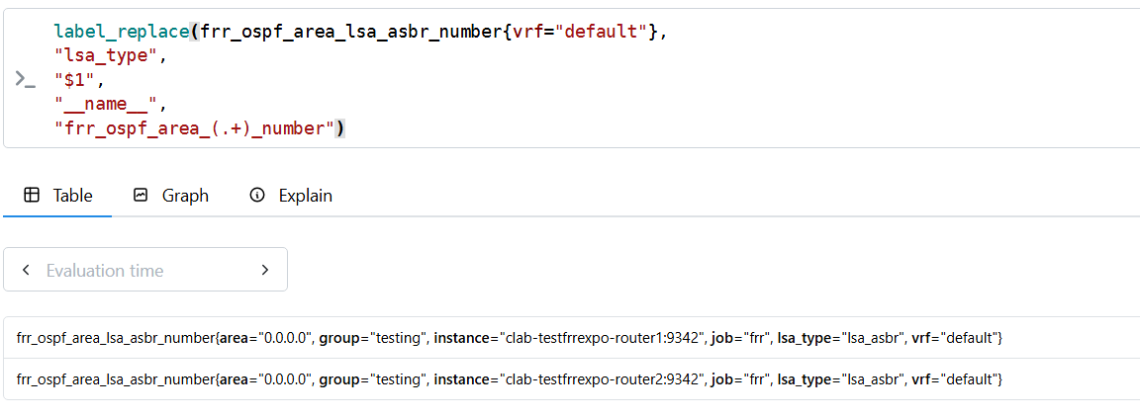
E così l’OR funziona!
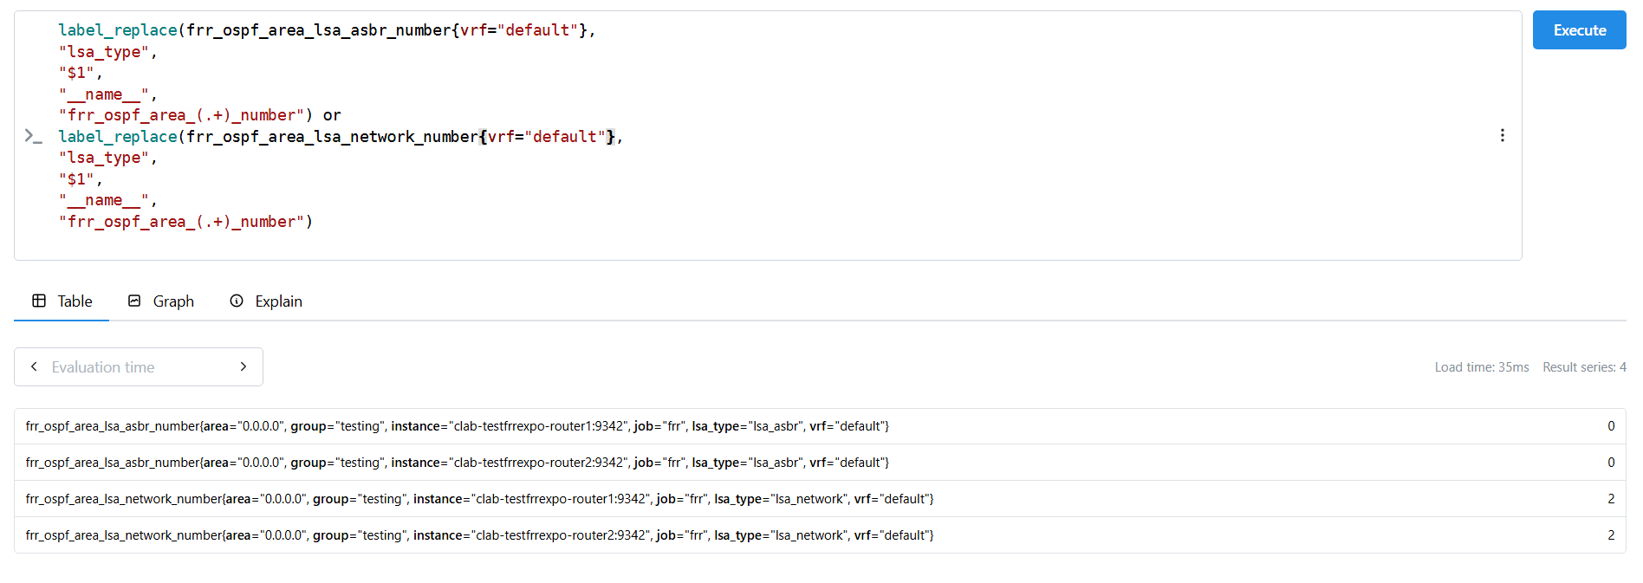
Query
parziale: senza router lsa e totale:
label_replace(frr_ospf_area_lsa_network_number{vrf="default", area="0.0.0.0"},
"lsa_type",
"Network (Type 2)",
"__name__",
".*") or

label_replace(frr_ospf_area_lsa_summary_number{vrf="default", area="0.0.0.0"},
"lsa_type",
"ABR Summary (Type 3)",
"__name__",
".*") or

label_replace(frr_ospf_area_lsa_asbr_number{vrf="default", area="0.0.0.0"},
"lsa_type",
"ASBR Summary (Type 4)",
"__name__",
".*") or

label_replace(frr_ospf_lsa_external_counter{vrf="default"},
"lsa_type",
"External Route (Type 5)",
"__name__",
".*") OR

label_replace(frr_ospf_area_lsa_nssa_number{vrf="default", area="0.0.0.0"},
"lsa_type",
"NSSA External (Type 7)",
"__name__",
".*") or

label_replace(frr_ospf_lsa_as_opaque_counter{vrf="default"},
"lsa_type",
"Opaque: AS Scope (Type 11)",
"__name__",
".*")

WAIT:
frr_ospf_area_lsa_number gauge Number of LSAs in the area

Quindi il totale è solo quello dell’area. Quelli esterni vanno conteggiati a parte, quindi in realtà posso effettivamente ricavare il numero di router lsa con la sottrazione:
frr_ospf_area_lsa_number{vrf="default", area="0.0.0.0"} -

frr_ospf_area_lsa_network_number{vrf="default", area="0.0.0.0"} -

frr_ospf_area_lsa_summary_number{vrf="default", area="0.0.0.0"} -

frr_ospf_area_lsa_asbr_number{vrf="default", area="0.0.0.0"} -

frr_ospf_area_lsa_nssa_number{vrf="default", area="0.0.0.0"}

Poi in realtà non serve unire tutte le query con l’or, si possono mettere più query nella stessa tabella, ma serve una trasformazione. Per i dettagli: https://scottstuff.net/posts/2026/04/19/grafana-tables/
- Merge series/tables: https://scottstuff.net/posts/2026/04/19/grafana-tables/#adding-a-second-timeseries
Per mettere tutte le serie in una sola tabella.
- Organize fields by name: Per decidere quali colonne mostrare e rinominarle
PROBLEMA:
Questo è il risultato:
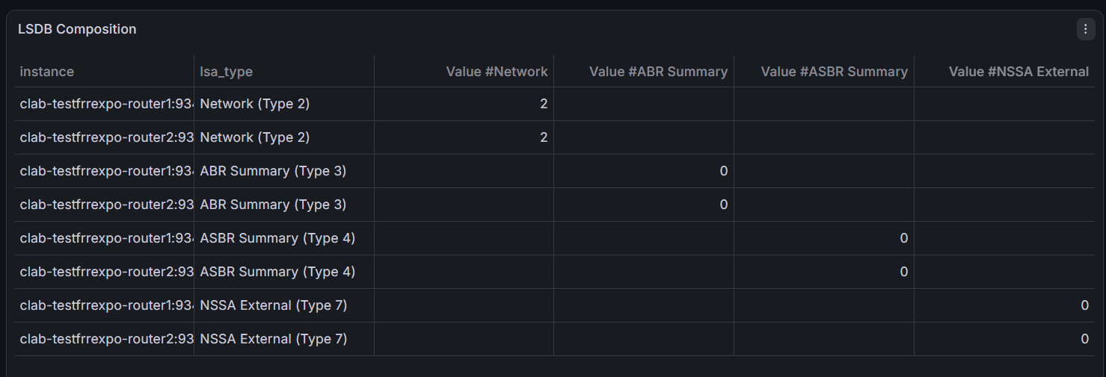
Quindi mi sa che voglio effettivamente tutto in una sola query :/
query | Router | label_replace (frr_ospf_area_lsa_number{vrf="default", area="0.0.0.0"} -  frr_ospf_area_lsa_network_number{vrf="default", area="0.0.0.0"} -  frr_ospf_area_lsa_summary_number{vrf="default", area="0.0.0.0"} -  frr_ospf_area_lsa_asbr_number{vrf="default", area="0.0.0.0"} -  frr_ospf_area_lsa_nssa_number{vrf="default", area="0.0.0.0"},  "lsa_type",  "Router LSA (Type 1)",  "__name__",  ".*")
query | Network | label_replace(frr_ospf_area_lsa_network_number{vrf="default", area="0.0.0.0"},  "lsa_type",  "Network (Type 2)",  "__name__",  ".*")
query | ABR Summary | label_replace(frr_ospf_area_lsa_summary_number{vrf="default", area="0.0.0.0"},  "lsa_type",  "ABR Summary (Type 3)",  "__name__",  ".*")
query | ASBR Summary | label_replace(frr_ospf_area_lsa_asbr_number{vrf="default", area="0.0.0.0"},  "lsa_type",  "ASBR Summary (Type 4)",  "__name__",  ".*")
query | NSSA External | label_replace(frr_ospf_area_lsa_nssa_number{vrf="default", area="0.0.0.0"},  "lsa_type",  "NSSA External (Type 7)",  "__name__",  ".*")
query | Total | frr_ospf_area_lsa_number{vrf="default", area="0.0.0.0"}
type | Table
labels | -
transformations | - 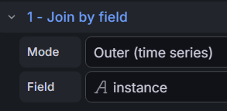  - Organize fields by name:  lasciati visibili solo instance (“Host”) e value (il valore della serie), rinominato per rispecchiare il tipo di LSA contato

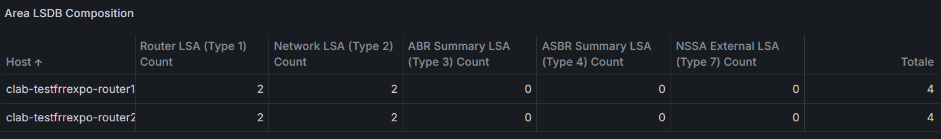

Stato pipeline
Per monitorare la raggiungibilità di FRR, degli exporter e lo stato dei collector.
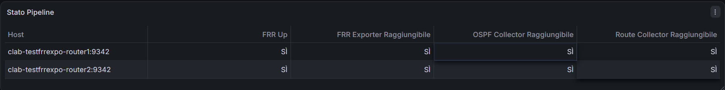
query | frr | frr_status_up{group="testing"}
query | frr exporter | up{job="frr",group="testing"}
query | ospf collector | frr_collector_up{group="testing", collector="ospf"}
query | route collector | frr_collector_up{group="testing", collector="route"}
type | table
labels | -
transfromations | - 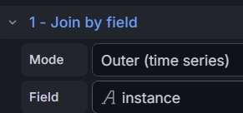  - Organize fields by name (nascoste colonne e rinominate colonne dei risultati)

<template tabella>

query
type
labels

PANEL POSSIBILI

GRAFO DI RETE
https://grafana.com/docs/grafana/latest/visualizations/panels-visualizations/visualizations/node-graph/

INDIVIDUAZIONE ABR, ASBR
Si può già fare, vedendo quali router (istanze) hanno interfacce in più aree.

INDIVIDUAZIONE DR E BDR IN RETE BROADCAST
già fattibile, vedendo, all’interno di una stessa area, per ogni istanza, quanti vicini vede ogni interfaccia.

presi da dashboard Prometheus Network Exporter
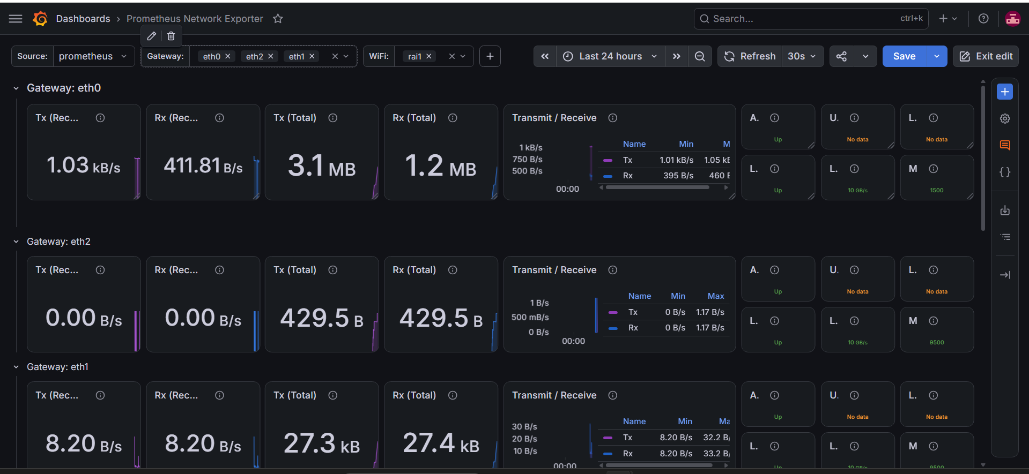
Qui si suppone che ci sia un gateway solo. Nel mio scenario in cui avrò 6 router, fare 1 panel per ogni interfaccia mi sembra eccessivo. Penso sia meglio fare 1 solo panel per router con tutte le sue interfacce. Magari si potrebbe anche indicare a quale area appartengono.

Traffico rete generato nei router dai vari scrape
Servirebbe l’exporter che mi fa differenziare in base agli IP (lo avevo visto in una dashboard ma non mi ricordo il nome). Idea: controllo se lo scrape sta utilizzando troppa banda.

Alerts (idee)
Idea per alert sulle adiacenze mal formate: https://chatgpt.com/s/t_6a96a85e42508191992a331bdcc86490
In sintesi, visto che uno stato 2-way può essere il comportamento inteso in una rete broadcast, ho pensato ad un modo per determinare se un’interfaccia si trova in una rete broadcast in base al numero di vicini (> 2) (Limitazione: suppone che frr exporter sia running su tutti i vicini nella rete). Su questa assunzione, lo stato è corretto se:
- sulla rete ci sono sull’interfaccia vedo solo 2 adiacenze full e le altre 2-way (DRother)
- sull’interfaccia vedo N adiacenze full, N = numero vicini.
Il numero di interfacce che parteci

PROBLEMI DA RISOLVERE
- Quando faccio stop e start di un container frr, frr_exporter va fatto ripartire a mano.
  - sol: fare script che me lo riavvia allo start? Creare immagine modificata di frr con l’exporter che parte automaticamente all’avvio?
-----------
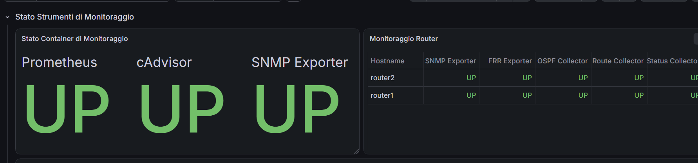
- non si capisce perché snmp expo è in entrambi i panel (uno è lo stato del container, l’altro è la raggiungibilità dei targe.
- anche di cAdvisor sarebbe da monitorare la raggiungibilità dei target. (possibile metrica da utilizzare: container_creation_time_seconds.
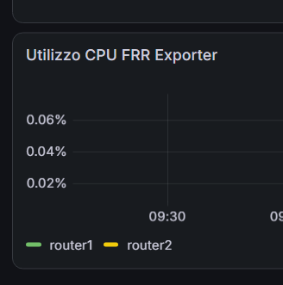
- forse si capisce poco che frr expo gira sui router, quindi qui si monitora la percent della router cpu usata dall’expo.
---------------------
RISOLTO: LA LEGENDA NON MI PRENDE IL NOME DELLA LABEL DIOCANE (img sotto)
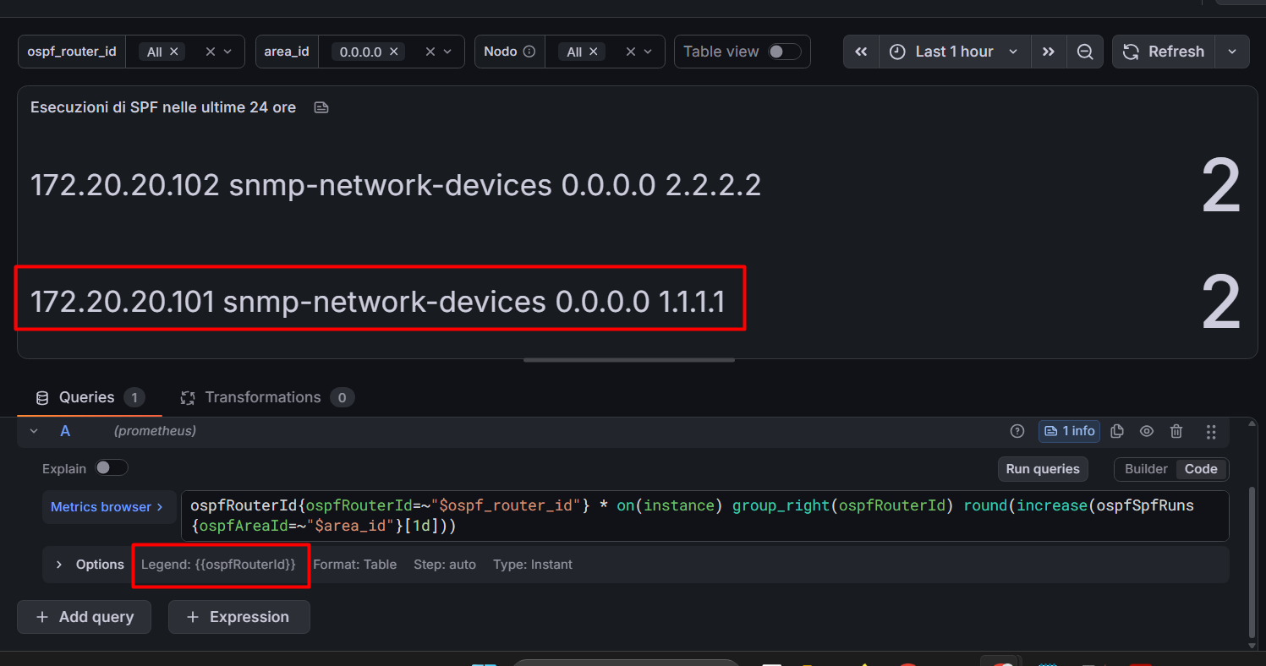
Mi sa che mi tocca usare una regex per selezionare solo l’ultimo ID

SOLUZIONE:
Il colpevole è "format": "table".
In modalità table il datasource Prometheus restituisce un unico frame con una colonna per ogni label (instance, job, ospfAreaId, hostname, group…) più la colonna Value. In quel formato legendFormat viene ignorato: non ci sono serie da nominare, ci sono campi. Il pannello Stat, con reduceOptions.fields: "" e values: true, prende allora tutti i campi del frame e te li mostra uno per uno — che è esattamente quello che vedi.
---------------------
qui anche peggio (img sotto):
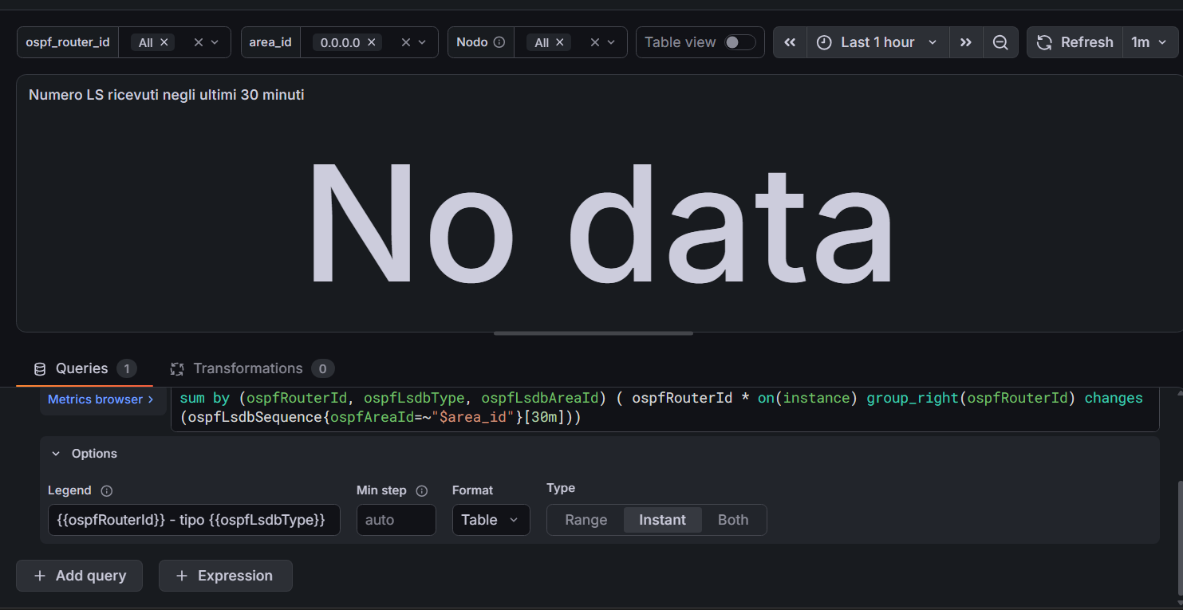
Però in prometheus gira (img sotto):
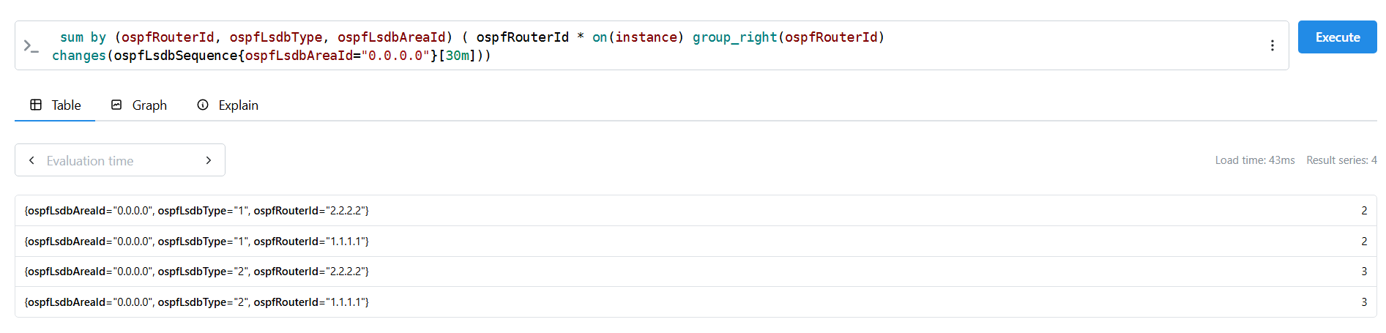

-------------------------
(RISOLTO) Mancata associazione ip index if descr:
Prima:

# generator.yml

ip_mib:
walk:
- ipAddressIfIndex # da ipAddressTable: indirizzo -> ifIndex
- ipAddressPrefixOnLinkFlag # da ipAddressPrefixTable: forza il walk della tabella
# (qualsiasi colonna va bene, serve solo a "toccare" la tabella
# così i suoi indici diventano label automaticamente)
lookups:
- source_indexes: [ipAddressPrefixIfIndex]
lookup: ifDescr

# scrape:
# HELP ipAddressPrefixOnLinkFlag This object has the value 'true(1)', if this prefix can be used for on-link determination; otherwise, the value is 'false(2)' - 1.3.6.1.2.1.4.32.1.6
# TYPE ipAddressPrefixOnLinkFlag gauge
ipAddressPrefixOnLinkFlag{ifDescr="",ipAddressPrefixIfIndex="2",ipAddressPrefixLength="24",ipAddressPrefixPrefix="10.0.0.0"} 1

Dopo (soluzione):
ip_mib:
walk:
- ipAddressIfIndex # da ipAddressTable: indirizzo -> ifIndex
- ipAddressPrefixOnLinkFlag # da ipAddressPrefixTable: forza il walk della tabella
# (qualsiasi colonna va bene, serve solo a "toccare" la tabella
# così i suoi indici diventano label automaticamente)
lookups:
- source_indexes: [ipAddressPrefixIfIndex]
lookup: "IF-MIB::ifDescr"

# scrape:
# HELP ipAddressPrefixOnLinkFlag This object has the value 'true(1)', if this prefix can be used for on-link determination; otherwise, the value is 'false(2)' - 1.3.6.1.2.1.4.32.1.6
# TYPE ipAddressPrefixOnLinkFlag gauge
ipAddressPrefixOnLinkFlag{ifDescr="eth0",ipAddressPrefixIfIndex="2",ipAddressPrefixLength="24",ipAddressPrefixPrefix="10.0.0.0"} 1

In pratica nella mia cartella per le MIB ho anche versioni “enterprise” (legate a vendor specifici?) delle MIB. Per ifDescr c’è un OID “normale” (IF-MIB standard) e uno enterprise, e senza specificare il modullo, mi veniva preso in automatico quello enterprise.

Varie
pw arista: RunningInCircles0!
pw docker hub: CuzcoEIlSuoVeleno0!

cool way to define binds: ~https://containerlab.dev/manual/nodes/#binds

Fix a notepad che non si apre
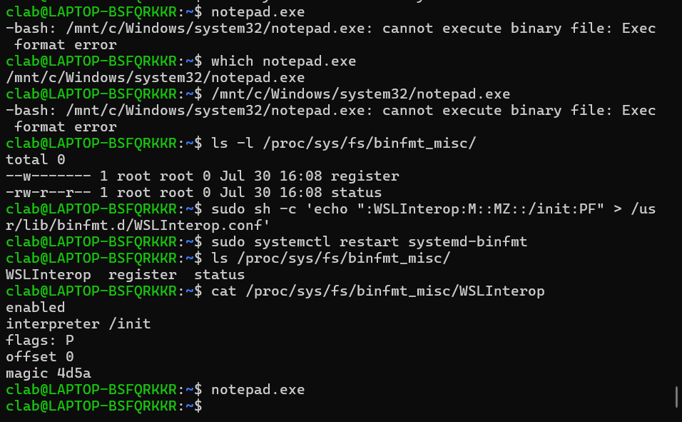
It works!
router1# conf t
router1(config)# interf lo1
router1(config-if)# ip addr 6.6.6.6/32
router1(config-if)# ^Z
router1# write
Note: this version of vtysh never writes vtysh.conf
% Can't open configuration file /etc/frr/vtysh.conf due to 'No such file or directory'.
Building Configuration...
Integrated configuration saved to /etc/frr/frr.conf
[OK]
router1# exit
clab@LAPTOP-BSFQRKKR:~/Documents/frrlab$ sudo cat router1/frr.conf
frr version 7.5.1_git
frr defaults traditional
hostname router1
domainname localdomain
no ipv6 forwarding
!
interface eth1
ip address 192.168.1.1/24
!
interface eth2
ip address 192.168.2.1/24
!
interface eth3
ip address 192.168.11.1/24
!
interface lo
ip address 10.10.10.1/32
!
interface lo1
ip address 6.6.6.6/32
!
router ospf
passive-interface eth3
passive-interface lo
network 192.168.1.0/24 area 0.0.0.0
network 192.168.2.0/24 area 0.0.0.0
network 192.168.11.0/24 area 0.0.0.0
!
line vty
!

Controllare port utilizzati
To check the listening ports and applications on Linux:
- Open a terminal application i.e. shell prompt.
- Run any one of the following command on Linux to see open ports:
sudo lsof -i -P -n | grep LISTEN
sudo netstat -tulpn | grep LISTEN
sudo ss -tulpn | grep LISTEN
sudo lsof -i:22 ## see a specific port such as 22 ##
sudo nmap -sTU -O IP-address-Here

Text tree generator
https://www.text-tree-generator.com/
Documento Tesi
├── Introduzione
│ ├── Presentazione dell'argomento di tesi
│ │ └── (monitoraggio piano dati)
│ └── Finalità del progetto
│ └── (applicabilità ad ambiente professionale)
├── Svolgimento
│ ├── Specifiche tecniche
│ │ └── (ambiente simulato, software open source, ...)
│ ├── Strumenti
│ │ ├── (pipeline: container frr -> frr exporter -> prometheus -> grafana)
│ │ ├── Containerlab
│ │ │ └── (docker containers, frr)
│ │ ├── Prometheus
│ │ │ └── (time series, prometheus server, tsdb, promql)
│ │ ├── FRR Exporter
│ │ └── Grafana
│ └── Risultati
├── Conclusioni
│ ├── Considerazioni
│ └── Possibili sviluppi
└── Bibliografia

source text:
Documento Tesi
=Introduzione
== Presentazione dell'argomento di tesi
=== (monitoraggio piano dati)
== Finalità del progetto
=== (applicabilità ad ambiente professionale)
=Svolgimento
== Specifiche tecniche
=== (ambiente simulato, software open source, ...)
== Strumenti
===(pipeline: container frr -> frr exporter -> prometheus -> grafana)
===Containerlab
====(docker containers, frr)
===Prometheus
====(time series, prometheus server, tsdb, promql)
===FRR Exporter
===Grafana
==Risultati
=Conclusioni
==Considerazioni
==Possibili sviluppi
=Bibliografia

Permessi cartelle binding
sudo useradd -M -r -s /bin/false prometheus
sudo chown -R prometheus:prometheus /opt/prometheus

Sulle cartelle dei container.

PASSWORD GRAFANA (TEST)
ZoccoloDiGnu
x reset:
sudo docker exec -it clab-testfrrexpo-grafana grafana cli a
dmin reset-admin-password ZoccoloDiGnu

Risorse

Prometheus
- PromQL: https://www.youtube.com/watch?v=RC1ivt-ZN_U

Grafana
- Ripetere righe e pannelli basandosi su variabili: https://medium.com/@platform.engineers/configuring-repeating-rows-and-panels-in-grafana-b365facf2bae
- State timeline: https://www.youtube.com/watch?v=a9wZHM0mdxo

cAdvisor
- https://www.dash0.com/guides/cadvisor-docker-monitoring#prerequisites
- https://github.com/google/cadvisor#quick-start-running-cadvisor-in-a-docker-container

x documentazione
Parlare di:
- time series
- TSDB
- observability

Domande (non necessariamente da fare ai relaotri)
- Grafana viene eseguito sul server controllore e poi invia i grafi/metriche/dashboard tramite HTTP al client dal quale faccio il monitoraggio? Oppure è da installare direttamente sul client, e riceve dal server le metriche raccolte con Prometheus?
- Visti alcuni siti che spiegano cos’è il monitoraggio di rete e cosa fa uno strumento di monitoraggio, mi sono resa conto che alcune delle feature principali non sono realizzabili solo attraverso FRR exporter. Fare un elenco di cose che il mio strumento (ora) può fare e cose importanti che non può fare, presentarlo ai prof e chiedergli se sia il caso di cercare altri strumenti per realizzarli.
- Aggiungo gli alert? Nel caso metterei quelli per segnalare se i processi di monitoraggio sono inattivi e per le adiacenze tra vicini non formate. Però potrebbero essere ridondanti, visto che ci sono già i panel? Problema: Se facessi un alert per lo stato dei vicini stuck, non potrei distinguere ad esempio se la relazione 2-way sia intesa (rete broadcast con router non DR/BDR) o se invece rappresenta un comportamento inatteso.

- ricerche su metriche SNMP interessanti per OSPF
- trovata immagine di SNMP exporter, testato, ma:
-- bisogna installare l’agent SNMP in FRR
--- gli strumenti sono indicati nella documentazione ufficiale di FRR, ma:
---- l’installazione del software indicato richiede compilazione, e l’immagine non è dotata di compilatore.
--- alternativa: package snmp-frr. problema: l’os del container mi scaricherebbe la versione per FRR 10.2.x (mettere comando dove si scopre questa cosa)
domanda:
- è possibile costruire un’immagine docker che abbia net-snmp già installato e che parta già configurato per SNMP?

Quali sono le metriche SNMP interessanti per la dashboard (da https://mibs.observium.org/mib/OSPF-MIB/)?
- ospfRouterId: A 32-bit integer uniquely identifying the router in the Autonomous System. By convention, to ensure uniqueness, this should default to the value of one of the router's IP interface addresses.
- ospfRxNewLsas: The number of link state advertisements received that are determined to be new instantiations. This number does not include newer instantiations of self-originated link state advertisements.
- ospfAsLsaCount: The number of AS-scope link state advertisements in the AS-scope link state database.
- ospfAreaBdrRtrStatus: A flag to note whether this router is an Area Border Router.
- ospfASBdrRtrStatus: A flag to note whether this router is configured as an Autonomous System Border Router.
- ospfSpfRuns: The number of times that the intra-area route table has been calculated using this area's link state database. This is typically done using Dijkstra's algorithm.
----
Buongiorno, scrivo perché sono incappata in un problema che non so come risolvere.
Giovedì scorso è stato deciso con il professor Mingozzi che avrei indagato sull’exporter SNMP per capire se potesse fornire delle metriche interessanti su OSPF da poter aggiungere alla dashboard, visto che quelle prese da FRR exporter non sono sufficienti per avere una visione comprensiva sullo stato del protocollo nei router.
Ho cercato quali informazioni SNMP fornisce su OSPF, ed effettivamente sembra che ce ne siano alcune che potrebbero fare al caso mio. In particolare da https://mibs.observium.org/mib/OSPF-MIB/ ho trovato:
- ospfRouterId: A 32-bit integer uniquely identifying the router in the Autonomous System. By convention, to ensure uniqueness, this should default to the value of one of the router's IP interface addresses.
- ospfRxNewLsas: The number of link state advertisements received that are determined to be new instantiations. This number does not include newer instantiations of self-originated link state advertisements.
- ospfAsLsaCount: The number of AS-scope link state advertisements in the AS-scope link state database.
- ospfAreaBdrRtrStatus: A flag to note whether this router is an Area Border Router.
- ospfASBdrRtrStatus: A flag to note whether this router is configured as an Autonomous System Border Router.
- ospfSpfRuns: The number of times that the intra-area route table has been calculated using this area's link state database. This is typically done using Dijkstra's algorithm.
Ho trovato un’immagine dell’SNMP exporter e l’ho aggiunta come container al lab. Per poter estrarre l’exporter è necessario che i router target siano configurati per SNMP, ma i container FRR nel lab non lo sono. Dalla documentazione di FRR (https://docs.frrouting.org/en/latest/snmp.html#snmp-support): “The supported SNMP agent is AgentX. We recommend to use the latest version of net-snmp which was formerly known as ucd-snmp. It is free and open software and available at http://www.net-snmp.org/ and as binary package for most Linux distributions.” Quindi ho provato a compilare il package da dentro il container del router, ma questo giustamente non è dotato di compilatore. Come potrei fare a costruire un’immagine docker partendo da quella FRR che abbia già installato net-snmp e FRR configurato per SNMP?

